**BURAINDO: An IOT Based Multifunction Smart Blinds   
Using Raspberry Pi**

A Capstone Project Presented to the Faculty of

Institute of Business and Computing Education

Mabalacat City CollegeMabalacat City, Pampanga

In Partial Fulfillment of the Requirements for the Degree of

Bachelor of Science in Information Technology

**By:**

**Lyjay Dred G. Cayanong**

**Jayvie F. De Leon**

**Shawn Nicole D. Farrow**

**Eunixen C. Lansang**

**Arlie T. Torres**

**Justin D. Yalung**

**February** **2023**

**Adviser’s Recommendation Sheet**

This capstone project entitled **“BURAINDO: An IOT-Based Multi-Function Smart Blinds Using Raspberry Pi”**, prepared and submitted **by Cayanong Lyjay, Dred G., De Leon, Jayvie F., Farrow, Shawn Nicole D., Lansang, Eunixen C., Torres, Arlie T., Yalung, Justin D**. in partial fulfillment of the requirements for the degree Bachelor of Science in Information Technology, is hereby recommended for the **FINAL DEFENSE.**

Approved By:

__________________________

**MR. FREDERIC D. SANTOS**

**Capstone Adviser**

Noted By:

___________________________________

**RITCHELL Z. ESCOTO, MIT**

**Capstone Instructor**

**Panel’s Approval Sheet**

This capstone project entitled **"BURAINDO: An IOT Based Multifunction Smart Blinds Using Raspberry Pi",** prepared and submitted by Lyjay Dred G. Cayanong, Jayvie F. De Leon, Shawn Nicole D. Farrow, Eunixen C. Lansang, Arlie T. Torres, Justin D. Yalung, in partial fulfillment of the requirements for the degree of BACHELOR OF SCIENCE IN INFORMATION TECHNOLOGY, is hereby approved and accepted.

**RITCHELL Z. ESCOTO, MIT FREDERIC D. SANTOS**

Capstone Instructor Technical Adviser

**CAPSTONE COMMITTEE**

Approved in partial fulfillment of the requirements for the degree of Bachelor of Science in Information Technology by the Committee on Capstone Project.

**DENNIS L. TACADENA, PCpE, DIT**

Chairman

**RITCHELL Z. ESCOTO, MIT AGUSTIN EDMIN S. YUZON**

Member Member

**MYRNA C. CALMA, CPA, Ph.D., FRIAcc**

*Dean, IBCE*

**Acknowledgement**

The success and outcome of this study were made possible by the help and direction from numerous people. The researchers are incredibly privileged to have gotten this all along with the achievement of their study. It required a lot of effort from each individual involved. They would like to thank the following:

The Lord, for all of the answered prayers during the year particularly during their journey in completing this research. This is one of their living testaments to how God's promises and miracles come to pass. The study's success was due to the researchers' intellectual talents and God's favor.

We appreciate and thank all the Mabalacat City Councilors, for granting us an opportunity to do the study and providing us financial support and leadership, which made us duly finish the study and despite having a busy schedule enduring the corporate affairs.

We heartily thank the Chairman of Barangay Duquit, Hon. Irene Villanueva, and the residences of Barangay Duquit. Also, Hon. Benjamin S. Pangan and Hon. Arnel Mungcal of Barangay Atlu-Bola, for granting us financial support despite having a busy schedule.

Researchers' Capstone Adviser, Mr. Frederic Santos, for his constant support and guidance for the development of the study, for cheering them up whenever challenges arise, and for providing them with knowledge on how to finish and improve this study.

The Capstone Panelists, Dr. Dennis L. Tacadena, Mr. Agustin S. Edmin Yuzon, and Mrs. Ritchell Z. Escoto are also thanked by the researchers for their time and effort in reviewing the paper, for their thoughtful comments and suggestions to improve the study, and for making the defense a pleasant experience.

**Dedication**

This research is entirely dedicated to our beloved parents, who have been sources of inspiration and strength when we felt like giving up, and who have continued to provide moral, spiritual, emotional, and financial support. To our brothers and sisters, relatives, mentors, friends, and classmates who offered pieces of advice and words of encouragement to help us finish this study. Finally, we dedicate this to the Almighty God, thanking Him for His guidance, strength, mental power, protection, and skills, as well as for providing us with a healthy life. We provide you with all of these options.

**Abstract**

The Internet of Things (IoT) is a key differentiation in many ways, such as how it improves convenience and efficiency; therefore, the researchers decided to develop an IoT device designed specifically for households. The researchers chose blinds because they have easy and quick method to get started with smart-home technology and are a perfect entry point for a home-related IoT device. The raspberry pi 4b micro-controller was used by the researchers in this study, with the installed smart blinds with various capabilities and features. The primary objective of this study is to create a prototype termed "Buraindo: An IOT Based Multi-function Smart Blinds Using Raspberry Pi." The prototype model is the general methodology used in this study. The researchers used this method to develop a prototype, test it, and then improve it as needed until an acceptable prototype was established. The researchers discovered that it is critical to appropriately display the data and to include the decimal digits. Additionally, they discovered that utilizing a powerful motor is necessary for the blinds to operate effectively. Since installing a speech recognition module would be too expensive, the researchers opted to use Google Speech Recognition. Derived from the findings, the prototype was built by the researchers that incorporated multifunctional smart blinds. Finally, successful alpha and beta testing results demonstrated that the application and prototype met the specifications, using the collected evidence. The research concluded that the product prototype "Buraindo: An IOT Based Multi-function Smart Blinds Using Raspberry Pi" was a success.

|  |  |
| --- | --- |
| **Table of Contents** | |
| **Preliminaries** | **Page no.** |
| Title Page  Adviser’s Recommendation Sheet  Panel’s Approval SheetAcknowledgementDedicationAbstract  Table of Contents  List of Figures  List of Tables  Appendices | i  ii  iii  iv  v  vi  vii  ix  xi  xii |
| **Chapter 1 – THE PROBLEM AND ITS BACKGROUND** |  |
| Introduction  Background of the Study  Objective of the Study  Scope and Limitations  Significance of the Study  Definition of Terms | 1  3  4  8  12  13 |
| **Chapter 2 – LITERATURE REVIEW** |  |
| Related Literature and Studies  Related Literature  RelatedStudies  Synthesis of the study  Conceptual Framework | 15  15  42  58  63 |
| **Chapter 3 – METHODOLOGY** |  |
| General Method Used  Procedures | 65  65 |
| **Chapter 4 – RESULTS AND DISCUSSIONS** |  |
| Product/Processes Screenshots Development  Testing Results | 71  90 |
| **Chapter 5 – SUMMARY OF FINDINGS, CONCLUSIONS, AND RECOMMENDATIONS** | |
| Summary of Findings  Conclusion  Recommendation | 104  105  108 |

|  |  |  |
| --- | --- | --- |
|  | **List of Figures** |  |
| **Figure No.** | **Title** | **Page No.** |
| 1 | Raspberry Pi 4B | 16 |
| 2 | DHT22 | 18 |
| 3 | L298N Motor Driver Module | 21 |
| 4 | Max7219 Dot Matrix 8x32 Module | 23 |
| 5 | Relay 5V 1 Channel Module | 24 |
| 6 | Nema 17 Stepper Motor | 26 |
| 7 | WS2812B LED Strip Lights | 27 |
| 8 | Air Humidifier | 30 |
| 9 | MIT APP Inventor V2 | 32 |
| 10 | Figma | 33 |
| 11 | Python | 34 |
| 12 | Blender 3D | 35 |
| 13 | Firebase | 36 |
| 14 | Raspberry Pi OS | 36 |
| 15 | Thonny | 38 |
| 16 | Window Blinds | 43 |
| 17 | Smart Light Manager | 44 |
| 18 | Suspended Particle Device | 47 |
| 19 | EEG | 48 |
| 20 | Air Quality Monitoring System | 51 |
| 21 | Control of Smart Home Operations | 53 |
| 22 | IoT Smart Blackout Curtain Including Voice Recognition | 55 |
| 23 | Smart Energy Efficient Home Automation System Using IoT | 56 |
| 24 | Effect of Peripheral Augmented Feedback | 57 |
| 25 | Conceptual Framework | 63 |
| 26 | Prototype Model | 65 |
| 27 | System/Mobile Application Developing | 72 |
| 28 | Mobile Application User Interface | 73 |
| 29 | Prototype Developing | 75 |
| 30 | Humidity and Temperature Monitoring | 77 |
| 31 | Humidifier Testing | 78 |
| 32 | Led lights control | 79 |
| 33 | Change color of led lights | 80 |
| 34 | Adjust brightness of led lights | 81 |
| 35 | Controlling Blinds | 84 |
| 36 | Alpha Testing | 86 |
| 37 | Beta Testing | 89 |

|  |  |  |
| --- | --- | --- |
|  | **List of Tables** |  |
| **Table no.** | **Title** | **Page No.** |
| 1 | Prototype Test Case | 90 |
| 2 | Mobile User Interface Test Case | 92 |
| 3. | Summary of Alpha Tester in terms of ISO25010 criteria | 93 |
| 4. | Summary of Alpha Tester in terms of ISO25010 sub criteria | 95 |
| 5. | Summary of Beta Tester in terms of ISO25010 sub criteria | 98 |
| 6. | Summary of Beta Tester in terms of ISO25010 criteria | 100 |
| 7 | Comparison of Alpha and Beta Tester | 102 |
| 8 | Software Requirements | 136 |
| 9 | Hardware Requirements | 137 |
| 10 | Desktop Computer Specification | 138 |
| 11 | Raspberry Pi Specification | 139 |
| 12 | Project Costing Table | 140 |
| 13 | Likert Scale | 142 |
| 14 | Researcher Questionnaire | 144 |
| 15 | Voice Recognition Commands | 149 |

|  |  |  |
| --- | --- | --- |
|  | **Appendices** |  |
| **Appendix** | **Title** | **Page No.** |
| A | User Manual | 122 |
| B | Appointment of an Adviser | 124 |
| C | Appointment of an English Reader | 126 |
| D | Hardware Design Circuit Diagram | 127 |
| E | Block Diagram | 128 |
| F | Flowchart | 129 |
| G | Storyboard | 130 |
| H | Structural Design | 133 |
| I | Final Design | 135 |
| J | Software Requirements | 136 |
| K | Hardware Requirements | 137 |
| L | Desktop Computer Specification | 138 |
| M | Raspberry Pi Specification | 139 |
| N | Project Costing Table | 140 |
| O | Likert Scale | 142 |
| P | Gantt Chart | 143 |
| Q | Researcher Questionnaire | 144 |
| R | Real-time Database | 147 |
| S | Voice Recognition Commands | 149 |
| T | Certificate of Plagiarism Scanning | 152 |
| U | Certificate of English Critic | 153 |
| V | Curriculum Vitae | 154 |
|  |  |  |

**Chapter 1**

**THE PROBLEM AND ITS BACKGROUND**

**1.1 Introduction**

Modern technology, particularly the Internet of Things, is radically altering our world. In the current environment, businesses and people communicate at previously unheard-of speeds, spreading information more rapidly than before. Decision-making is sped up by the IoT, or Internet of Things, which is the seamless networking of diverse mechanical components and includes sensors [1]. The Internet of Things (IoT) is a game-changer in many aspects, including how it increases comfort, convenience, safety, and efficiency, and improves health.

Smart blinds are a simple way to get started with smart home technology and are suitable entry points for any home because they do not have to be installed during construction and can be installed anywhere [2]. Although it ceases to appear that opening or closing a blind is a difficult task that should be automated, there are benefits to motorizing and programming the blinds.

Blinds can be closed completely, eliminating view, daylight, and sunshine. They can be slanted, eliminating glare, and controlling daylight but allowing some view. They can be opened up completely, allowing full access to sunshine, daylight, and view. Additionally, these can block glare from the sunlight and guide solar radiation toward the ceiling while still allowing illuminance to into the space.

A multi-function device provides several benefits. Humidifiers are excellent for relieving allergy symptoms or combating dryness induced by air conditioners. If the users accidentally neglect to pay attention to humidity levels; although, operating it too much can cause mold or mildew to build in the home [3].

Blinds can be raised and lowered as usual while the users at home, or completely closed, blocking out all light and sunshine.

Raspberry Pi 4 Model B expands on the already incredible Pi concept. The Pi 4b is one of the most powerful versions of the greatest tinkering PC on the market because of its tiny size, and flexible form factor [4]. The raspberry pi 4b has many features that can be used to develop, it has an integrated Wi-Fi module, and can also be used to install speech recognition stronger than its forerunners. A quicker processor makes the Pi 4 easier to operate and enables to creation of more challenging projects.

The researchers thought of the name “Buraindo” through their brainstorming and one of the members translated the word “blinds” into Japanese word which is “Buraindo” and that was how the researchers came up with the name of their study.

The researchers developed a smart blind that has different features entitled “Buraindo: An IOT Based Multi-function Smart Blinds using Raspberry Pi. The micro-controller that the researchers used in this study is the raspberry pi 4b. This aimed to have a comfortable room with the installed smart blinds that have different features. Buraindo has speech commands to control the blinds, temperature monitoring that can be seen on the blinds and their humidity level, and a digital clock. The blinds also have humidifiers that moisturizes the air which can relieve the user. A led light can change to many different colors of lights that the user may want. The mobile application that is connected to the Buraindo is the controller of the prototype which has many interfaces.

**1.2 Background of the Study**

The main purpose of the study is to provide the user all the benefits that comes with the blinds and humidifier into a single prototype. There are various advantages to having the user’s home's humidity levels adjusted. Humidification can dramatically moisturize the air spreading throughout their home. This is especially crucial for senior citizens and families with young children. If a family member or loved one already has a respiratory ailment like Asthma, controlling humidity levels is an important step that would improve their comfort and relieve some of their symptoms. Maintaining proper relative humidity levels in their house will make it safer, healthier, and more comfortable for the user and their family.

The researchers decided to use a Venetians Duo Roller Curtain Korean blind because these blinds are a creative new twist on traditional blinds. They are made up of two layers of roller blinds with alternating clear and patent stripes, giving users the ability to adjust the amount of light that enters the room.

Low humidity and dry air can cause dry skin, cracked lips, sinus congestion/headaches, dry throats, inflamed vocal cords, bloody noses, and dry noses, and also things quickly catch fires when the humidity is quite low.

In many instances, the temperature sensor's quickness and precision are critical. It is widely utilized in situations where maintaining an exact temperature is critical. Temperature sensors, for example, are employed when products must be held at a specific temperature. It is also possible to control the room's temperature.

**1.3 Objective of the Study**

The main objective of this study is to develop a prototype entitled “Buraindo: An IOT Based Multifunction Smart Blinds Using Raspberry Pi.” In line with this, the study aims to achieve the following specific objectives:

1. To gather information through the use of physical interviews, brainstorming, and the use of online platforms.

2. To identify the software and hardware requirements.

2.1 Software requirements:

2.1.1 Figma

2.1.2 Firebase

2.1.3 Python

2.1.4 Raspberry Pi OS

2.1.5 Thonny IDE

2.1.6 3D Blender

2.1.7 Mit App Inventor V2

2.2 Hardware requirements:

2.2.1 Air Humidifier

2.2.2 DHT22

2.2.3 L298N Motor Driver

2.2.4 Max7219 Dot Matrix 8x32 Module

2.2.5 Nema 17 Stepper Motor

2.2.6 Raspberry Pi 4B

2.2.7 Relay 5v 1 Channel Module

2.2.8 WS2812B Led Strip Lights

3. To design a mobile application and prototype using the design and analytical tools:

3.1 Block Diagram

3.2 Flowchart

3.3 Hardware Design Circuit Diagram

3.4 Storyboard

3.5 Structural Design

4. To construct a multifunction smart blind using raspberry pi with the following IoT devices:

4.1 Air Humidifier

4.2 DHT22 Humidity Temperature Sensor

4.3 L298N Motor Driver Module

4.4 MAX7219 dot Matrix 8x32 Module

4.5 Nema 17 Stepper Motor

4.6 Relay 5v 1 Channel Module

4.7 WS2812B LED Strip Lights

5. To integrate the IoT devices into the smart blinds with the following features:

5.1 A humidity/monitoring which displays the current room humidity and temperature.

5.2 A digital clock which displays the current real-time clock.

5.3 A blinds which can be controlled manually or automatically.

5.4 A humidifier which can be controlled manually or automatically.

5.5 Speech recognition commands through the use of a mobile phone.

5.6 A controllable led strip lights.

6. To create a mobile application user interface with the following parameters:

6.1 Temperature Panel

6.2 Humidity Panel

6.3 Light Panel

6.4 Blinds Control Panel

7. To develop a mobile application with the following features:

7.1 Temperature and humidity monitoring.

7.2 Manual/Automatic control for the humidifier .

7.3 Remote control for the led lights, to change the color of the led or the brightness of the led.

7.4 Manual/Automatic control of a smart blinds.

8. To interconnect the mobile application to the prototype.

9. To test the mobile application and the prototype, the researchers would use test cases and a questionnaire of ISO 25010.

**1.4 Scope and Limitation of the Study**

The scope of the study focuses on developing Buraindo. The prototype has multifunction smart blinds with additional features that can be controlled by speech commands using the mobile application.

The researchers gathered information through physical interview, brainstorming, and the use of online platforms.

The researchers identified the hardware and software requirements that are needed in developing the prototype, Buraindo. The software requirements that were used for the study are Figma, Firebase, Python, Raspberry Pi OS, Thonny IDE, 3D Blender and Mit App Inventor V2. The hardware requirements that would also be used for the study are Air Humidifier, DHT22, L298N Motor Driver, Max7219 Dot Matrix 8x32 Module, Nema 17 Stepper Motor, Raspberry Pi 4B, Relay 5v 1 Channel Module, and WS2812B Led Strip Lights. The researchers utilized the design and analytical tools in modeling the prototype and the mobile application. The researchers also designed a block diagram to understand the flow of the system. Furthermore, they used a flowchart to understand the concept or flow of the mobile application. Hardware design circuit diagram were also used as a guide for the researchers in connecting wires for the prototype. They even created a storyboard to visualize how the mobile user interface would be developed. Also, a 3D blender was used to create a structural design for the researchers to see how the prototype design would turn out.

A multifunction smart blind was constructed using the raspberry pi 4B as the microcontroller. The researchers used air humidifier to connect to the relay 5v 1 channel then connected it to the raspberry pi which allowed the raspberry pi to have access to control the air humidifier. They also used dht22 temperature and humidity monitoring sensor to monitor the room. To display the output of dht22, the max7219 dot matrix 8x32 module was used which was connected to the raspberry pi then obtains the data that the dht22 is sensing. Right then, it displays the output of dht22 to the max7219 dot matrix 8x32 module. The researcher used nema 17 stepper motor to control the blinds, in order for the stepper motor to function. The stepper motor needs to be connected to the l298n motor driver which is also connected to the raspberry pi to control the voltage of the nema 17 stepper motor and sends signals on how would the motor would work. Moreover, they utilized ws2812b led strip lights. Since the ws2812b led strip lights are programmable, these were also used to connect it to the raspberry pi to be programmed and allows the user to control the led lights.

The study also aimed to integrate the IOT devices into the smart blinds that has features for temperature and humidity display, which would help the user to monitor the room temperature and humidity. A humidifier that would blow a scent and produce moisturized air to avoid having dry skin. The led strips lights, on the other hand, are used to enhance the user’s mood.

This study also aims to create a mobile application user interface that would monitor the four parameters through a mobile application that monitors and controls the following: temperature panel, humidity panel, led lights panel, and blinds control panel.

The researchers also developed a mobile application with the following features. The temperature panel would display the current room temperature in degree Celsius. The main function of this panel is to provide a convenient and easy-to-read display of the current room temperature, allowing users to monitor.

The humidity panel, also known as humidity monitor, is a device that measures and displays the relative humidity of a specific environment. The panel consists of sensor, such as a hygrometer, that detects the humidity and would display unit that shows the humidity reading. The panel can do several things such as: display the current room humidity level, allow the user to monitor the humidity level, provide the user with the ability to set the humidifier to “Auto-mode” or “Always-on” and automatically turns on the humidifier when the humidity level reaches 30% below and turns off when it reaches 45% above.

The LED lights panel provides a convenient and user-friendly interface for controlling and managing LED lights. The application allows the user to easily turn the lights on and off, adjusts their brightness, and selects the color of the lights. The user can perform a variety of tasks such as: turning the LED lights on or off, selecting the color of the lights, adjusting the brightness of the lights and choosing different LED effects. The LED lights panel mobile application provides a simple and intuitive way for users to control and manage their LED lights, allowing them to easily customize the lighting to suit their preferences and needs.

The blind control panel displays various information and options related to the blind control panel, such as the current status of the blinds (open or closed) and the current position of the blinds(up or down), a button to open or close the blinds a button to access the schedule settings for the blinds, where the user can set a schedule for the blinds to open or close automatically, an arrow icon to manually control the position of the blind, allowing the user to move the blinds up or down in increments, and a button to activate speech recognition, allowing the user to give command to the system through speech.

Speech recognition is only available through the use of a mobile phone by tapping the speech icon. Making use of speech recognition, the user should give commands to the systems, and the system would receive the specific commands and process the command given.

The researchers interconnected the mobile application to the prototype with the use of Internet and firebase. The mobile application gets the data and also sends data to the firebase which the raspberry pi would receive the data from the firebase to process the task given which would be transmitted to the IOT devices that are connected to the raspberry pi.

In order to test if the mobile application and the prototype are all functional, the researchers tested the prototype and the mobile user interface through test cases and the use of questionnaire ISO 25010, which was verified by IT experts.

However, the developed mobile application is only applicable to android phones. The developed system incapable to install a voice recognition module due to finances was replaced with a mobile speech recognition that can still use speech commands. The mobile user interface is incapable of monitoring the air humidifier liquid level. The proposed system was also incapable to function if the users is disconnected to the Internet. Most of the data on mobile applications rely on the database that is being transferred. The air humidifier liquid should only use humidifier solutions; there is a tendency that if tap water is used, the users may feel a little static or electrical discharge which is bad for appliances. The mobile user interface is only allowed for one person due to the reasons of design constraints which the researchers were unable to overcome wherein if many users are using the same application, different users can also use the system even if it is not in range. As a solution, the researchers included a login system that is only for specific use of the owner. The scheduled blinds may only be set to daily and is incapable to choose a specific day, were to set the blinds open or close.

**1.5 Significance of the Study**

Following is a list of the significant contributions of the study:

Foremost, to the **economic context,** compared to the other normal blinds in the market having a smart blind is much more appealing to customers because of all the added functions and benefits.

To the **global context**, more and more people will learn the advantages of having an IoT product in their homes which will hopefully encourage them to embrace IoT technology in the future.

In the **environmental context,** if the user has an air-conditioned room in their house, they will be able to fully make use of the humidifier’s advantages and in schools, this would help watch the temperature within a room and maintain the humidity and keep the students moisturized.

To the **societal context**, the **future researchers**, **household context,** involving the masses into the study and requiring them to test and try the prototype will give more accurate results and feedback especially within the locals because this study helps the household members to keep an eye on the temp in a space and maintain the humidity.

**1.6 Definition of Terms**

The concepts and operations of a term can be defined in two ways: Conceptual term and operational term. The conceptual term refers to the universal meaning of a word or group of words, while the operational term signifies the specific usage of the concept or term.

**Buraindo** – is a Japanese translation for blinds.

**Humidifier** - adds moisture in the air to reduce dryness throughout the room. It relieves dryness in our skin, lips, nose and throat.

**Microcontroller** – is a device that control all the function in the entire system. It is also programmable with/without peripherals.

**Mobile Application** – is a software for mobile devices that is connected to the micro-controller that can be used as a remote.

**Raspberry Pi** – a small computer and a programmable device that has all the important feature of a motherboard but without peripherals.

**Relay** - is an electromagnetic switch that operates depending on the input signal. It can be turned ON/OFF when the measuring current exceeds the sitting current.

**Smart Blinds** - An IoT based multifunction blinds.

**Chapter 2**

**REVIEW OF RELATED LITERATURE AND SYSTEM**

**Related Literature and System**

This chapter provides a review of related literature and the system that underpins the study's theoretical and conceptual framework. It includes the generalization and synthesis made after a thorough review of the related literature and system.

**2.1 Literature**

The advantages of using Raspberry Pi computers in higher education and high schools are covered in this essay. A powerful computer that is similar to a credit card in size is called the Raspberry Pi. It was created under the auspices of the nonprofit Raspberry Pi Foundation, with the main objective of introducing kids to computer-related skills. In addition to computer science expertise, it is also a good choice to learn the basics of electronics. The students have gained an understanding of how to install and operate to use the Raspberry operating system to connect and network to the Internet and create programs that use programming in the Python programming language and design and develop hardware-based applications.  From our personal experience with Raspberry Pi, the study conclude that it is a great device for students to learn new knowledge and skills in the fields of electronics and computer science. (Balon,2019) [5]

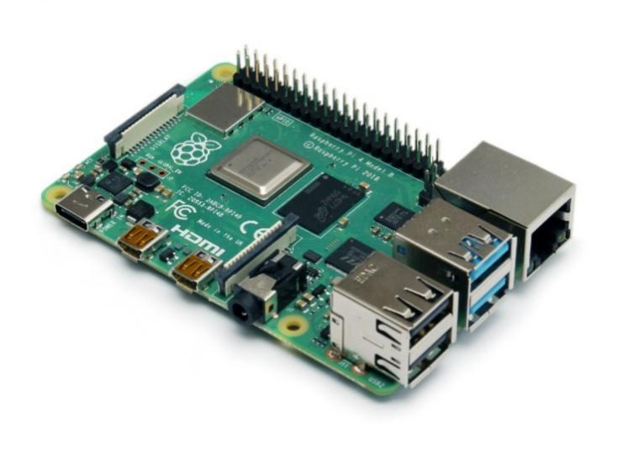`

**Figure 1.** Raspberry Pi 4B

For students who want to pursue careers that aren't connected to computer science.  dedicated computers are crucial to these types of courses however the limitations of computer labs at universities prohibit their usage.  There is a Raspberry Pi laptop computer which was introduced by the end of year 2012, and is employed with some success for this particular purpose.  However, its portability is limited due to the requirement for additional peripherals to work, like an external mouse, keyboard, and display.  The Raspberry Pi can indeed utilize a laptop for these peripherals however, this requires some extra effort.  The recently launched Raspberry Pi Zero eliminates much of the effort. (Black, 2018) [6]

The equipment that would be selected for the project is the most important factor to think about when creating the product.  On the average at this point, if the users want to sell the product for a period of let's say three or four years before deciding to move to a different board.  Therefore, the user is looking at a pre-built embedded development board that can be integrated into an application, would suggest the minimum lifespan of this board be seven years or more. If the user is working on an individual hobby or personal project, all of the factors mentioned above are suitable.  If, however, the user is creating a commercial or industrial product, then be mindful of several other important aspects before picking an appropriate embedded board.

There are many benefits of using a Raspberry Pi, huge processing capacity in an extremely compact boar. It has many interfaces HDMI as well as numerous USB, Ethernet, onboard Wi-Fi as well as Bluetooth numerous GPIOs, USB powered, and more.  It supports Linux, and Python making it simple to create applications. Accessible examples and community support. Developing an embedded board is likely to cost quite a bit both money and time. ([Aggarwal](https://www.allaboutcircuits.com/author/pallav-aggarwal), 2019) [7]

The primary difference between and the pace between the Raspberry Pi 4 and its predecessors. With a speedier CPU, more RAM, and the Gigabit Ethernet connection, every performance indicator is improved.  The USB ports are also upgraded.  This Raspberry Pi 4 is generally the most reliable version of Raspberry Pi. Plus, it has the same flexibility and versatility that makes it ideal for virtually any computing task. The Raspberry Pi 4 is the first version to come with different RAM configurations.  The updates have been made to prior models using minor changes such as Pi Zero and Pi Zero W as well as the Raspberry Pi 3 and 3B+ are included.

Additionally, the Raspberry Pi 4 requires a specific Power source for USB-C. Repurposing an old PSU equipped with a micro-USB, USB Type C adapter isn't going to work since Raspberry Pi 4 demands 600mA (3W) on average while idle.  This is obviously higher when the load is heavy.  If the user has HATs, cases and pHATs, it needs to determine if they're appropriate for use with Pi 4.  In the time since its initial launch in 2004, there aren’t many changes to this Raspberry Pi model B.

The dimensions of the board remain at 85.60mm in size 56.5mm as well as the port ports (Ethernet and power, as well as TRRS) remain exactly in their same place. These changes to the board are kept a certain limitation with the Raspberry Pi 4 modifications.

In particular, there is USB-C power connectors as well as 2 micro-HDMI ports.  Therefore, the expansion boards may work on this Pi 4, and it’s likely that your Raspberry Pi case won’t function. Using the Raspberry Pi 4 platform is able to handle nearly everything.  From robots to operating as a solid desktop replacement, a Raspberry Pi is what everybody should have. ([Cawley](https://www.makeuseof.com/author/ccawley/) , 2020) [8]

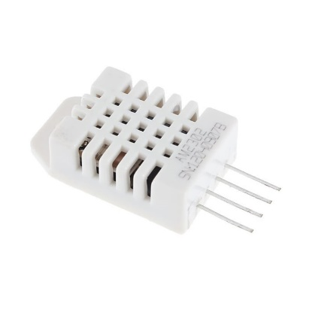

**Figure 2.** DHT22

Internet of Thing, a new technology that allows small processing-capable devices capture or retrieve data from a sensor and then send it to the central computer, is called Internet of Thing. Internet of Thing, a new technology that allows small processing-capable devices capture and retrieve information from sensors and send it to the central computer, is called Internet of Thing.  Oyster mushroom cultivation, like many other cultivations, requires the highest level of temperature and humidity for oyster mushroom growth.  The cultivation should be kept between 25 and 30 degrees Celsius, with humidity between 70% and 90% RH.  This research aims to create an automated monitoring system using the Internet of Things. It uses the Cayenne API and DHT22 sensors to retrieve information to the computer.  The Internet access would be provided for the device via wireless connectivity, and the sensor would send the information to the farmers. If the farmer wants to verify the humidity and temperature, the stored data can be exported in CSV format. (Adhiwibowo, 2020) [9]

Weather stations designed to gather quantitative data on weather conditions in a location.  Because of the unpredictable weather changes each day, monitoring weather conditions in an environment is very important.  This research attempts to create a weather station accessible via website via an IoT platform.  This microcontroller is the Arduino Mega 2560. The weather parameters measured include temperature, humidity, rain detection, FC-37 rain sensor and air pressure using the BMP180 sensor.  All measurements are saved to SD Card and displayed on TFT LCD 2.0and website with ESP8266 wi-fi module.  This research revealed that the measurement results of all sensors differed with PCE-THB40 module, with an average error of 3.74% in temperature, 2.14% in air humidity, and 0.32% per centile for air pressure. (Kusriyanto, 2018) [10]

To discuss DHT11 and DHT22, which are the most popular temperature and humidity modules for Arduino or Raspberry Pi.  They are slower than other temperature sensors but have many advantages, including low power consumption and long-term stability.  These DHT sensors has many different purposes such as home projects, including weather stations, environmental control systems, equipment testing, inspection, and farm/garden monitoring.

These DHT sensors can be used for a variety of purposes, including home projects such as weather stations, environmental control systems, equipment testing, inspection, and farm/garden monitoring. DHT sensors are made up of two parts: a capacitive humidity sensor and a thermistor with an analog-to-digital converter chip. The DHT11 digital temperature and humidity sensor is a low-cost entry-level model. It has the ability to detect temperature, relative humidity, and temperature. AM2302 and RHT03 are other names for this sensor. The DHT22 uses a temperature and humidity sensing technologies, as well as specific digital module acquisition technology to maintain excellent reliability and long-term stability.

(Temperature Range: DHT11: -20 to 60 vs DHT22: -40 to 80. Temperature Accuracy: DHT11: +-2% vs DHT22: +-0.5%. Humidity Range: DHT11: 5 to 95% RH vsDHT22: 0 to 100% RH.  Humidity Accuracy: DHT11: +-5% vs DHT22: +-2%). In summary, the DHT22 is superior to the DHT11 in all aspects, from temperature range, accuracy, humidity range and humidity accuracy.  Although the DHT22 has a slightly higher price, you get better specs for a slightly lower price. (Yida, 2019) [11]

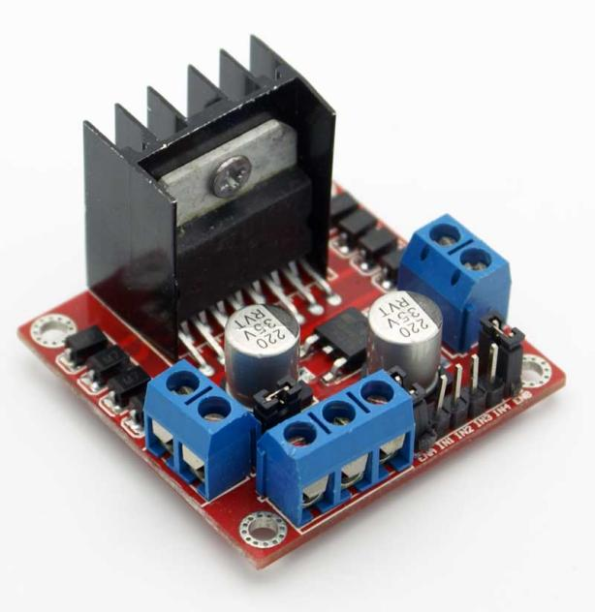

**Figure 3.** L298N Motor Driver Module

The study presents a low-cost, computer-controlled stepper motor controller that is suitable for moving samples.  This study created a monitoring system that uses the L298, a commercial electronic module, to replace a traditional complex electronic circuit with multiple discrete components.  A stepper motor connected to a translation was also utilized for Z-scan (nonlinear optics experiment) in which needed accurate sample movement.  We are using LabVIEW as a visual programming language and making the programs necessary to move the stepper motor available for download. (Romero, 2019) [12]

This study will design an automatic gate motor prototype using a DC motor. It would be possible to open and close the gate manually by using an app on a smartphone.  The DC motor is powered by a 12 V battery that was installed on the prototype turnstile.  To ensure that the DC motor opens and closes properly, it needs serrations to adjust the gate to accommodate the sizes of the teeth (gear). The components are arranged in an Arduino uno circuit using HC-05 Bluetooth module and Motor Driver l298n to reverse the polarity within the DC motor. The study also uses the fence as a load. Finally, the Bluetooth RC Controller application is used to input commands so that the DC can move as desired. (Hasibuan, 2021) [13]

This manuscript would focus on the benefits of the a4 vending machines and the many benefits it offers students.  A combination of microcontrollers and sensors allows for an efficient machine to produce a4 sheets, depending on how much money is inserted.  Students can access a4 sheets easily, which allows for easy to complete daily assignments.  Motor Driver L298N module is designed to configure and control the operation and functioning of motors, solenoids, and relays.  This driver contains a dual full bridge that can carry high current and voltage.  The driver contains logic pins that serve as enablers, and help in activating the dc motors according to the received signal.  This motor driver can control the speed, direction and delay of the spin, in addition to the rotor speed. (Sarfraz, 2021) [14]

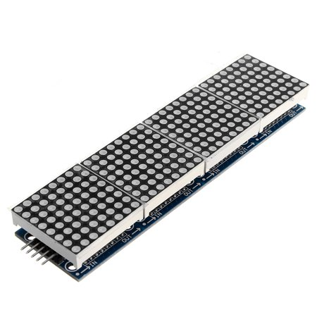

**Figure 4.** Max7219 Dot Matrix 8x32 Module

This script describes a new way to teach children the alphabets of different languages and their numbers.  The device features an 8X32 Matrix display that can show alphabets and numbers of different languages. It can be managed in additional voice commands, TV remote control or an android app on a smartphone. An RTC module (Real-Time Counter) is used to retrieve data such as time and calendar. This interface is provided by Arduino Mega 2560.

Each character is displayed on an 8X32 Matrix Display. The monochrome bitmap of each character was taken, and then converted using "LED Matrix Studio".  The device's power consumption is very low so it is workable even in areas where there is no electricity.  It can add additional features to the device, including music, animation and mathematical search. (Safdhan, 2021) [15]

The study shows how to` use the 8x32 MAX7219 LED Matrix Display with Arduino.  The 8x32 LED matrix module has MAX7129 LED driver and is compatible with Arduino Board & all other microcontrollers.  An 8x32 LED matrix contains 256 LEDs (Light Emitting Diodes), which are laid out in a matrix with 8 rows and 32 columns (8x32 Dot Matrix LED).  Using an 8x32 LED matrix display, made up of four single modules that are internally connected.  You can also separate the modules because each module has the identical Maxim MAX7219 chip that ships with the data and power connection. (Saputra, 2021) [16]

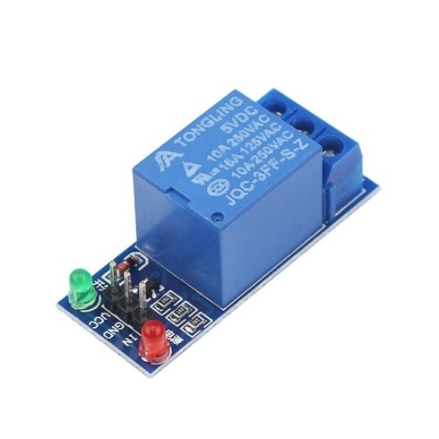

**Figure 5.** Relay 5V 1 Channel Module

This describes the design and implementation for a single-phase overcurrent protection relay using an Arduino NANO. Relay is an electromagnetic switch that operates depending on the input signal. When the measuring current exceeds the sitting current, the light turns on or off. Relay proposed provides greater operational flexibility, high reliability, and speed with a simple controller.  The relay was tested and designed on an electric system. (Hameed, 2020) [17]

An on-off switch is sufficient for most electrical equipment and systems.  An [programmable relay](https://www.c3controls.com/configurator/programmable-relays-accessories/#accessory-type) is an affordable and easy way to add automation to your lighting system.  Automated lighting systems could be configured to turn on and off for a specific time.  It can be programmable to switch on and off according to predefined schedules, or triggered by sensors. Programmable relays can also be used to control industrial equipment and building systems.

They were thought to be suitable for all applications that a relay is used. However, because they are too costly and have lower I/O (inputs, outputs), many people thought they would work. Engineers came up with another solution.  Programmable relays combine all the advantages of the PLC but at a lower complexity and cost.  When lower I/O points need to be met, programming relays can be used. Because they are primarily relays and timers, programming relays could be adjusted more quickly and easily compared to their PLC counterparts. Programmable relays have more capabilities than PLCs, even though they were rapidly expanding. They are now invading PLC territory.

Programmable relays work best for simple applications that cease require frequent changes.  Programmable relays borrow design principles from PLCs. They have multiple inputs and outputs.  Relay, counter, and timer functions are likewise accessible in one unit. Some programmable relays have more than 20 inputs or outputs. (Ayushman, 2019) [18]

In today's technologically advanced market, industrial controlling is increasingly internet-based.  As operating speeds improve dramatically, internet-based industrial control will be a revolution at the factory level. The relay module is an independent hardware device that allows remote device switching.  It allows remote control of devices via the Internet or network.  Relays are switches that can open or close circuits electronically or electromechanically.  The relay's 5V trigger voltage has been used to supply a +5V DC source to one end of it and ground the other through a switch.  The diode serves to protect the switch against a high voltage spike caused by the relay coil. However, the relay may also be utilized to modulate AC circuits such as heaters, lamps, and motors that draw much more electricity. (Arefin, 2020) [19]

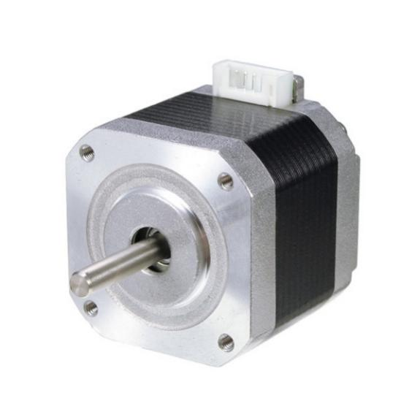

**Figure 6.** Nema 17 Stepper Motor

This paper describes the process of building an automated voice-picking robot.  The unit is capable of avoiding obstacles and picking up objects to place them in the right spot.  It features four wheels and 45-degree rolling. The model can be controlled remotely via wireless connectivity.  Materials include polylactic acid polymers, metal plates, and six NEMA17 stepper motors and an ATmega3287P microcontroller.  The robot's performance was tested and found that it works as expected. It can be used in many logistics, industrial, or manufacturing processes. (Avila, 2020) [20]

Arduino UNO is the microcontroller that controls the entire setup.  Open-source syringe pumps are used to deliver the drug.  Pump movements are executed by a 12V NEMA17 stepper motor.  An Android application has been created using Android Studio. The inputs can be given in the form the desired drug dose.  This application converts the drug dose to the required number of steps to run the stepper.  The fundamental idea of the stepper motor is a lead-screw mechanism. (Surya, 2018) [21]

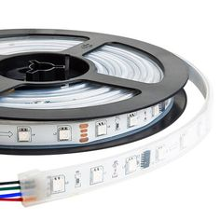

**Figure 7.** WS2812B LED Strip Lights

Appliances for the home are created and produced for the market. The majority of people discover that APPs are loaded on smartphones or tablets to manage certain household appliances. Even different brands or models of light bulbs require specialized control software to work with the relevant light bulbs. Because there are numerous brands of home appliances from numerous manufacturers, smart and intelligent technology for smart homes is therefore challenging to utilize. In this study, we create a mechanism and implement a prototype web system to accomplish an instant and visualized digital light switch for the smart home and address the issues. In order to validate this research, we created a light tube and light bulb as the proof of concept (PoC) to show it in a smart house using a NodeMCU-32 microcontroller unit integrated with WS2812B LED strips. (Tsao, 2021) [22]

This study's objective is to examine the many specifications and design criteria, additionally the difficulties associated with using digital RGB LEDs for interior lighting and signage in automobiles. In order to do this, efficient automobile RGB LEDs (ISELED) and accessible through commerce RGB LEDs (WS2812B) were compared in terms of optical characteristics like spectrum, uniformity, and temperature dependence. The optical measurements highlight the value of tolerances in production, temperature correction, and calibration (binning). It also demonstrates how crucial an effective RGB data transmission protocol is for addressing several LEDs without observable slow or unsteady animations. (Blankenbach, 2020) [23]

Custom PCBs, modules, and smart RGB LED strips are frequently used in the creation of electronic products. They are affordable, have an easy-to-use protocol, a convenient pinout and footprint, and a dazzling luminosity. As opposed to that, WS2812B strip is an upgraded variation with increased efficiency and stability. A control circuit and RGB chip are both included in this intelligent control LED light source's 5050 component package. (Garcia, 2022) [24]

To set up sensors in accordance with the layout to see if the plan could be implemented. Express (Node.js) was set up to act as the web server for the Raspberry Pi, while Express was served as the socket server. In Bootstrap 5 Alpha, a graphical information dashboard was created that shows sensor data and alerts users to any infractions. ESP8266 was used to set up the appropriate sensor nodes as wireless nodes, and WebSocket was used to communicate data to the Pi server. At a height of 1.2 m, the temperature sensor was placed immediately after the entry. It was necessary for visitors to put their foreheads close to the sensor so that the server could capture and send the temperature reading. An IR obstacle detection switch was employed and set to operate within a 2 cm–5 cm range in order to ensure that the proper distance was maintained when employing the sensor. To identify front of line minimum distance violations, a time-of-flight sensor was positioned 1 m above the ground. The queue area was marked with (ws2812b) LED strip that was 5 meters long. Green LEDs designate a "safe" standing area. In order to spot any violations of the required distance, the RPi camera was placed close to the line. (Bashir, 2020) [25]

The WS2812B programmable color LEDs have become the center of a colossal number of projects. These well-liked LEDs are available in strings that can be trimmed to the desired length, and all the lights in a string can be individually controlled using just a single-wire serial data connection. To produce enormous, albeit low-resolution, two-dimensional screens, several strings can be layered. The color of WS2812B LEDs is controlled by a 24-bit integer. Each LED in a string of these gadgets can accept a continuous stream of 24-bit color values across its data link, which is how intelligent they are. (Burke, 2018) [26]

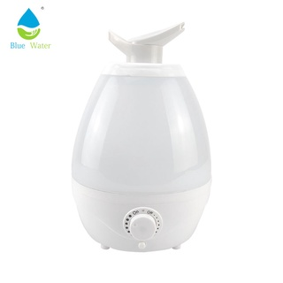

**Figure 8.** Air Humidifier

The use of a humidifier adds moisture in the air to reduce dryness, which can irritate a variety of bodily parts.  Humidifiers are particularly useful for dry skin, lips, nose, throat, or throat.  They may also be utilized in alleviate symptoms of the [flu](https://www.healthline.com/health/cold-flu/flu) and common cold.  Humidity is a natural moisturizing agent, which can help relieve dryness.  Humidifiers are used to relieve dry skin, dry sinuses/headache, dry nose, nasal irritation, dry throat, dry vocal cords, dry cough, cracked lips, and dry sinus congestion.

The type of humidifier that you choose will depend on your budget, preferences, and the size of what you need to add moisture.  There are five types: central humidifiers; evaporators; impeller humidifiers; steam vaporizers; and ultrasonic humidifiers.  Ultrasonic humidifiers use ultrasonic vibration to produce a cool mist. Prices vary depending on the size of the unit. Warm and cool mist models are available. If the owner has children, an ultrasonic humidifier, particularly the cool-mist model, is an excellent choice. (Debra, 2020) [27]

Humidity is blamed for a variety of harmful effects. The goal of this research is to develop an automated humidifier/dehumidifier controller. This device regulates and monitors humidity levels in order to reduce humidity and make the room more comfortable. The humidity sensor determines the humidity in the room, after which the device can either humidify or dehumidify it.  This reduces odors such as mold and mildew. It also helps to decrease dust and reduce the chance of mold forming on clothing and furniture. Finally, it makes things simpler to breathe in and feel more comfortable at home. Arduino Uno is the controller used in this study.  The Arduino Uno's input supply is connected to its pin via a humidity sensor. The LCD will then display the humidity value.  Relay that powered humidifier and dehumidifier operation. (Mon, 2020) [28]



**Figure 9.** MIT APP Inventor V2

The goal of the online platform MIT App Inventor is to introduce computational thinking ideas through the creation of mobile applications. Students build apps by dragging and dropping elements into a design view and programming application behavior in a visual block language. In this chapter, the background of the creation of MIT App Inventor, the project goals and how it influences system design, and the methods MIT used to create the platform and how it would influence by computational thinking literature. The utilization of components as abstractions, the alignment of building blocks with students' mental models, and the advantages of quick, iterative design for learning are some important lessons. (Patton, 2019) [29]

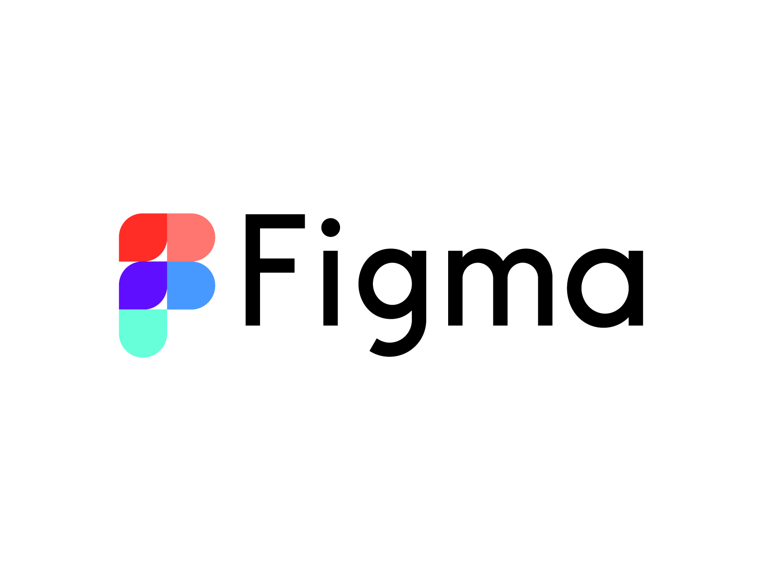

**Figure 10.** Figma

Fast, like Figma. Drag, zoom, download, and edit actions are all quick. When the users are designing, the user need everything to flow swiftly and smoothly alongside the users. Figma gets it right. For their users to share templates, plugins, and files, Figma created a community. Directly in Figma, micro-interactions, animations, and prototypes may be made in an absurdly simple way. A web-based design tool is called Figma. There is no software to deal with. It is therefore compatible with all platforms, including Macs, Windows PCs, Linux computers, and even Chromebooks. Additionally, it includes a fantastic auto-save option that saves your work to the Cloud because it is web-based. (Shoemaker, 2021) [30]



**Figure 11.** Python

This article introduces readers to the acceptance of technology by business and society, where Python-coded computer programs are now essential. The growing use of data and the development of the "Big Data" sector are discussed in detail in this essay. Then, as a result of the big data sector, there are details concerning data science and machine learning. The publication also turns the emphasis away from "Big picture" data and toward Python programming. It explains the significance of this programming language and how the usage of free and open-source Python tools makes the process of data analysis easier. Included are Python's benefits over other languages that are related to it, including C and MATLAB. Finally, this project will evaluate a number of Python packages that are available for download from open-source websites. A Python programmer, whether experienced or newbie, can learn how the Python packages can help them examine data functions in a variety of various professional domains. This paper will discuss one specific dataset example that can be used with the Matplotlib program in detail. To demonstrate the functions a programmer can access while utilizing Python-based libraries, a Matplotlib sample is provided. It illustrates how simple Python is to use when viewing data from a dataset. (Meharban, 2021) [31]



**Figure 12.** Blender 3D

Blender3D is a free and open-source 3D modeling tool that can be used on all the popular operating systems, including Microsoft, Linux, and macOS. On suitable systems and platforms, it offers a stunning experience through the usage of the OpenGL interface. Perhaps the most distinctive quality of Blender is its accessibility. Even though it is best suited for freelancers and enthusiasts, professionals also favor it. When it comes to tools, Blender provides the popular DAE and FBX formats for game creators. (Serdar, 2021) [32]



**Figure 13.** Firebase

Google's platform for mobile and web development, Firebase, aids business owners in creating, enhancing, and scaling their app offerings. The platform provides a number of tools that greatly simplify the product development process. Machine Learning Kit, Hosting, Storage features, and Realtime Database are some of the ready-to-use offerings. A few free products are also available over the infrastructure, including Analytics, Crash Reporting, and Cloud Messaging. The cloud is used to host the services. The work of developers is substantially facilitated by this, allowing them to concentrate on the overall experience the product has to deliver. The platform offers programmers an API that enables synchronization of app data between clients and cloud storage with Firebase. (Sykutera, 2020) [33]



**Figure 14.** Raspberry Pi OS

Modern memory hierarchies are complex pieces of hardware that combine memory controllers, caches, and memory management units to keep modern high-speed processors fed with data. Non-volatile memory has been introduced recently, which has further complicated the matter. Operating systems are highly tuned to current memory systems; modifying them to take advantage of new developments is a difficult process. The low-level code involved is complex and hard to follow. This makes teaching students about modern memory systems a struggle, as wading through the complicated code in a full operating system like Linux can be frustrating. To this end it develops vmwOS, a simple operating system created for low-cost Raspberry Pi development boards. Despite their low cost, these widely used boards support the majority of modern memory system features, such as 64-bit addresses, multi-level caches, multi-core, and full ARMv8 processor and MMU support. vmwOS is simple enough that students can follow the code and make changes to explore the memory hierarchy. There are several memory research topics that can be investigated using this infrastructure, including a detailed examination of simulating non-volatile memories. (Mezger, 2018) [34]



**Figure 15.** Thonny

Students with varying levels of aptitude, enthusiasm, and experience enroll in introductory programming courses. This paper introduces Thonny and Runestone Academy, two technological tools that can be used to improve introductory courses. These tools allow instructors to keep track of individual students' development. This provides for early detection of pupils who are falling behind in their studies and allows for early intervention in such circumstances. Overall, this results in a better course with increased throughput and student retention. Thonny is a Python IDE for creating Python apps. Python scripts should be saved as Python files. Thonny also offers a running tool for an IDE's output program. By default, the Thonny IDE is installed in the Raspbian Scratch desktop. default. It can be found under the Programming menu (Kurniawan, 2019). [35]

**Block Diagram**

A dynamic reliability block diagram (DRBD) is widely used in a variety of industrial fields due to its capability of representing the dynamic behaviors of systems, despite its difficulty in dealing with common cause failures and the difficulty in obtaining quantitative results due to the lack of a simple and practical solution method. Although several methods, such as the Petri net, Markov chain, and dynamic Bayesian network (DBN), have been proposed for studying DRBDs, they are often overly complex and unworkable due to things like state explosion in a Markov chain and a DBN and a difficult conversion process in a Petri net. The DRBD now has a common cause failure block to address these issues, and this work provides a brand-new solution approach based on a dynamic uncertain causality graph (DUCG). The conversion rule converts the DRBD into a DUCG, which has fewer parameters and can be easily analyzed using the reasoning method of the DUCG. The conversion rule transforms the DRBD into a DUCG, which has fewer parameters and can be easily analyzed using the DUCG's reasoning method. Finally, using a subsea blowout preventer (BOP) control system as an example, a more accurate and concise BOP control system model is constructed. (Lulu, 2019) [36]

**Flowcharts**

During the requirements phase of software development, business process models are built prior to the detailed software design. Even disciplined agile methodologies incorporate business process modeling prior to the start of development cycles. Because they give sufficient mapping elements with software design and development planning, their usage in estimating software development duration could be advantageous. In this research, we offer a method for estimating the length of a software project based on the Common Software Measurement International Consortium (COSMIC) method and applied to a data flow diagram. This method is based on the examination of data flow diagrams and the extraction of basic business processes, data flows, and data stores. The research presents a strategy to improving the COSMIC technique by calculating the time of the software development process based on both data movement-related and data manipulation-related software functional sub-processes. (Kazi, 2022) [37]

**Hardware Design Circuit Diagram**

The industrial industry's business climate is evolving. Product focus has shifted from hardware to process and function. A current example the development and marketing of functions is of industrial interest. This feature might be realized as a product comprised of hardware, software, and services, and sold as a function rather than hardware. This is a function view. also known as functional products. A circuit diagram is a simplified representation of an electrical circuit's components that uses either photos of individual sections or standard symbols. It depicts the relative placements of all the elements as well as their connections. It is frequently used to show an electrician the circuit visually. (Tang, 2019) [38]

**Storyboard**

A storyboard is a visual drawing that is ordered in a sequence based on a story, the creator of the story may quickly express the story to readers or others. Because a storyboard encourages people to imagine a tale by following the images that have been shown. It is a drawing of the ideas for the final production; it is also used to develop, improve, and invent scripts; and it is an excellent form of communication with the creation team. (Sulha, 2019). [39]

**Structural Design**

The methodical analysis of a structure's stability, strength, and rigidity is known as structural design. The creation of a structure that can bear all applied loads without failing over the course of its designated life is the main objective of structural analysis and design. A structure's main job is to sustain or transfer loads. The device will most likely fail to execute its intended purpose, perhaps with devastating repercussions, if the structure is incorrectly designed or constructed, or if the actual applied loads exceed the design specifications. A well-designed structure reduces the possibility of costly failures. (Nageim, 2018) [40]

**ISO25010**

ISO25010 is a software quality standard titled "Systems and software engineering - Systems and software Quality Requirements and Evaluation (SQuaRE) - System and software quality models." It describes the models, which are made up of characteristics and sub-characteristics, for both software product quality and software quality in use, as well as practical advice on how to use the quality models. ISO 25010 assists you in ensuring the high quality of your software. (Britton, 2021) [41]

**Prototype Model**

The prototyping model is a systems development process in which a prototype is produced, tested, and then tweaked until an acceptable output is obtained from which the entire system or product can be developed. This model is most effective when not all of the project needs are known in advance. It is a collaborative, iterative, trial-and-error process between developers and users. Users have a better knowledge of how the product operates since it promotes team collaboration and flexible design techniques. (Lewis, 2021) [42]

**2.2 Related System**

The massive expansion of buildings to accommodate the ever-increasing population and needs of the inhabitants comes at a high cost to the environment. The need for thermal comfort, which is required to ensure the inhabitants' high productivity, is depleting energy resources and contributing to the carbon footprint. Commercial buildings are outfitted with a range high-powered HVAC system to provide the necessary thermal comfort. All of this has shifted the focus to the need for green buildings and sustainable development. With this vision, we intend to use the power of smart blinds to create a comfortable and sustainable environment. (Utkarsh,2021) [43]

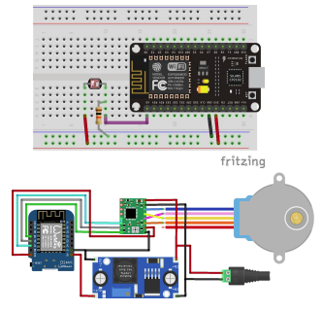

**Figure 16.** Window Blinds

Window blinds are a common household item because they block natural light from entering and provide a sense of security because people outside cannot see through them. Blinds also promote higher power efficiency and lower power consumption, as windows lose approximately 30% energy used for heating a house. As a result, window blinds are an essential item to have in one's home, but also can be inconvenient when one has to remember whether they are open or closed. (Um,2022) [44]

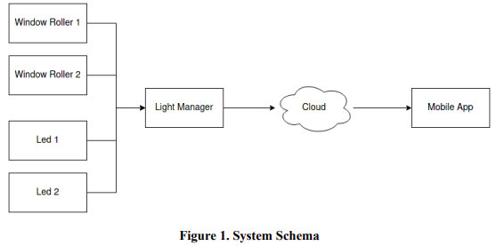

**Figure 17.** Smart Light Manager

The goal of this diploma thesis was to create and put into effect a Smart Home system with remotely controlled roller blinds based on the Raspberry Pi 4b system. A PC, a mobile phone, or voice commands with the ability to control the roller blinds. Limit switches have been attached to the window frame to ensure their safe operation, and the control system software has been programmed with an automatically activated emergency mode in the event of wireless communication problems. Devices commonly used in home automation systems, such as voice assistants and light points, have also been integrated. Because ready-made, high-quality products are widely available, they were heavily used in the project. The exceptions are the automatic roller blind control and drive systems, for which the following components were used: servo motor, ESP8266 circuit, and printed parts using FDM and SLA technologies. The presentation of network protocols used in Smart Homes took up a significant portion of the project. The Home Assistant system and its effective programming received special attention. (Pytlowski,2021) [45]

Indoor heating and cooling costs are significant worldwide, and windows are among the most significant sources of inefficiency in the average building. Blinding Sun Systems set out to address this growing issue by investigating, creating, and developing a tool that could be applied to automate and retrofit existing window blinds in order to maximize the quantity of solar radiation permitted to pass. By researching the smart home market, the feasibility of introducing such product was predicted. Blinding Sun Systems then theorized design concepts, developed CAD models of those concepts, performed engineering analyses to see if the product would work as intended, created experiments to test the product's efficacy, and combined all of these elements to present a prototype model of their solar sensing blinds product. (Baglione Jr., 2018) [46]

It would propose to use an innovative grating optical filter with smart window to provide dynamic annual and daily window transmission control without the need for blinds or similar devices. The filter reduces direct solar radiation while allowing diffused and reflected radiation to pass through, resulting in more comfortable conditions for daylighting, insolation, and sun protection in rooms. A method for calculating the grating filter is changed, and numerical modeling is performed to demonstrate the capabilities of the new method of dynamic transmission control. The optimal geometric parameters of the filter are determined for a single-glazed smart window at a given azimuth of the window orientation (Zakirullin, 2021). [47]

The home automation market has grown rapidly in recent years, and it is expected to grow by 143 percent between 2015 and 2022. Over the following years, connected home automation system will be realized, and home automation systems for sale enables users to control any home device seamlessly from an easy-to-use interface. While there are numerous home automation companies on the market, none have truly captured the concept of the connected smart home. All of the systems are deficient in some way, whether it is the reliance on internet connectivity or the slow response time. (Lennon, 2018). [48]

The paper describes the algorithm for a house climate monitoring and control system. Algorithms for controlling temperature and relative humidity inside a building are created by monitoring environmental parameters and changing the performing devices – open/close windows and turn on/off air conditioning. Controlling the lighting level is accomplished by adjusting the window blinds and lighting bodies to ensure a smoother transfer of light, moreover, the day's darkest hours. Depending on whether or not there are residents inside the building, different settings are planned (Valov, 2020). [49]

When the window is left open, the light can disrupt sleep in the morning or burn the plants by the window. Although there are many existing solutions for smart window blinds, we want to create a smart light manager for every home that can adjust the level of light based on the user's preferences. In our project, we will use light sensors (both inside and outside the house) to open window rollers and turn on/off led based on the constraints set by the user in the mobile app. (Gaponcic, 2021). [50]

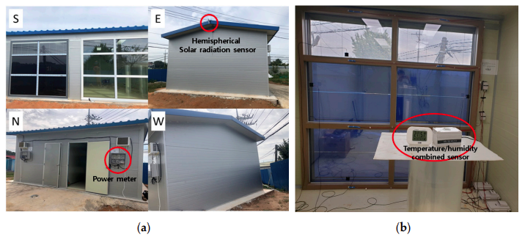

**Figure 18.** Suspended Particle Device

Between 60 and 70 percent of a house's or office's total energy load is lost through the building's exteriors, with heat loss from windows and doors approaching 40 percent in the case of offices. As a result, there is a demand for glass that can artificially control the transmittance of visible light. By responding to environmental conditions, smart windows with suspended particle device (SPD) film can reduce energy consumption. To evaluate the impact of SPD windows on the energy needs for cooling and heating in Korea, we set up a testbed with SPD windows. To verify the simulation model with regard to SPD window modeling, measurements and simulation were compared using TRNSYS18. (Ko, 2020). [51]

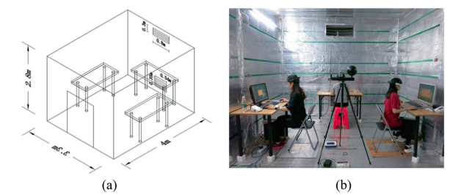

**Figure 19.** EEG

Greater energy efficiency is possible in the construction industry, in both residential and tertiary buildings, thanks to smart window systems. One can adjust a glazing's thermal and optical behavior to the ever-changing conditions of the environment in which the building is located by dynamically modulating its spectral qualities in the visible and infrared wavelength ranges. This enables the building to effectively restrict the entry of solar energy (Cannavale, 2020). [52]

In Trondheim, Norway, a case study was conducted to assess occupant satisfaction with two different control strategies (fully automatic and manual) for the use of blinds and ceiling lights in cell offices. 11 volunteers of different ages, genders, and ethnicities worked in two test cells of a laboratory for a total of 19 calendar days, largely using a personal computer for office work. The participants were asked to complete a computer-based questionnaire about their thermal and visual comfort. Concurrently, the indoor operational temperature, illuminance level, and operation of windows, blinds, and ceiling lights were recorded (Lolli, 2019). [53]

Although smart blinds are among the most creative smart devices, and the first that come to mind when the users think of home automation. Having motorized shades that rise and fall in response to voice instructions or on a predetermined schedule is one of the simplest ways to give the impression that someone is home while the users are away. Additionally, smart blinds might lower the energy costs. Increased light, reduced heat, and use of the sun can all result in cost savings. The Tilt My Smart Roller Shades software, which is compatible with windows. 23 inches to 74 inches wide, handles all of your key controls once installed. The Bluetooth-based app is available for iOS and Android devices. Set schedules, enable sunrise/sunset functions for raising and lowering your blinds, and make adjustments all from the convenience of your smartphone or tablet (Bizzaco,2022). [54]

This article describes a system that uses polymer optical fiber (POF) sensors to assess relative humidity and temperature. The sensors are based on changes in the POF's Young's and shear moduli when temperature and relative humidity change. The system consists of two POFs, one with a predetermined torsion stress and the other with a stress-optic effect that caused a change in the refractive index of fiber. Variations in temperature and humidity produce changes in fiber stress since there is a relationship between stress and material qualities, which results in changes in the refractive index of the fiber. The sensor interrogation is made up of only two photodiodes, giving in an easy-to-use, inexpensive system that can measure a humidity level between 5–97 percent and temperature with the range of 21–46 °C. For temperature and relative humidity measurements (the root mean squared errors (RMSEs) between the proposed sensors and the reference were 1.12 °C and 1.36 percent, respectively). Furthermore, fiber etching produced a 2-second reaction time sensor for a 10% relative humidity change, which is a one shortest response times yet recorded with connection to intrinsic POF humidity sensors (Mecenas,2020). [55]

Automated sunshade controllers serving big side-lit, open-pla\offices face an insurmountable challenge in achieving visual and seasonal thermal comfort, especially when occupied positions are spatially and temporally transient. Few proposals have addressed issue in the present literature. This paper offers a novel model-based shading controller that fills this gap by conditionally optimizing vertical eye illuminance at any occupied location. Two surrogate model strategies based on the radial basis function neural network; real-time daylight simulations were used to create the controller. In the worst-case scenarios, compared to the online surrogate model, the offline surrogate model can forecast timely vertical illumination which uses an accelerated optimization technique to produce the best combined shading outcomes in a timely way. The unique prediction models incorporated in the controller were tested for correctness. In Harbin, China, comparative simulated scenarios were created for an open-plan office. The performance of the suggested control strategy was investigated and assessed in terms of visual comfort, daylighting, electrical energy savings, and seasonal solar heat gains, demonstrating the benefits of our proposed control approach (Luo, 2021). [56]

The study investigated EEG signal shifts during cognitive processing engagement at various temperature and relative humidity in the air in this study (RH). As subjects, 32 youthful, in good health, and accustomed to Changsha, China's subtropical environment were recruited. In a climate room, they were exposed to four different air temperatures (26, 30, 33, and 37 °C) as well as two different relative humidity levels (50 and 70 percent). They engaged in mental exercises and had their EEG signals monitored throughout 175 minutes exposures to each heat condition. Relative power of -band increased greatly when relative humidity was 70%, whereas relative power of -band, -band, and -band declined significantly when relative humidity was 70%. This could indicate that the subjects were sleepier but not drowsy, they find it more challenging to think effectively. Additionally, subjective assessments revealed that they were less awake and that thinking was more challenging for them. However, there were no differences in performance on activities that assessed cognitive abilities. As a result, it's uncertain if an EEG can be reliable indicator regarding variations in cognitive function as a result of differences in the buildings' internal environment future studies should look into this more (Zhu, 2019). [57]

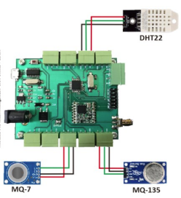

**Figure 20.** Air Quality Monitoring System

Particularly during the COVID 19 pandemic, indoor air quality is a critical issue.  Good indoor air quality will improve occupants' productivity and comfort.  Two essential components of thermal comfort are temperature and relative humidity within an area.  This paper describes the development of an Internet of Things (IoT) temperature and humidity monitoring system in the classroom.  The system is composed of three components: logger nodes and a gateway logger. It also includes an interconnected cloud server.  The logger node, ESP8266 / ESP32 microcontroller and DHT22 sensor, is located at the edge IoT system.  The Raspberry Pi 4 is used as the logger gateway.  It collects recurring information from the logger nodes (temperature, humidity) via the publish-subscribe protocol and then sends it to MongoDB Atlas cloud. (Widjaja, 2022) [58]

The lives of humans, and all living things, depend on air.  Clean air is essential for every living thing to live optimally. It must be maintained in good quality.  The standard of the air is a key factor in making a cozy and healthy environment. If the air quality is poor, then it can cause health problems for everyone who breathes in the air.  As a controller, the system uses ATmega328P -AU, DHT22 sensor to measure temperature and humidity, MQ-7 sensor to measure CO gas, and MQ135 sensor to measure CO2 gas. Antares serves as a cloud service to store data that can be displayed on Android.  The average error value was found for temperatures of +0.8 degrees Celsius, humidity of 3.1% RH, CO+- 10 ppm, and CO2+- 16 ppm.  The Antares cloud stores sensor data and displays them on Android. (Firdaus, 2019) [59]

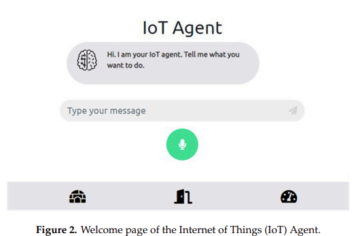

**Figure 21.** Control of Smart Home Operations

A IoT system was developed to detect signals from sensors and provide power via battery. It is implemented on Arduino WeMoD1 Wi-Fi system.  This project used two sensors, the DHT22 sensor as well as the light sensor.  DHT22 has two sensors that detect the temperature and humidity in the house.  The light sensor detects light and dark in the house.  An ESP8266 chip that provides internet connectivity on Arduino can send the data to IoT ticket.  This system is designed to connect two sensors. The Arduino and battery send data via an external Wi-Fi chip ESP8266. RESTful, the standard for communication between computers systems, allows Arduino to communicate with IoT tickets by RESTful.  The DHT22 sensor has a temperature and humidity sensor.  Allowing the voltage to pass through the resistor of the light sensor will detect the presence of light. (Giang, 2021) [60]

The Internet of Things (IoT), an emerging Internet-based architecture that allows data and services to be exchanged in a global network, is a new technology.  The Internet of Things has enabled more devices to connect to the Internet to allow people to share and get data and program actions.  The study presents an IoT Agent, which is a web application that allows remote monitoring and control of smart homes.  The IoT Agent incorporates a chatbot that can understand voice and text commands using natural language processing.  NLP makes home devices more intuitive and easier to control. The system can understand voice commands and text and respond accordingly.  Our solution uses several Application Programming Interfaces (APIs), including the Dialogflow API to integrate NLP into our IoT system, Web Speech API to enrich user experience with voice recognition, synthesis features, and MQTT (Message Queuing Telemetry Transport), for lightweight control of actuators, and Firebase for data storage.  The most important innovation is that it integrates multiple third-party APIs as well as open-source technologies into one mashup. This demonstrates how an IoT application can be created today using a multitier architecture.  This tiered architecture is very helpful for rapid development of smart-home applications. (Alexakis, 2019) [61]

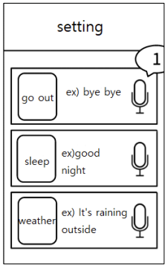

**Figure 22.** IoT Smart Blackout Curtain Including Voice Recognition

Smart blackout curtains automatically open and close according to user settings. This allows busy people to sleep comfortably without having to manually operate them.  The blackout curtain using IoT technology can be used to open or close the curtain depending on temperature, illumination, voice recognition, and fine dust. This technology is incorporated into the opening function by each sensor. It is expected that it will provide convenience and benefits for the user's life, allowing them to operate from anywhere.  The fine dust can be measured by placing a window sensor on the curtain. This will allow people to live in a healthy environment and respond to the problem of fine dust.  This paper is intended to give comfort and enable people to live a healthy lifestyle by grafting existing curtains with IoT (one of the next-generation technologies) and voice recognition. (Kim, 2020) [62]

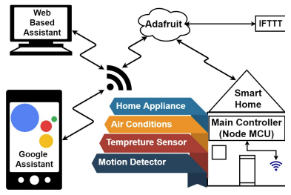

**Figure 23.** Smart Energy Efficient Home Automation System Using IoT

Because of the widespread availability of Internet everywhere, IoT-based applications have become the most advanced technology.  This cutting-edge technology has made it easier to use web-based and android-based technologies.  This paper proposes a smart, energy-efficient home automation system that can control and access the equipment’s from anywhere in the world.  This system uses an Internet connectivity module that is attached to the main supply unit. It can be accessed via the Internet.  The static IP address is required for wireless connectivity. Multimodal applications are used for home automation. Voice recognition commands can be made by the user via the Google Assistant, or through a web-based application.  This work aims to improve the security and intelligence of our home automation system (Vishwakarma, 2019). [63]

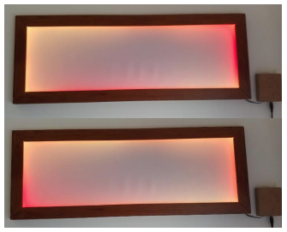

**Figure 24.** Effect of Peripheral Augmented Feedback

There are increasing numbers of smart homes.  Smart homes make difficult decisions. Each decision is dependent on multiple variables.  Smart systems are becoming smarter and more integrated into everyday life.  A smart home is usually a closed system. The user cannot see the decisions that are made behind the scenes.  The system's status can be communicated to the user, which could improve the user experience.  The study created an artefact to show the status of smart systems through lighting. This was done in order to better understand the effects of peripheral augmented information on system understanding.  This artifact was deployed in two environments over three weeks. The study also conducted qualitative interviews before and after the deployment.  Our results show that lighting is a good way to transfer system statuses to users, provided they understand the mapping.  The microprocessor connects via cables to an SPI-I2CUART bidirectional logic level convertor.  This device converts the 3.3V signal from the ESP8266 into a 5V signal.  This signal is required for the WS2812B led. They are placed on a strip and used in our prototype.  This type of LEDs was chosen because they can be programmed in Arduino and one cable is needed to transmit data to all LEDs.  The WS2812B have a chip embedded within the LED, so they can be individually addressed (Melaet, 2019). [64]

Our modular solution allows it to be scaled up to create large-area sensing systems.  The safety mode and interaction modes are the two operating modes of the sensing system.  The interaction mode uses the sensor's ability to locate the point of action and gesture commands are used for robot manipulation.  The safety mode allows the robot to avoid potential hazards by actively using the sensor.  The top layer of FPCB was equipped with LEDs (WS2812B), which provide visual feedback to the user who interacts with the sensor.  The WS2812B integrated control LED light source is an intelligent control LED.  The advantage of this light source is that it requires minimal wiring. Multiple can be connected together to form a stripe. Only the control signal input pin must be connected to the microcontroller (MCU) (Zhang, 2019). [65]

**2.3 Synthesis of the Study**

The researchers used raspberry pi 4b according to (Cawley, 2020). A specific power source for USB-C.  Repurposing an old PSU equipped with a micro-USB, USB Type C adapter isn't going to work, since it is the Raspberry Pi 4 requires 600mA (3W) on average while idle. The dimensions of the board remain at 85.60mm in size 56.5mm as well as the port ports there is USB-C power connectors as well as 2 micro-HDMI ports [8], which was used as the microcontroller for the study. The researchers also used DHT 22 as the monitoring temperature sensor according to (Yida, 2019) to discussing DHT11 and DHT22, which are the most commonly used temperature and humidity modules for Raspberry Pi. DHT sensors consist of two parts a capacitive humidity sensor and a thermistor with a basic chip that converts analog to digital [11] which was used for the humidity and temperature sensor. They also used L298N Motor Driver Module according to (Sarfraz, 2021). The DC motor is powered by a 12 is designed to configure and control the operation and functioning of motors, this driver contains a dual full bridge that can carry high voltage and high current. This motor driver can control the speed, direction and delay of the spin, as well as the rotor speed [14] to control the Nema 17 Stepper Motor. The study also made use of Max7219 Dot Matrix 8x32 Module (Saputra, 2021). The 8x32 LED matrix module has MAX7129 LED driver and is compatible with Arduino Board & all other microcontrollers an 8x32 LED matrix contains 256 LEDs (Light Emitting Diodes), which are laid out in a matrix with 8 rows and 32 columns. It is also known as an 8x32 Dot Matrix LED [16] to display the temperature and humidity level. The researchers used Relay 5V 1 Channel Module (Arefin, 2020). The relay module is an independent hardware device that allows remote device switching. It allows remote control of devices via the Internet or network.  Relays are switches that can open or close circuits electronically or electromechanically the relay's 5V trigger voltage has been used to supply a +5V DC source to one end of it and ground the other through a switch [19], which was used as to connect the air humidifier. The study also made use Nema 17 Stepper Motor (Surya, 2018) Pump movements are executed by a 12V NEMA17 stepper motor.  An android application that has been created using Android Studio. The inputs can be given in the form of the desired drug dose, this application converts the drug dose to the required number of steps to run the stepper.  The basic principle of the stepper motor is a lead-screw mechanism [21] to control the blinds. The researchers used WS2812B LED Strip Lights (Burke, 2018). The WS2812B programmable color LEDs have become the center of a colossal number of projects. These well-liked LEDs are available in strings that can be trimmed to the desired length, and all the lights in a string can be individually controlled using just a single-wire serial data connection. The color of WS2812B LEDs is controlled by a 24-bit integer. Each LED in a string of these gadgets can accept a continuous stream of 24-bit color values across its data link, which is how intelligent they are [26], which was used to add a luminous glow in the room. The researchers used Air Humidifier (Mon, 2020) This device regulates and monitors humidity levels to reduce humidity in the room and make it more comfortable. This reduces odors such as mold and mildew. Finally, it makes it easier to breathe in and feel more comfortable at home the LCD will then display the humidity value, relay that powered humidifier and dehumidifier operation [28] to produce moisture in the air. The software used by the researcher are MIT App Inventor V2 (Patton, 2019). The goal of the online platform MIT App Inventor is to introduce computational thinking ideas through the creation of mobile applications. The utilization of components as abstractions, the alignment of building blocks with students' mental models, and the advantages of quick, iterative design for learning are some important lessons [29], which was used for the mobile application. Figma (Shoemaker, 2021). A web-based design tool is called Figma. There is no software to deal with. It is therefore compatible with all platforms, including Macs, Windows PCs, Linux computers, and even Chromebooks. Additionally, it includes a fantastic auto-save option that saves your work to the Cloud because it is web-based [30] to design the user interface of the mobile application. Python (Meharban, 2021) A Python programmer, whether experienced or newbie, can learn how the Python packages can help them examine data functions in a variety of various professional domains to demonstrate the functions a programmer can access while utilizing Python-based libraries, a Matplotlib sample is provided. It illustrates how simple Python is to use when viewing data from a dataset [31] a programing language used for the micro controller raspberry pi 4b. Blender 3D (Serdar, 2021), Blender3D is a free and open-source 3D modeling tool that can be used on all the popular operating systems, including Microsoft, Linux, and macOS, even though it is best suited for freelancers and enthusiasts, professionals also favor it. When it comes to tools, Blender provides the popular DAE and FBX formats for game creators [32] to visualize the initial design of the prototype. Firebase (Sykutera, 2020) Google's platform for mobile and web development, Firebase, aids business owners in creating, enhancing, and scaling their app offerings machine Learning Kit, Hosting, Storage features, and Realtime Database are some of the ready-to-use offerings the platform offers programmers an API that enables synchronization of app data between clients and cloud storage with Firebase [33] to use for online data base. The related system that would integrate Buraindo are window blinds (Utkarsh,2021). The massive expansion of buildings to accommodate the ever-increasing population and needs of the inhabitants comes at a high cost to the environment. All of this has shifted the focus to the need for green buildings and sustainable development. With this vision, we intend to use the power of smart blinds to create a comfortable and sustainable environment [43]. Daylighting Dynamic Control by Smart Window (Zakirullin,2021). It is proposed to use an innovative grating optical filter with smart window to provide dynamic annual and daily window transmission control without the need for blinds or similar devices. A method for calculating the grating filter is changed, and numerical modeling is performed to demonstrate the capabilities of the new method of dynamic transmission control. The optimal geometric parameters of the filter are determined for a single-glazed smart window at a given azimuth of the window orientation [47]. The Motorized Smart Blinds (Bizzaco,2022). Although smart blinds are among the most creative smart devices, and the first that come to mind when we think of home automation. Set schedules, enable sunrise/sunset functions for raising and lowering your blinds, and make adjustments all from the convenience of your smartphone or tablet [54].

**2.4 Conceptual Framework**

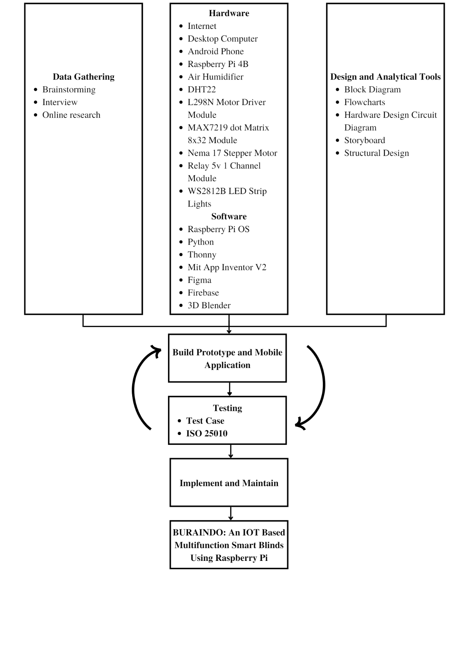

**Figure 25.** Conceptual Framework

The conceptual framework shows that the researchers gathered data through the use of brainstorming, physical interview and online platforms to identify the software and hardware for developing Buraindo. The hardware and software needed for the study are shown on table no. 1 which was used for developing. When the quick design has been designed, the researchers proceeded to the coding and building prototype. The list of hardware which were used in building the prototype and the software was used in developing the system. After the prototype and the system has been developed, the researchers proceeded to the testing in which iso 25010 was used for testing. Once testing is done, it would be implemented and maintained. The outcome then is the Buraindo.

**Chapter 3**

**METHODOLOGY AND DESIGN**

**3.1 General Method Used**

The research design that was conducted for this study is a prototype model, which is shown below. Through prototyping, it enables the researchers to utilize this method to study Buraindo and use it to develop, test, and improve the product until its final output. The figure below illustrates the design model and the process in achieving the final product.

**3.2 Procedures**

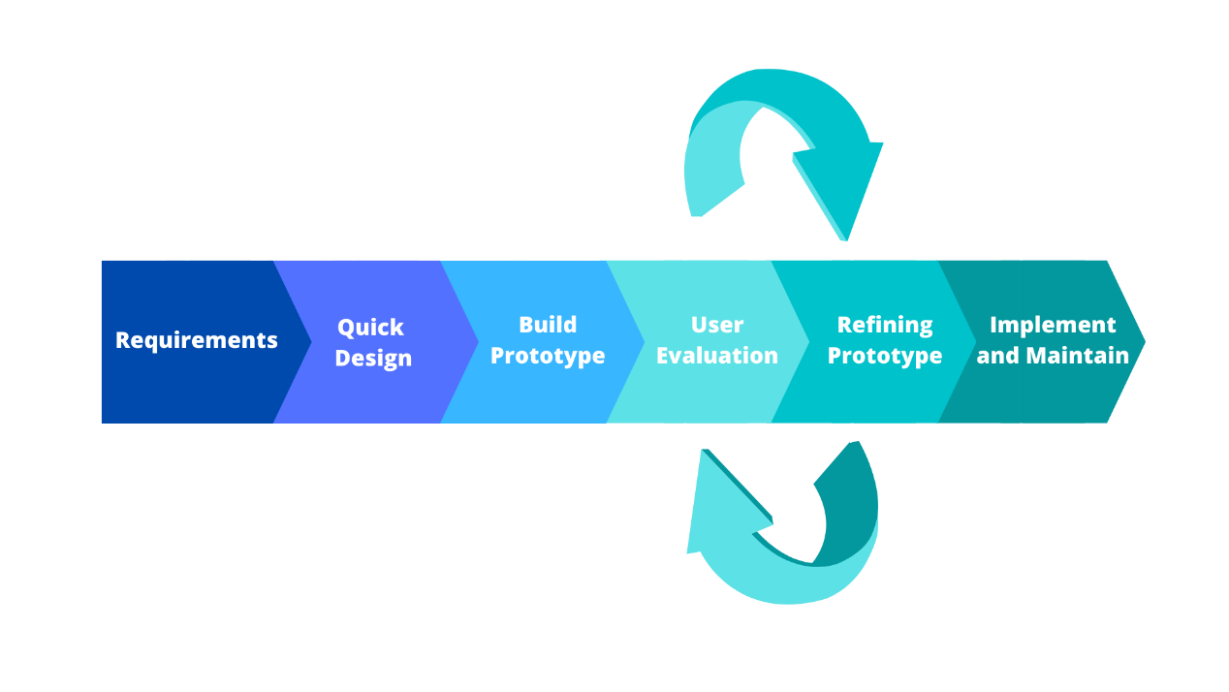

**Figure 26.** Prototype Model

(Source: *https://www.guru99.com/software-engineering-prototyping-model.html*)

**Requirements**

Requirement analysis is the first step in developing a prototype model. The researchers consulted an engineer to identify the components that would be needed for the study (refer to the appendix V). They also brainstormed and used the online platform to gather different information that may contribute to the study and looked thoroughly for review related literature in making this study possible.

Some gathered information were put in tables or diagrams. The researchers used tables to list down the software and hardware requirements which are used in constructing the prototype and the system (see appendix J and appendix K).

The desktop computer specification that is used to develop the mobile application and the raspberry pi specification that is also used to develop the system are also listed in tables (see appendix L and M).

The researchers used the project costing table to list all the finances that were used for the study (see appendix N).

After gathering the concepts and ideas, the researchers concluded that there should be a multifunction smart blinds system with a temperature, humidity sensor, a humidifier, a real-time digital clock, led strip lights, a voice recognition, and a mobile application interface to manually or to automatically control the prototype.

To monitor the progress of the developing prototype the researchers used Gantt Chart (see appendix P) and to test the mobile application and the prototype, test cases and iso 25010 were utilized for the testing (see appendix Q).

**Quick Design**

The second phase is the quick design, in which the researchers are able to design a quick design. Once the requirements are known, it helps the researchers to visualize how the product should be developed. MIT APP Inventor V2 was discovered by the researcher which is a good tool to develop a mobile application with the help of MIT APP Inventor V2, the researchers drew a storyboard to be used for developing a mobile application (see appendix G). In addition, the researchers also created their prototype design with the use of Blender software which is useful for creating 3D objects (see appendix H). Figma also used for designing the mobile user interface (Figure 27). The block diagram helps the researcher to understand how the system would work in development (see appendix E). The hardware design circuit diagram is used to guide the researchers in connecting the wires from the IoT devices to the raspberry pi (see appendix D). The flowchart is also used to guide the researchers on how the mobile application should work (see appendix F).

**Build Prototype**

Building a prototype will utilize the data acquired in quick design which was used to develop the prototype. The researchers followed the Gantt chart in developing the prototype (see appendix P). The researchers identified that DHT22 is a humidity temperature sensor that monitors the room temperature and humidity. Furthermore, the researchers also investigated Nema 17 Stepper Motor rotates 1.8° which helps them to operate the close and open of Smart Blinds. They also found out that WS2812B is a programmable led light which allows the research to control the led lights through the use of a mobile application. A humidifier is added to produce moist air which controls the humidity level of a room. In addition, voice recognition was programmed to allow voice control of the system. The researchers have identified all the functions of the components. They started connecting the components to the raspberry pi, building the prototype, and developing the mobile application. After fulfilling the requirements, the researchers interconnected prototype and mobile application with the use of internet and firebase which were connected to each other.

**User Evaluation**

At this stage, the researchers conducted test cases, an alpha test and beta test to test the functionalities of the prototype and the mobile application. The alpha test helped the researchers to identify if there are possible bugs in the mobile application and if the prototype needs adjustment and if there are recommendations and suggestions for the prototype and mobile application (see figure 36). The beta test also helped the researchers to identify the bugs and possible error that possibly occur and the researchers also checked if there are adjustments needed for the prototype and if the mobile application needs further enhancements (see figure 37). The respondents for the beta tester are the household members and the number of respondents for the beta testing is thirty participants (30). The participants that were chosen for the beta testing was chosen through the use of random sampling method. The test started in the month of October after the prototype and mobile application was developed until early of November. The questionnaires that were used for the testing is ISO25010 that was validated by Engr. Oliver R. Santos who is an Electronic Engineer Expert (see appendix V). The system and mobile application were evaluated in terms of functional suitability, usability and portability. The data that was collected are compiled and analyzed so conclusions can be derived. Frequency Distribution is utilized to determine the number of responses. The results from the Likert Scale were used to find out the overall assessment of the respondents and is used to interpret the test results (see appendix O for the Likert Scale).

In order to interpret the results from the Likert Scale, the data that were gathered are compiled and analyzed. The formula that was used to get the mean score of the results is x = ∑fx / n.

**Refining Prototype**

Once the user evaluation was conducted, the researchers gathered the results of the test cases, alpha and beta test and if there are suggestions and feedback to the developed prototype and mobile application. The researchers made adjustments to the prototype and mobile application until the recommendations and feedbacks are met.

**Implement and Maintain**

After it has been developed to its final stage, The prototype is tested and put into service. The prototype would be implemented to household who are in range of upper-class family. To avoid malfunctions, routine maintenance is performed to avoid malfunctions. The prototype is limited to the final defense and maintenance is not included in the scope of the study. However, it is part of the stage, that the researchers discussed thoroughly.

**Chapter 4**

**RESULTS AND DISCUSSIONS**

**Product/Processes Screen Shots Development**

The researchers developed a multifunction smart blind that was in accordance to the study’s objective. As the developer finished developing the system’s main functionalities, the researchers conducted series of tests to ensure that the prototype was functioning properly and effectively. Please refer to the figures below for more information on the system prototype and testing process.

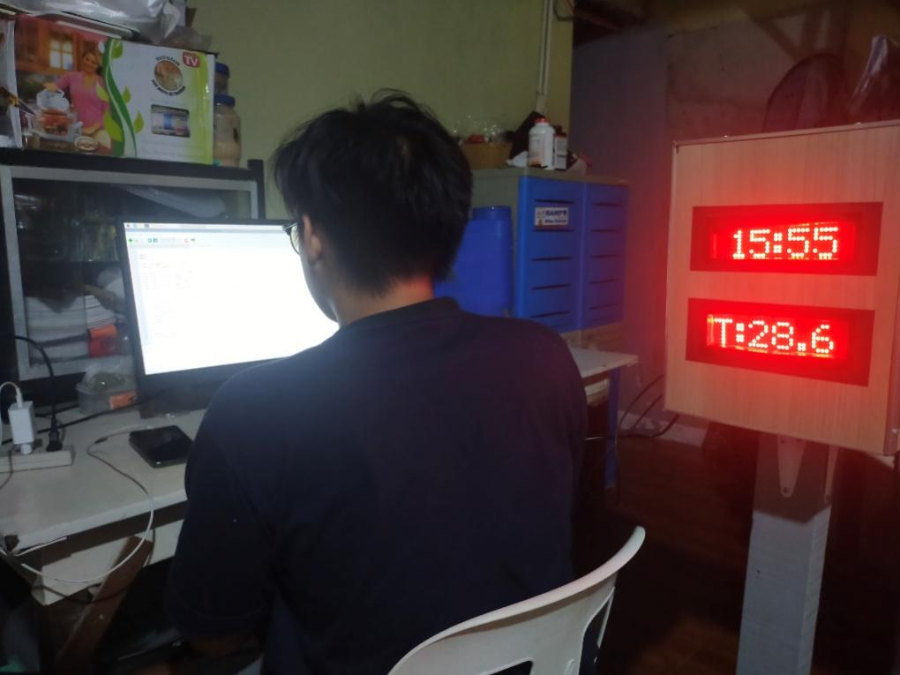

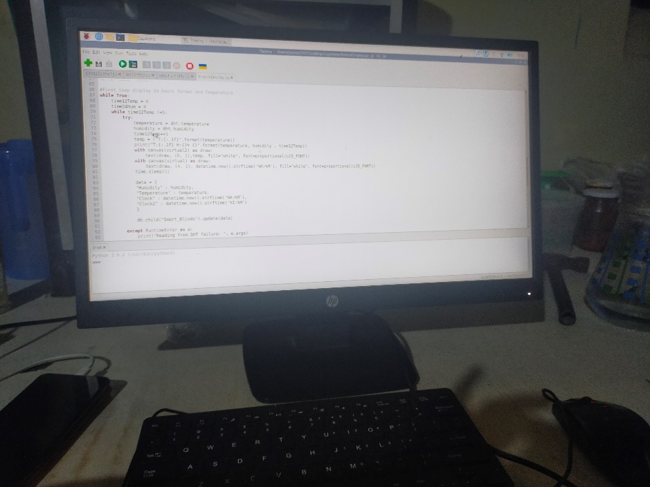

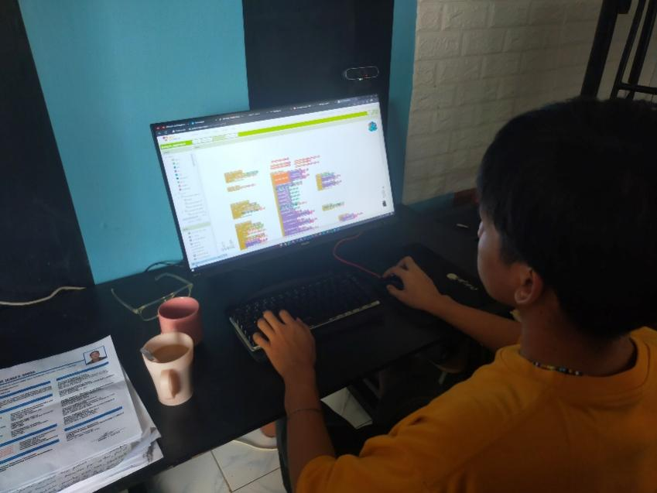

**Figure 27.** System/Mobile Application Developing

Figure 27 shows the development stage of system and mobile application after developing the system and the mobile application, the researchers interconnected the mobile application and the system to control the prototype.

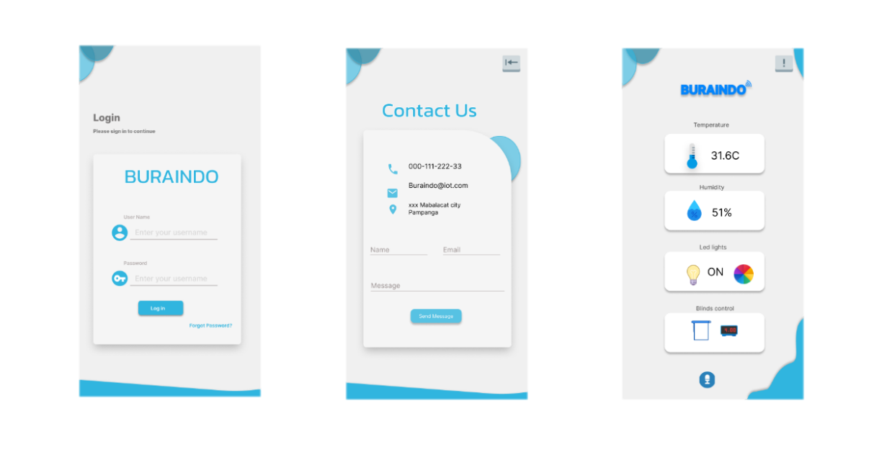

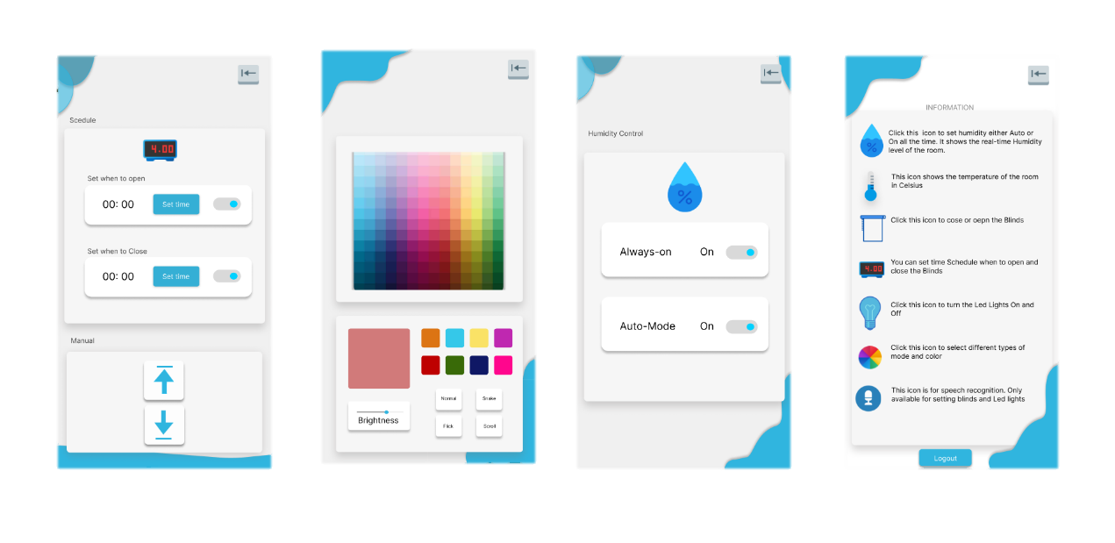

**Figure 28.** Mobile Application User Interface

The result of the storyboard, which is the mobile user interface that was developed for Buraindo, is represented in the figure above. The mobile application's launch screen displays the first screen of the mobile application which is the login page. If the user forgot the password, the user needs to contact administrator to request for reset password and if the users were able to login, it will proceed to the monitoring and control parameters which is temperature, humidity, led lights, speech recognition, and blinds control.

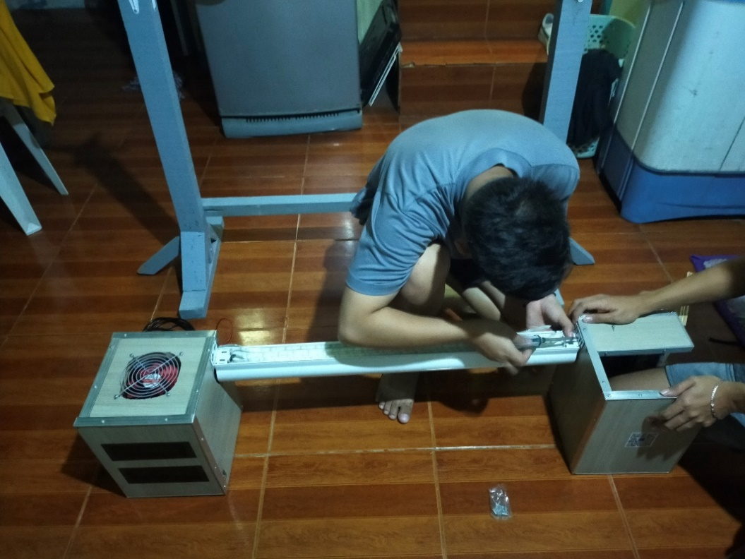

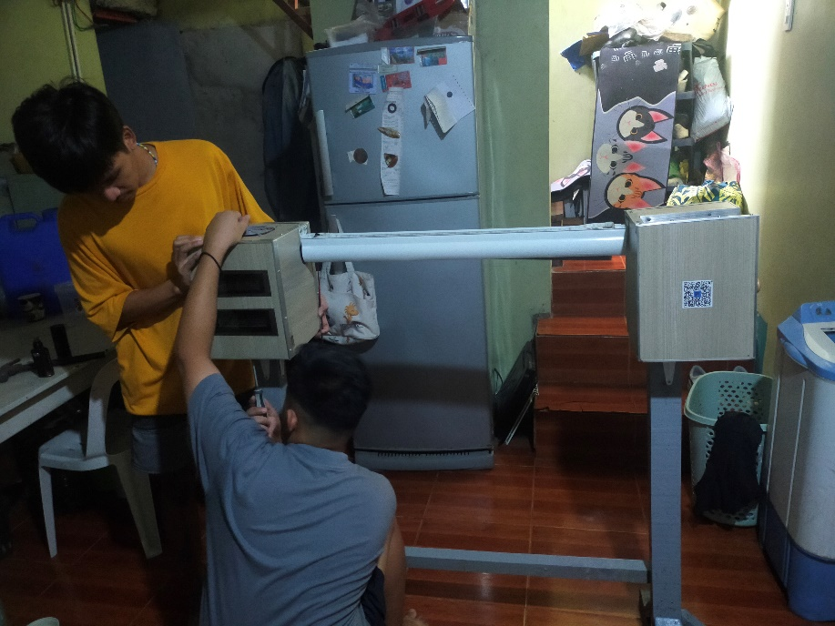

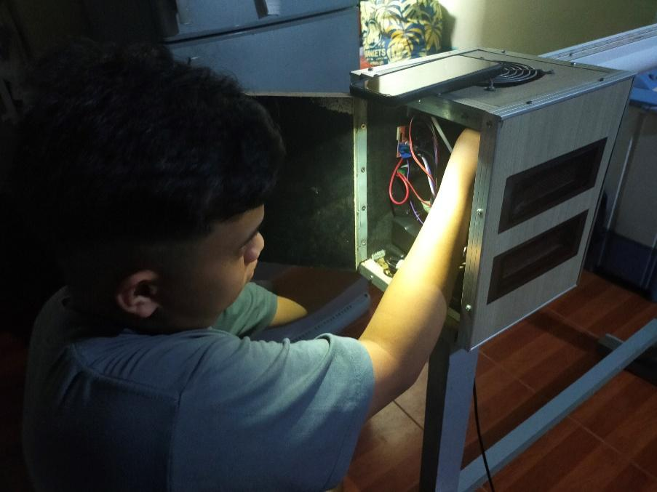

**Figure 29.** Prototype Developing

Figure 29 shows the development stage of developing the prototype Buraindo. The researchers gathered all the IoT components and installed it to the prototype. In order to display the blinds properly, since the researchers were unable to place the blinds on the windows, they used woods to use as a stand for the prototype to showcase it properly.

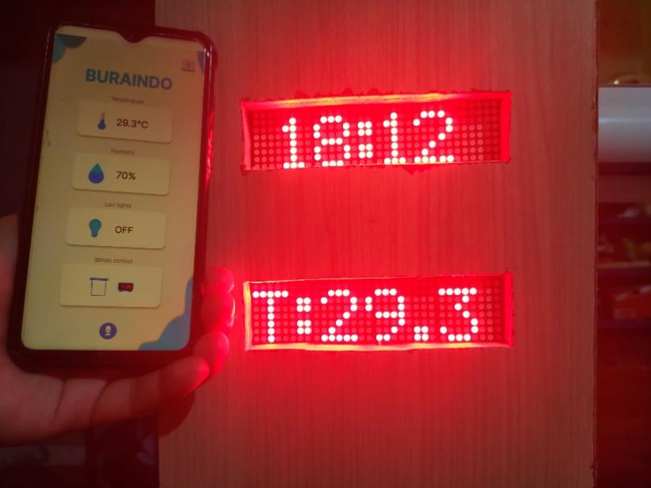

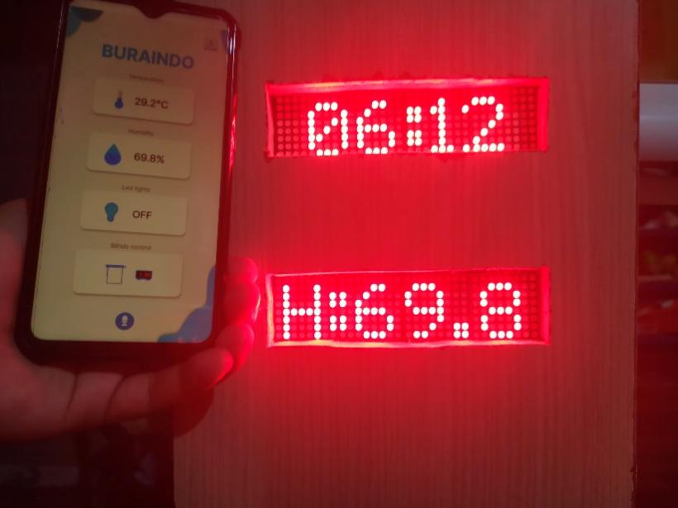

**Figure 30.** Humidity and Temperature Monitoring

Figure 30 shows the result of checking of humidity and temperature sensor. The humidity and temperature sensors were able to display the data that the sensor gathered which can be monitored beside the blinds or even if the users is away from home. The users may also monitor the room humidity and temperature through the use mobile application.

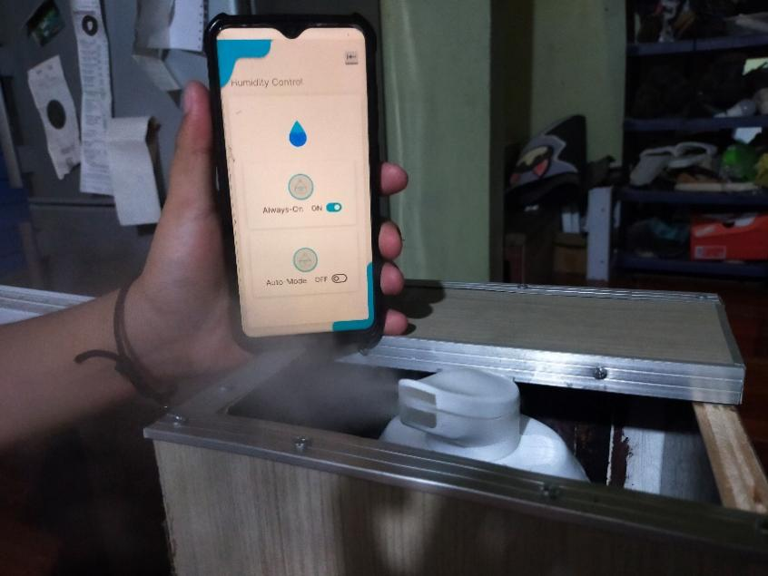

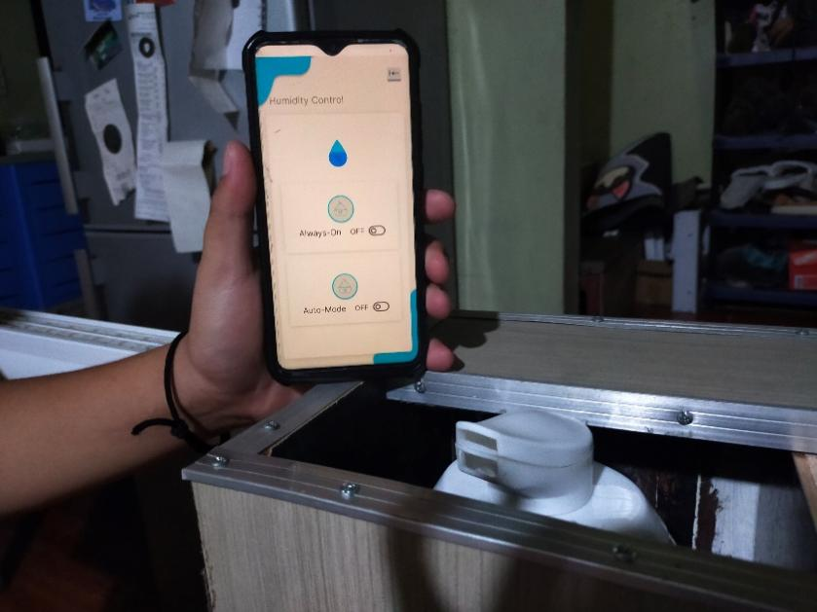

**Figure 31.** Humidifier Testing

Figure 31 shows how to test the humidifier. If the user selects the “Always-On,” the humidifier would immediately be turned on and will start to produce moist air as long as it has liquid inside the container. Otherwise, if the user turned on the “Auto-Mode” the humidifier would then automatically be turned on once the humidity level hits 30% below; if the humidity level reaches 45%, then it would be automatically turned off.

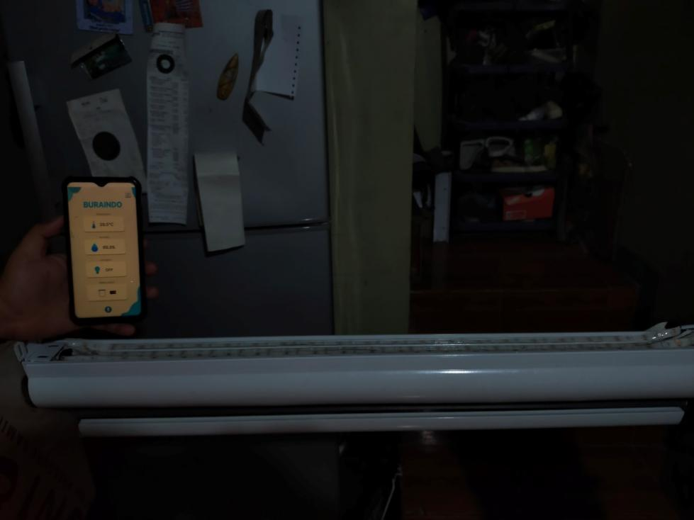

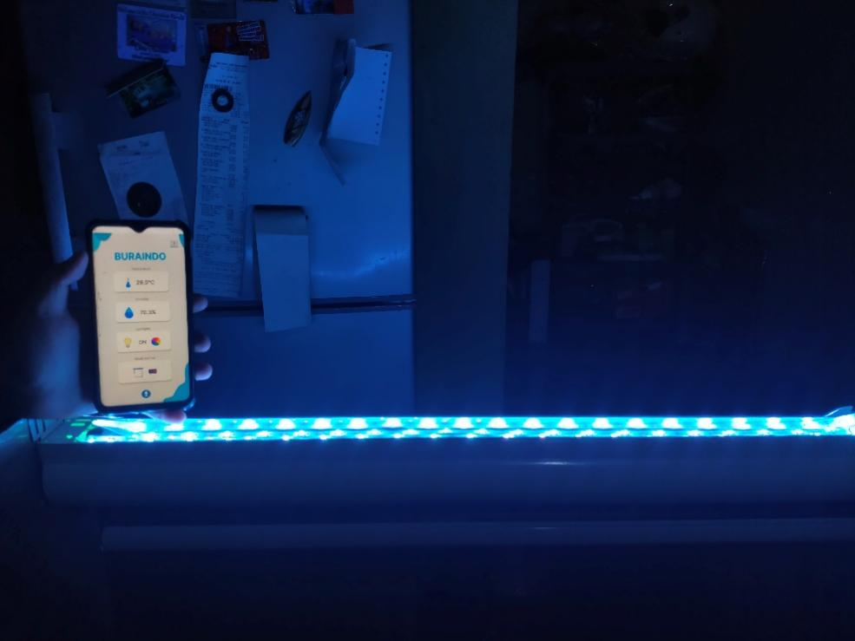

**Figure 32.** Led lights control

Figure 32 shows the controlling of led lights. Once the user taps the light bulb icon, the led lights would be turned on otherwise it will be turned off.

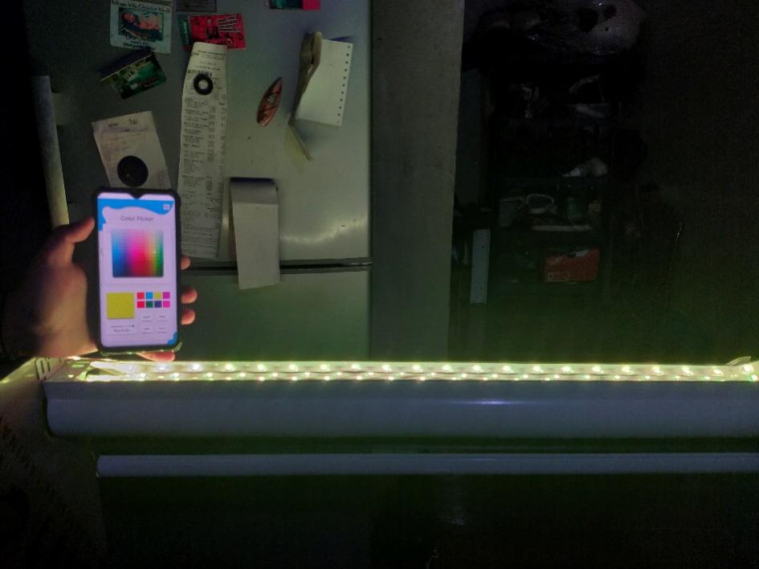

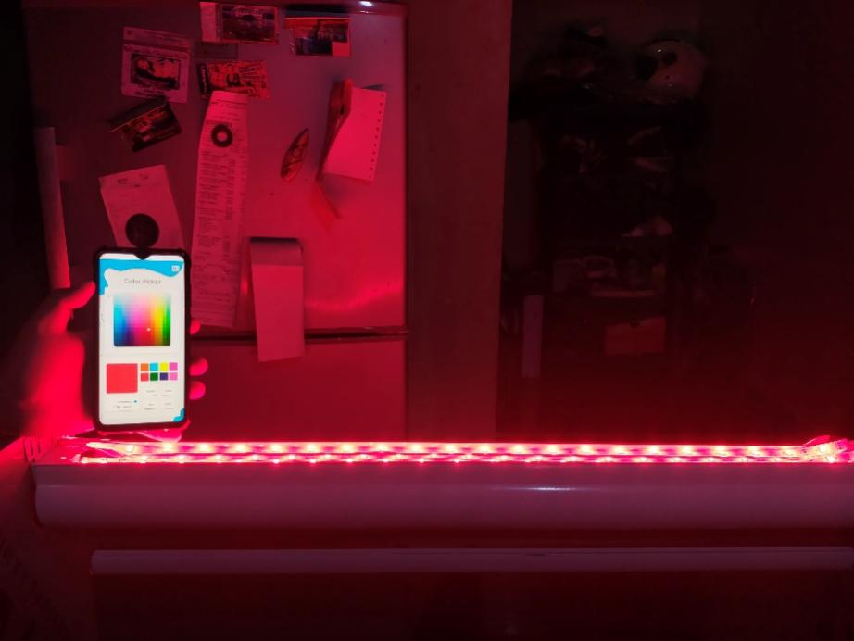

**Figure 33.** Changing color of led lights

Figure 33 shows the results of testing the color changing of the led lights. If the users select a specific color along the color picker; then, the led lights would display the color that the user has chosen. If the user also clicks the effects button below the color tab; then, the led lights will have an effect based on the user preferences.

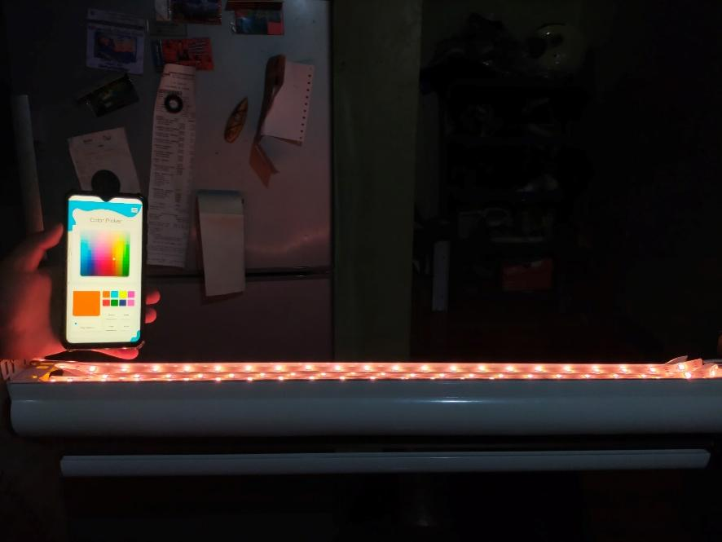

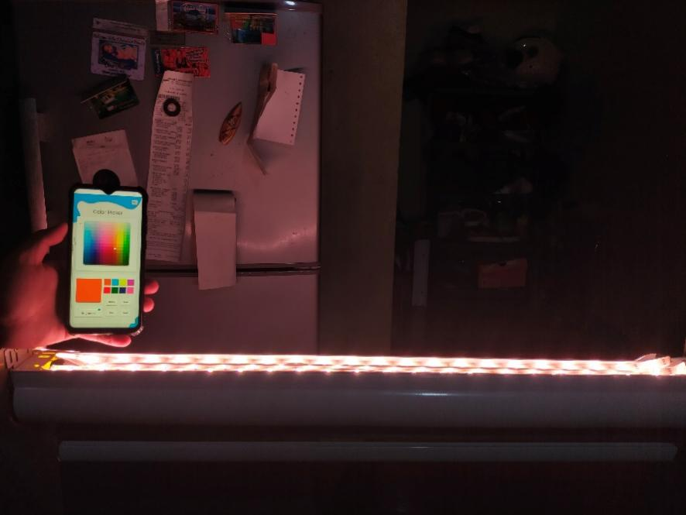

**Figure 34.** Adjust brightness of led lights

Figure 34 represents the testing of adjusting the led lights brightness. The intensity of the LED lights may be adjusted by the user to suit personal preferences. If the user wants a dimmer light, then the user would just scroll the brightness to the left to lower the led lights intensity and also if the user wants a brighter led lights just turn the brightness to the highest.

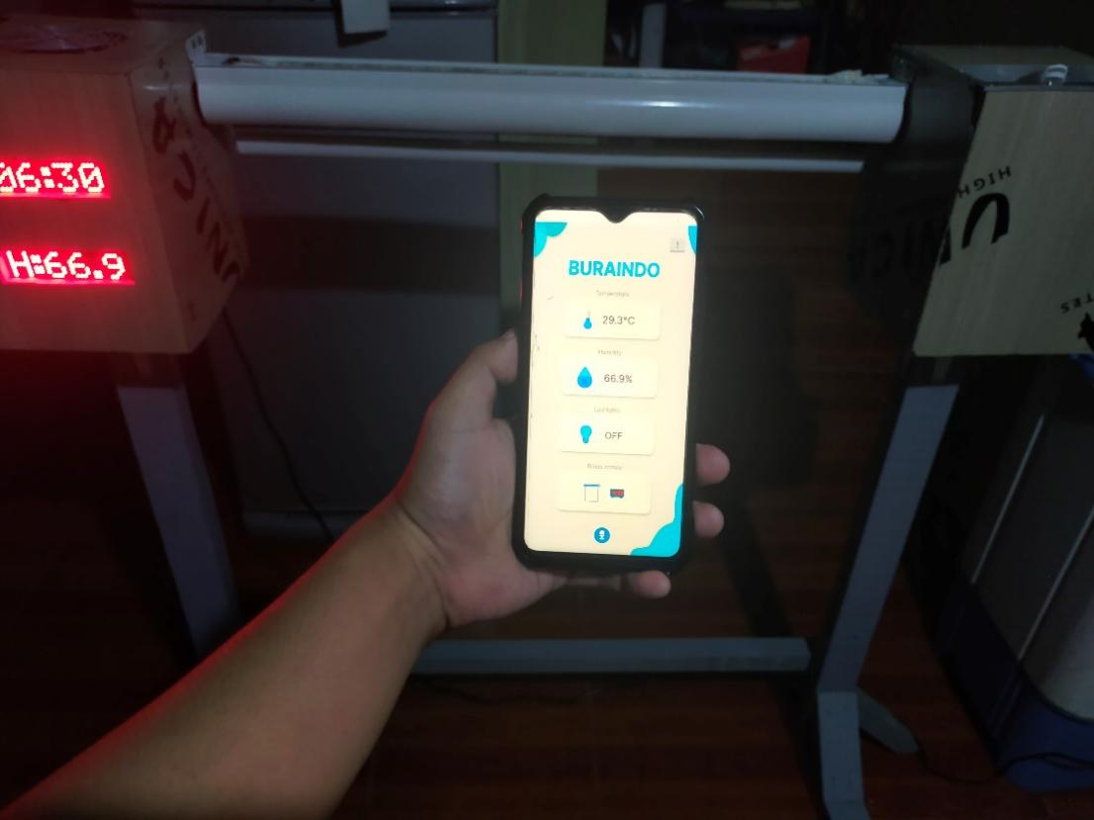

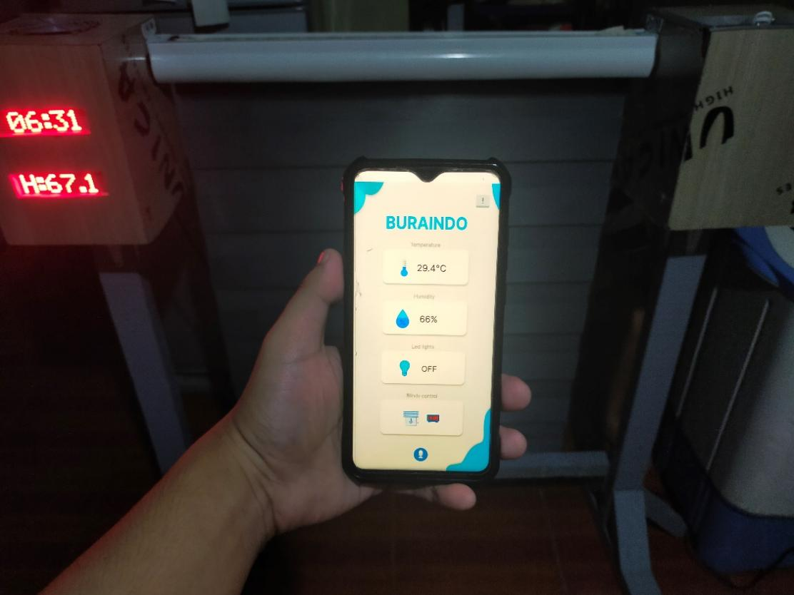

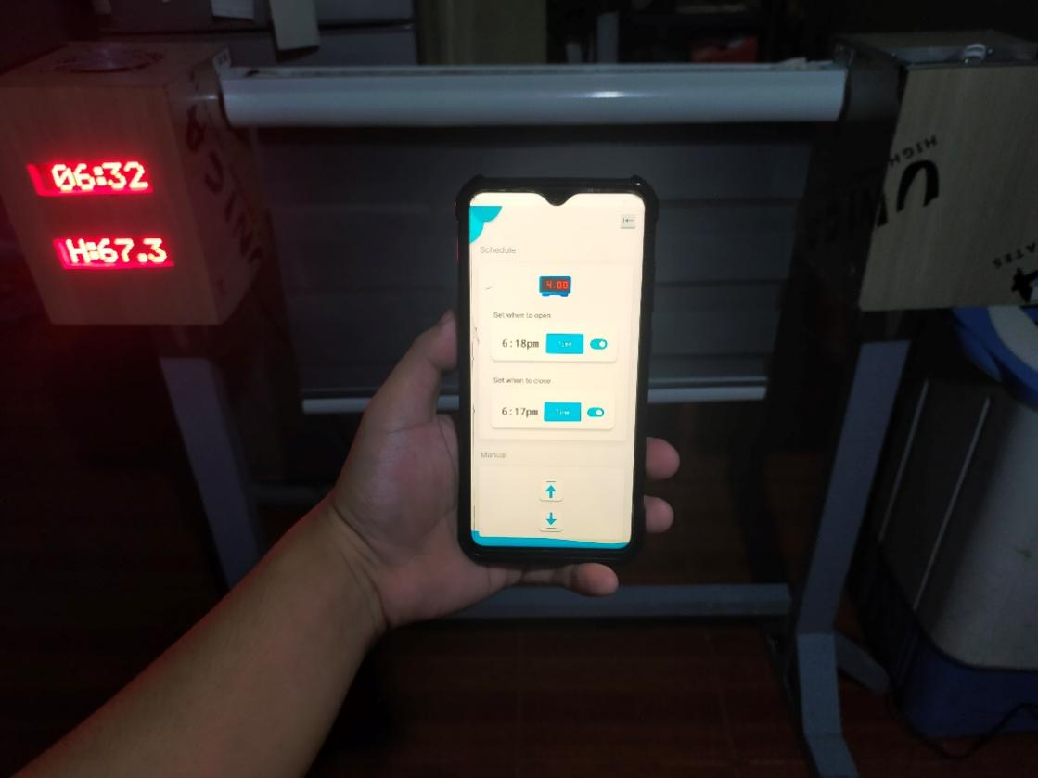

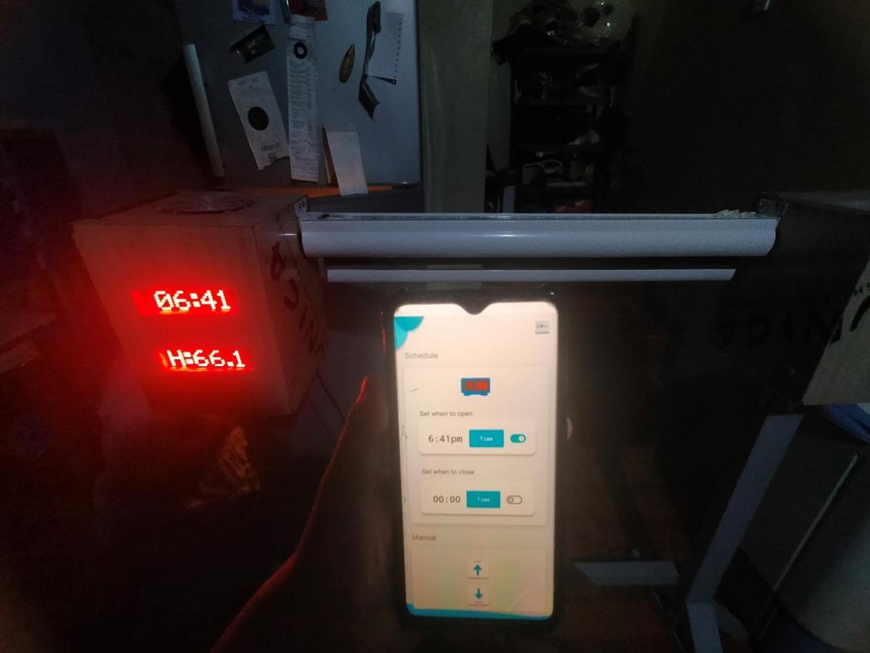

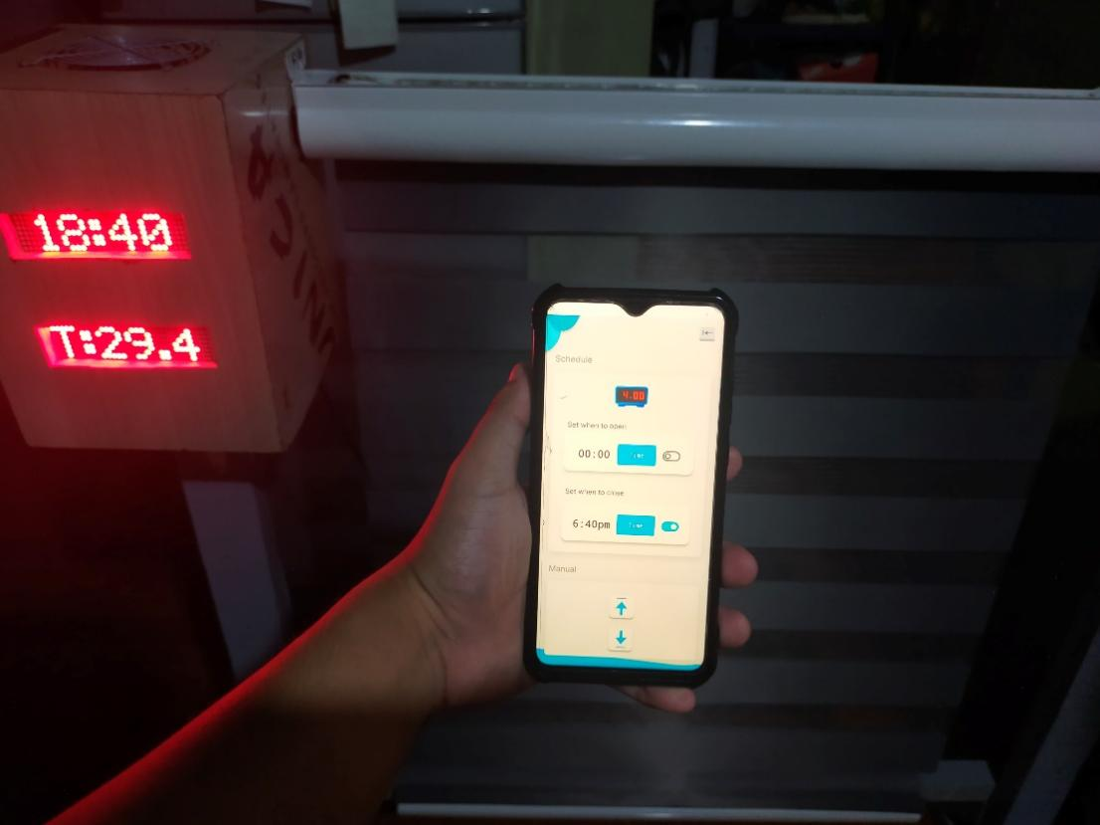

**Figure 35.** Controlling Blinds

Figure 35 shows the testing of controlling the blinds. Once the user taps the blinds icon it would then open, the nema 17 stepper motor would start rotating for the blinds to be pulled up for it to work the blinds must be properly closed first. If the user went to the blinds control parameter and click the up button then the blinds would open slightly until the user reaches the maximum open of blinds. If the user also taps the down button, then the blinds will close slightly until fully closed. Once the blinds reach its peak then the fully open and close would be enabled. The user may also set what time the blinds will be opened and also be closed. Once the clock besides the blinds matches the time the motor would starts to operate based on the system requirements and the user’s preference.

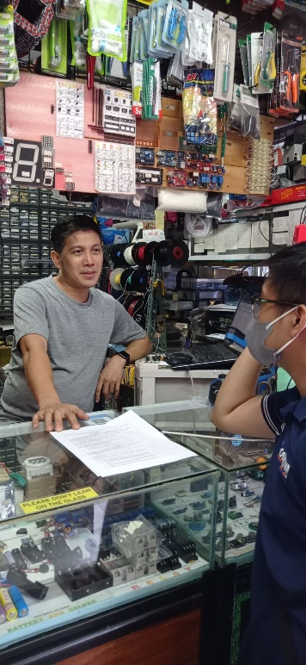 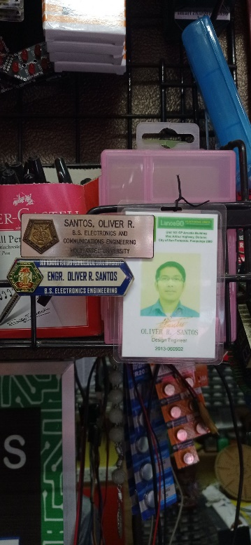

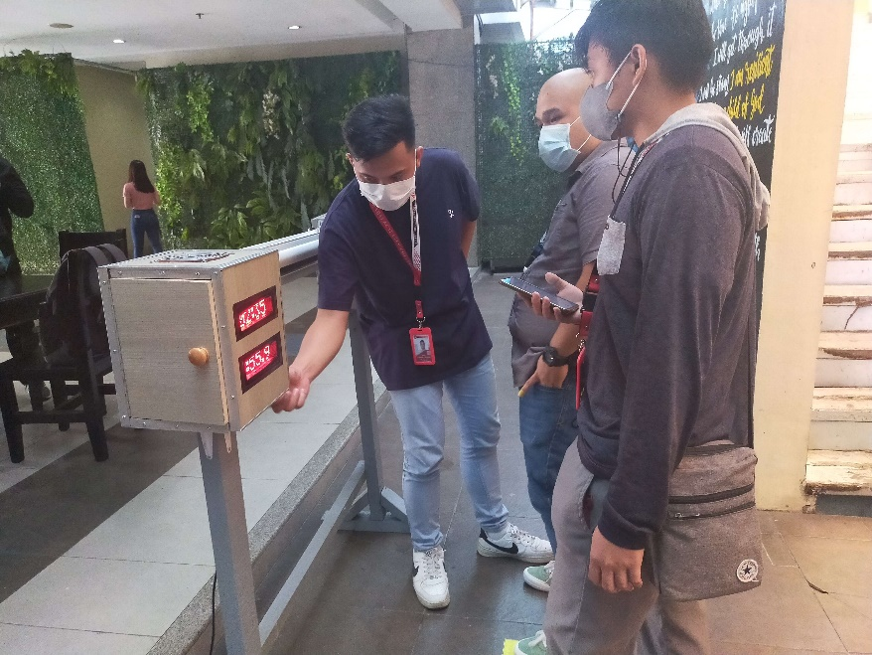

**Figure 36.** Alpha Testing

The researchers conduct an alpha test for the prototype and the mobile application to the IT expert to know if there are suggestions or feedbacks that are needed for the prototype and also to identify if there are bugs, error that may occur before releasing the final product.

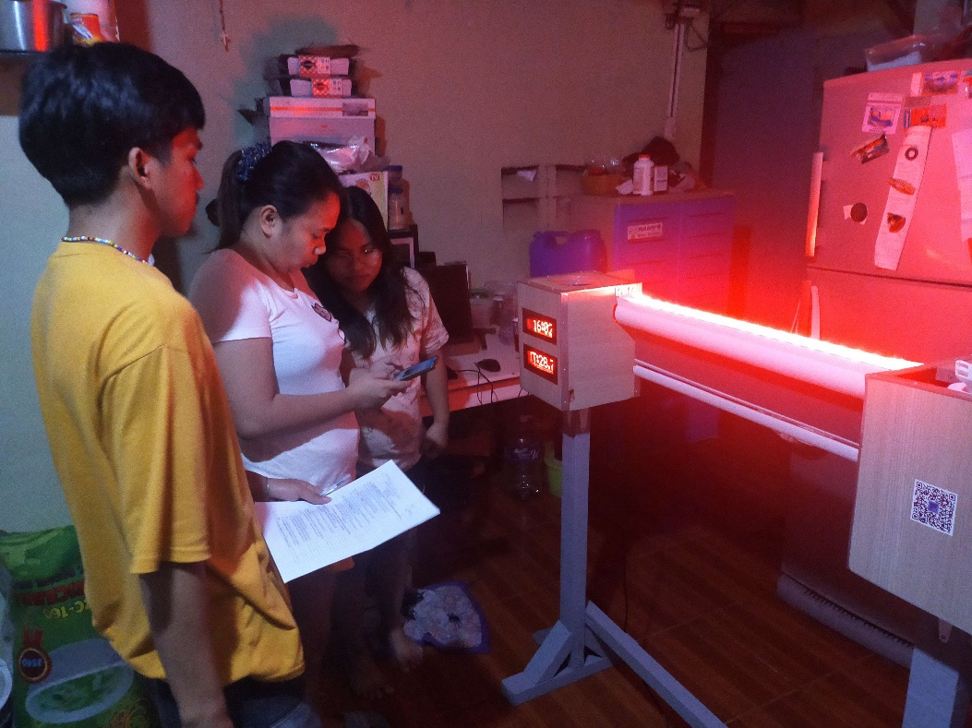

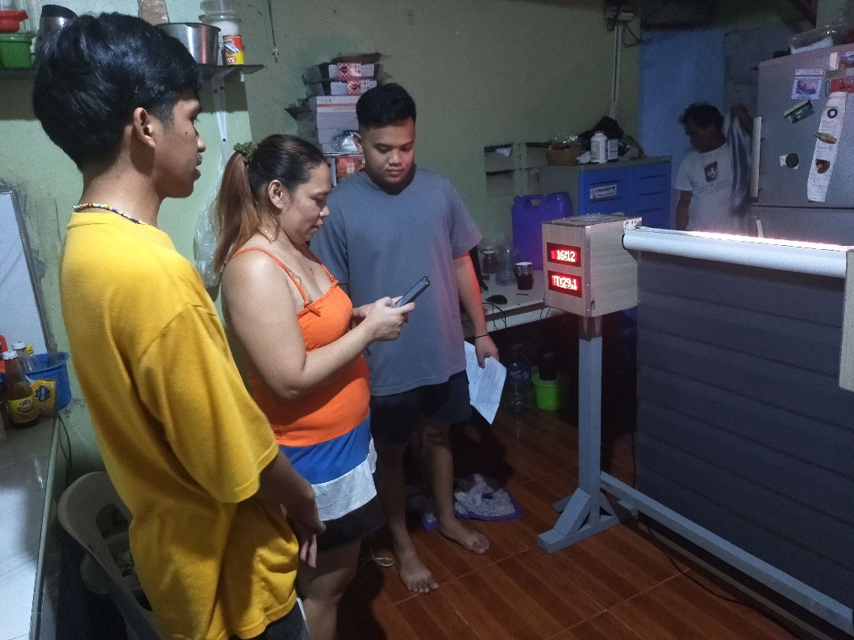

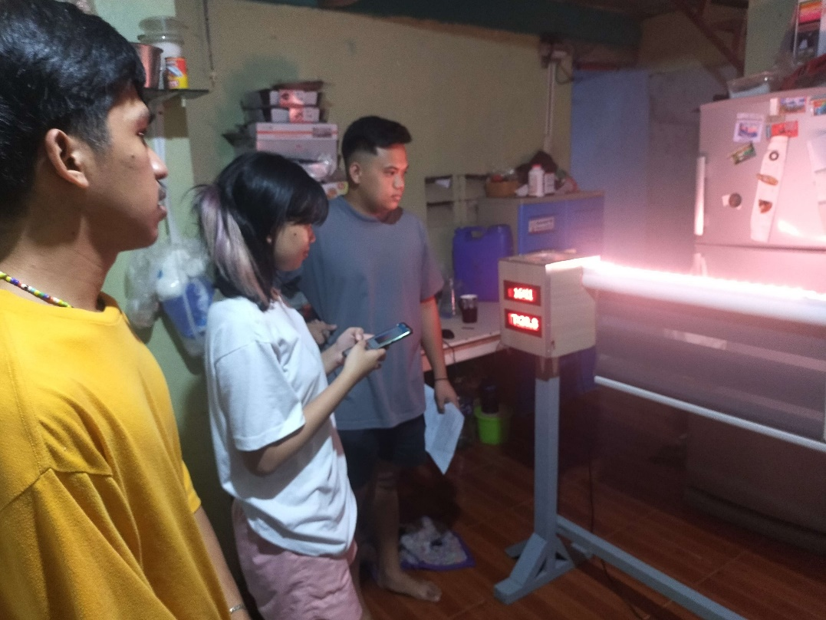

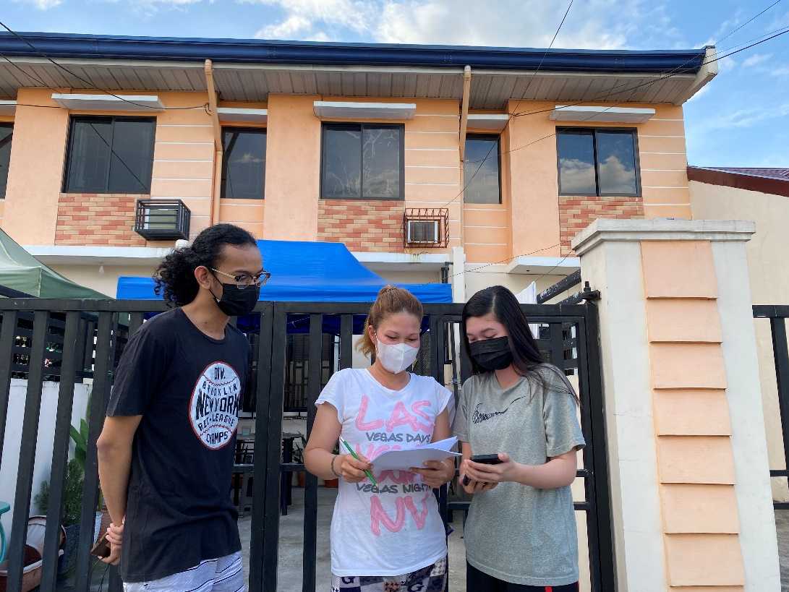

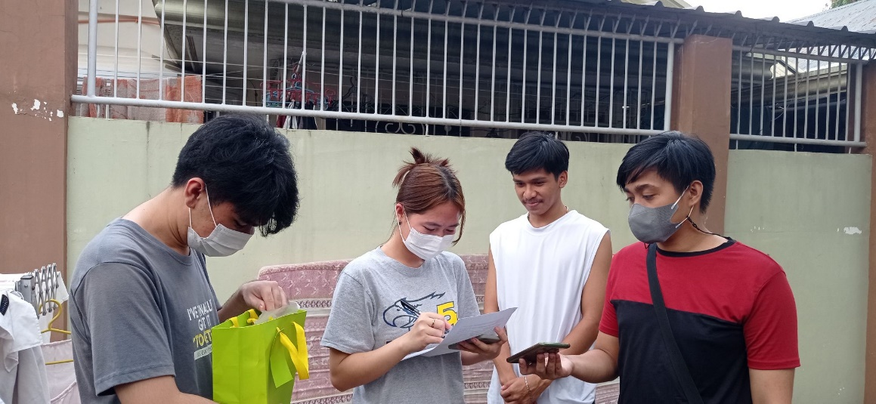

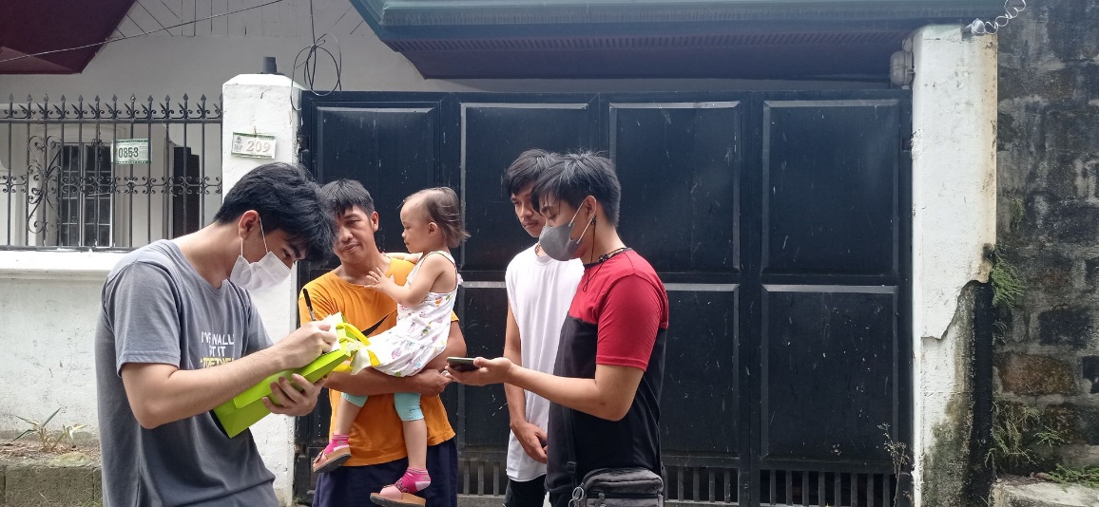

**Figure 37.** Beta Testing

The researchers conducted a beta test to different household members to test the functionalities of prototype and mobile application and to gain insights on how would the researchers would implement the product and to get feedback and suggestions on how to improve the prototype designs based on the beta tester feedbacks.

**Testing Results**

**Table no. 1** Prototype Test Case

|  |  |  |
| --- | --- | --- |
|  | **Yes** | **No** |
| 1. Does the automatic humidifier turn on when the humidity level reaches 30% below? | 10 | 0 |
| 1. Does the automatic humidifier turn off when the humidity level reaches 45% above? | 10 | 0 |
| 1. Does the humidifier turn on when the manual button was turn on? | 10 | 0 |
| 1. Does the humidifier turn on and off when using voice commands? | 10 | 0 |
| 1. Does the MAX7219 dot Matrix displays temperature, humidity and real-time clock? | 10 | 0 |
| 1. Does the WS2812B led strip lights turn on when it is turn on? | 10 | 0 |
| 1. Does the led strip lights display specific color accurately? | 10 | 0 |
| 1. Does the led strip lights effects display works? | 10 | 0 |
| 1. Does the led strip lights turn on and off when using voice commands? | 10 | 0 |
| 1. Does the led strip lights change effects when using voice commands? | 10 | 0 |
| 1. Does the led strip lights change led color when using voice commands? | 10 | 0 |
| 1. Does the Nema 17 Motor open and close the blinds automatically? | 10 | 0 |
| 1. Does the Nema 17 Motor open and close the blinds scheduled? | 10 | 0 |
| 1. Does the Nema 17 Motor open and close the blinds manually? | 10 | 0 |

Testing the functionalities of the protype will be represented by the test cases shown in the table above. Each of the prototype functions was tested more than ten times to ensure that each prototype performs in accordance with its intended function. After conducting preliminary tests there is some slight delay for the system to response on its functionality, it was discovered that the speed of Wi-fi connectivity affects the whole system.

When the humidity level reaches 30% and the auto of humidifier is turned then the humidifier will start to function, but it does not monitor the liquid inside the humidifier which the users need to monitor.

The researcher found out that nema 17 stepper motor works properly in opening or closing the blinds. It can be manually controlled through the use of mobile application.

After completing the prototype testing and ensuring that all wires are properly connected and all devices are working, the researchers confirmed that the prototypes are all functional based on test cases trials.

**Table no. 2** Mobile Application User Interface Test Cases

|  |  |  |
| --- | --- | --- |
| **Mobile Application User Interface Test Cases** | **Yes** | **No** |
| 1. Does the mobile app UI display temperature level? | 10 | 0 |
| 1. Does the mobile app UI display humidity level? | 10 | 0 |
| 1. Does the mobile app UI display if the led lights are on or off? | 10 | 0 |
| 1. Does the mobile app UI display if the blinds were open or close? | 10 | 0 |

The test cases for the features of the mobile application user interface were shown in the table above. For each test case, more than 10 trials we carried out to ensure that the mobile application user interface are in sync with the prototype.

The researchers were able to create a user interface for a mobile application that displays the room temperature and humidity. The DHT22 records the humidity and temperature of a room and the data gathered by the sensor will be sent to the database. As a result, the mobile user interface was able to display the current room humidity and temperature.

Finally, the mobile user interface test case was run ten times to ensure that the mobile applications are all functional and in sync.

**Table no. 3** Summary of Alpha Tester in terms of ISO25010 criteria

|  |  |  |
| --- | --- | --- |
| **Criteria** | % | Interpret % |
| **Functional Suitability** | 100% | Very Agree |
| **Usability** | 80% | Very Agree |
| **Portability** | 100% | Very Agree |
| **Total** | 93.33% | Very Agree |

The tables above show the summary of Alpha Tester in terms of ISO25010 criteria which would be interpreted through the use of Likert scales. The Likert scale would be seen in appendix O. The prototype and mobile application overall Functional Suitability test has garnered a mean percentage of 100 with a verbal interpretation of “Very Agree”. This means that the majority of alpha tester are very satisfied and agreed that the application user-interface was completely functional. The application correctly displays the expected result from the prototype sensors. The system is pleasingly appropriate to accomplish the desired result. The overall Usability test has garnered 80 with a verbal interpretation of “Very Agree”. This means that most of the alpha tester were easily able to operate and control both the application and prototype. The application has a user-friendly interface design that user have navigate and learned it easily with minimal guidance of the researchers. The overall Portability test has garnered a mean percentage of 100 with a verbal interpretation of “Very Agree”. This means that majority of the alpha tester were able to adapt the system to the blinds and install the mobile application easily on to their mobile phone. The overall total of 93.33 mean percentage with a verbal interpretation “Very Agree”. This means that the overall result is satisfied with the outcome.

**Table no. 4** Summary of Alpha Tester in terms of ISO25010 sub criteria

|  |  |  |  |  |
| --- | --- | --- | --- | --- |
| **Criteria** | Yes | % | No | % |
| **Functional Suitability** | | | | |
| **Functional Completeness** | 6 | 100% | 0 | 0% |
| **Functional Correctness** | 6 | 100% | 0 | 0% |
| **Functional Appropriateness** | 6 | 100% | 0 | 0% |
| **Usability** | | | | |
| **Appropriateness Recognizability** | 3 | 100% | 0 | 0% |
| **Learnability** | 6 | 100% | 0 | 0% |
| **Operability** | 24 | 100% | 0 | 0% |
| **User Interface Aesthetics** | 2 | 33.33% | 4 | 66.67% |
| **Accessibility** | 4 | 66.67% | 2 | 33.33% |
| **Portability** | | | | |
| **Adaptability** | 3 | 100% | 0 | 0% |
| **Installability** | 6 | 100% | 0 | 0% |
| **Total** | 66 | 91.7% | 6 | 8.3% |

The table shows the summary of Alpha Tester in terms of ISO25010 sub criteria shows the score under Functional Suitability. The Functional Completeness that answered “yes” was 6 which 6/6 * 100 = 100% percentage score which means that the majority of alpha testers agree that the application user-interface was completely functional. The Functional Correctness that answered “yes” was 6 which 6/6 * 100 = 100% percentage score which means the alpha testers agree with the application correctly display the expected result from the prototype sensors. The Functional Appropriateness that answered “yes” was 3 which 3/3 * 100 = 100% percentage score which means that majority of the alpha tester agrees that the system is pleasingly appropriate to accomplish the desired result. Under the sub criteria of usability shows the Appropriate Recognizability that answered “yes” was 3 which 3/3 * 100 = 100% percentage score which means that the alpha testers agree that the mobile interface icons are recognizable. The Learnability that answered “yes” was 6 which 6/6 * 100 = 100% percentage score which means that the majority of alpha testers agrees that the mobile interfaces are user-friendly and easy to understand. The Operability that answered “yes” was 24 which 24/24 * 100 = 100% percentage score which means that the majority of alpha testers agree that the mobile application and prototype are operatable. The User Interface Aesthetics that answered “yes” was 2 which 2/6 * 100 = 33.33% percentage score and 4 “no” which 4/6 * 100 = 66.67% percentage score which means that the majority of alpha testers agree that the mobile interface graphical user interface and icon are recognizable. The Accessibility that answered “yes” was 4 which 4/6 * 100 = 66.67% percentage score and 2 “no” which 2/6 * 100 = 33.33% percentage score which means that most of the alpha testers agree. Under the portability, the adaptability answered “yes” was 3 which 3/3 * 100 = 100% percentage score which means that the alpha testers agree that the system can be installed on different blinds and the Installability that answered “yes” was 6 which 6/6 * 100% = 100% percentage score which means the alpha testers agree that mobile application can be installed easily. The total that answered “yes” was 66 which is equivalent to 66/72 * 100 = 91.7% percentage score and 6 “no” which 6/72 * 100 = 8.3% percentage score.

**Table no. 5** Summary of Beta Tester in terms of ISO25010 sub criteria

|  |  |  |  |  |
| --- | --- | --- | --- | --- |
| **Criteria** | Yes | % | No | % |
| **Functional Suitability** | | | | |
| **Functional Completeness** | 60 | 100% | 0 | 0% |
| **Functional Correctness** | 60 | 100% | 0 | 0% |
| **Functional Appropriateness** | 59 | 98.33% | 1 | 1.67% |
| **Usability** | | | | |
| **Appropriateness Recognizability** | 28 | 93.33% | 2 | 6.67% |
| **Learnability** | 57 | 95% | 3 | 5% |
| **Operability** | 239 | 99.58% | 1 | 0.42% |
| **User Interface Aesthetics** | 55 | 91.67% | 5 | 8.33% |
| **Accessibility** | 41 | 68.33% | 19 | 31.67% |
| **Portability** | | | | |
| **Adaptability** | 24 | 80% | 6 | 20% |
| **Installability** | 30 | 100% | 0 | 0% |
| **Total** | 653 | 94.64% | 37 | 5.36% |

The table shows the summary of Beta Tester in terms of ISO25010 sub criteria shows the score under Functional Suitability. The Functional Completeness that answered “yes” was 60 which 60/60 * 100 = 100% percentage score which means that the majority of beta testers agree that the application user-interface was completely functional. The Functional Correctness that answered “yes” was 60 which 60/60 * 100 = 100% percentage score which means the beta testers agree with the application correctly display the expected result from the prototype sensors. The Functional Appropriateness that answered “yes” was 59 which 59/60 * 100 = 98.33% and 1 “no” which 1/60 * 100 = 1.67% percentage score which means that majority of the beta tester agrees that the system is pleasingly appropriate to accomplish the desired result. Under the sub criteria of Usability shows the Appropriate Recognizability that answered “yes” was 28 which 28/30 * 100 = 93.33% percentage score and 2 “no” which 2/30 * 100 = 6.67% percentage score which means that the beta testers agree that the mobile interface icons are recognizable. The Learnability that answered “yes” was 57 which 57/60 * 100 = 95% percentage score and 3 “no” which 3/60 * 100 = 5% percentage score which means that the majority of beta testers agrees that the mobile interfaces are user-friendly and easy to understand. The Operability that answered was 239 which 239/240 = 99.58% percentage score and 1 “no” which 1/240 = 0.42% percentage score which means that the majority of beta testers agree that the mobile application and prototype are operatable. The User Interface Aesthetics that answered “yes” was 55 which 55/60 * 100 = 91.67% and 5 “no” which 5/60 * 100 = 8.33% percentage score which means that the majority of beta testers agree that the mobile interface graphical user interface and icon are recognizable. The Accessibility that answered “yes” was 41 which 41/60 = 68.33% percentage score and 19 “no" which 19/60 = 31.67% percentage score which means that most of the beta testers agree. Under the Portability, the adaptability answered “yes” was 24 which 24/30 * 100 = 80% percentage score and 6 “no” which 6/30 * 100 = 20% percentage score which means that the beta testers agree that the system can be installed on different blinds. The Installability that answered “yes” was 30 which 30/30 * 100 = 100% percentage score which means the beta testers agree that mobile application can be installed easily. The total of who answered “yes” was 653 which 653/690 * 100 = 94.64% percentage score and 37 “no” which 37/690 * 100 = 5.36% percentage scores.

**Table no. 6** Summary of Beta Tester in terms of ISO25010 criteria

|  |  |  |
| --- | --- | --- |
| **Criteria** | % | Interpret % |
| **Functional Suitability** | 99.44% | Very Agree |
| **Usability** | 89.58% | Very Agree |
| **Portability** | 90% | Very Agree |
| **Total** | 93.01% | Very Agree |

The tables above show the summary of Beta Tester in terms of ISO25010 criteria which were interpreted through the use of Likert scales. The Likert scale could be seen from appendix O. The prototype and mobile application overall Functional Suitability test has garnered a mean percentage of 99.44 with a verbal interpretation of “Very Agree”. This means that the majority of beta tester are very satisfied and agreed that the application user-interface was completely functional. The application correctly displays the expected result from the prototype sensors. The system is pleasingly appropriate to accomplish the desired result. The overall Usability test has garnered 89.58 with a verbal interpretation of “Very Agree”. This means that most of the beta tester were easily able to operate and control both the application and prototype. The application has a user-friendly interface design that user have navigate and learned it easily with minimal guidance of the researchers. The overall Portability test has garnered a mean percentage of 90 with a verbal interpretation of “Very Agree”. This means that majority of the beta tester were able to adapt the system to the blinds and install the mobile application easily on to their mobile phone. The overall total of 93.01 mean percentage with a verbal interpretation “Very Agree”. This means that the overall result is satisfied with the outcome.

**Table no. 7** Comparison of Alpha and Beta Tester

|  |  |  |  |  |  |
| --- | --- | --- | --- | --- | --- |
| **Alpha** | | | **Beta** | | |
| **Criteria** | % | Interpret % | **Criteria** | % | Interpret % |
| **Functional Suitability** | 100% | Very Agree | **Functional Suitability** | 99.44% | Very Agree |
| **Usability** | 80% | Very Agree | **Usability** | 89.58% | Very Agree |
| **Portability** | 100% | Very Agree | **Portability** | 90% | Very Agree |
| **Total** | 94.56% | Very Agree | **Total** | 93.01% | Very Agree |

The table above shows the comparison of the results of alpha and beta testers. The prototype and mobile application overall Functional Suitability test of alpha has garnered 100 mean percentage with a verbal interpretation of “Very Agree” and the beta has also garnered 99.44 mean percentage with a verbal interpretation of “Very Agree” which means that the alpha and beta were satisfied with the functionalities of the mobile application and the prototype. The overall Usability test of alpha has garnered 80 mean percentage with a verbal interpretation of “Very Agree” and the beta has also garnered 89.58 with a verbal interpretation of “Very Agree” which means that the alpha and beta were easily able to operate and control both the application and prototype. The user was able to navigate the interface and learned it easily with minimal guidance of the researchers. The overall Portability test of alpha has garnered 100 with a verbal interpretation of “Very Agree” and the beta has also garnered 90 with a verbal interpretation of “Very Agree” which means that the alpha and beta were able to install the mobile application with ease. The overall total of alpha is 94.56 with a verbal interpretation of “Very Agree” and beta has 93.01 with a verbal interpretation of “Very Agree” which means that the alpha and beta tester were satisfied with the functionalities of mobile application and the prototype.

**Chapter 5**

**SUMMARY OF FINDINGS, CONCLUSIONS, AND RECOMMENDATIONS**

This chapter consists the summary of findings, conclusions, and recommendations based on the results of the study BURAINDO: An IOT Based Multifunction Smart Blinds Using Raspberry Pi.

**Summary of Findings**

The summary of findings that the researchers were able to identify based on the trials, errors and results of the study, are specified below:

The researchers included the temperature monitoring, during the development phase. They used dht11 but the researcher’s encountered problem which the dht11 only records whole number reading. Hence, the researchers looked for another solution to solve this problem, which leads them to the use of dht22. The dht22 [9][10][11] is able to read decimal digits without rounding off the number. In order to display the data digitally, the researchers used seven segments led to display the data. Unfortunately, the researchers found out it was out of stock, which the researcher learned the use of dot matrix [15][16] that could be also used to display the data digitally. For the blinds to be controlled through the use of a motor, the researchers thought servo motor would work but due to its functions which leads to incompatibility, it was replaced by the nema 17 stepper [20][21] which was the best solution for this and which would be able to hold the blinds as it also has the capability to open or close through the rotation of motor. The researchers also included speech recognition module but due to the module being expensive, the researchers used Google speech recognition. Additionally, led lights were added to the prototype. For the led lights to be programmed, the researchers used ws2812b [22][23][24][25][26] for the led strip lights since it is a programmable led light which can be programmed according to the user’s preference. The researchers also used analytical and design tools such as flowcharts [37], hardware design circuit diagram [38], storyboard [39] and structural design [40]. MIT app inventor v2 [29] was used by the researcher to develop the mobile application and for the mobile user interface design figma [30] was used. To program the prototype the researcher used raspberry pi 4b [5][6][7][8] as the microcontroller and the programming language that was used is python [31]. In order to connect the prototype and the mobile application, firebase [33] was used wherein the mobile application sends the commands into the firebase which the raspberry pi receives the data and process it to control the prototype. The researchers successfully developed the mobile application and the prototype.

**Conclusions**

Based on the findings, the following are the conclusions of this research study: The prototype that included multifunctional smart blinds with extra functions that can be operated by voice commands using a mobile application has been developed by the researchers. Information was acquired by the researchers through in-person interviews, group discussions, and the use of online resources. The researchers have identified all the requisite hardware and software requirements in developing the prototype Buraindo. The researchers were able to design the prototype and mobile application using design and analytical methods. The researchers created a block diagram to depict the system's flow. The researchers also used a flowchart to describe the flow of the mobile application and a hardware design circuit to guide the wiring of the prototype. The researcher drew a storyboard for the mobile user interface. The researchers also used 3D blender to build the prototype's initial design.

The temperature panel, humidity panel, led lights panel, and blinds control panel were all monitored and controlled by the researchers' mobile application user interface, which could monitor the four parameters.

The raspberry pi 4B microcontroller was used by the researchers to build a multifunction smart blind. They, then, attached an air humidifier to the relay 5v 1 channel and hooked it up to the raspberry pi, allowing the raspberry pi to control the air humidifier. To monitor the room, the researchers employed a dht22 temperature and humidity monitoring sensor. The researchers used the max7219 dot matrix 8x32 module and linked it to the raspberry pi, which received the data so that the dht22 could sense it. It, then, presented the dht22 output to the max7219 dot matrix 8x32 module. To operate the blinds, the researchers used the nema 17 stepper motor, which was connected to the l298n motor driver, and which was also connected to the raspberry pi and regulated the voltage of the nema 17 stepper motor and supplied signals on how the motor functioned. The ws2812b led strip lights were also utilized by the researcher. Because the ws2812b led strip lights are programmable, the researchers connected it to the raspberry pi so that it could be programmed and controlled by the user.

The researchers combined IOT devices into the smart blinds with the following features: temperature and humidity display, allowing the user to monitor the room temperature and humidity. A humidifier that emitted a smell and provided moist air to prevent dry skin. A led strip light that improves the mood of the user.

The researchers developed a mobile application that had the following capabilities. The temperature panel revealed the current temperature of the room. The humidity panel displayed the current room humidity and allowed the user to monitor the humidity level as well as set the humidifier to auto or manually operate the humidifier. To control the led strip lights and to control the blinds. The researcher also includes the use of speech recognition through the mobile application.

The researchers used the internet and Firebase to connect the mobile application to the prototype. The mobile application collects the data and sends it to the Firebase, from which the raspberry pi receives data to perform the task given, which is then transferred to the IOT devices linked to the raspberry pi. The researchers used test cases and the questionnaire ISO 25010 that was verified by an IT expert to test the product.

Lastly, alpha and beta testing result showed that the application and prototype have complied with the requirements. In totality, the total mean score of alpha and beta test are 94.56% and 93.01% and interpreted as “very agree”. This means that the users are pleasingly and satisfied in the developed product. As for the researchers, it means that the study achieved the overall objective of the study. With the evidence made by the developers and researchers. The study concluded that the product prototype entitled “Buraindo: An IOT Based Multifunction Smart Blinds Using Raspberry Pi” was successfully achieved.

**Recommendations**

The researchers have thought of multiple recommendations for the future and for the first one, they came up with including a voice recognition module in the system to be able to use the voice commands without the use of a mobile phone. To improve the IoT components design to minimize the spaces and to be able to fit on any kinds of Korean blinds. Next, in case the electricity went out, install a solar panel to the blinds. In addition, it is also a good idea to include liquid sensor for the humidifier to monitor humidifier liquid level. Furthermore, future researchers could also add a temperature and humidity recorder which monitors the highest temperature and humidity within the day and finally the future researchers could also include a calendar to control the blind on when to open and to close it on a specific day.

**References**

[1] Kingston Technology. (2021, Apr). *Beyond Smart Cities: How IoT is Changing the World* [Online]. Available:

https://www.kingston.com/en/blog/servers-and-data-centers/how-iot-is-changing-the-world

[2] SmarterHome. (2019, Oct. 14). *How to Get Started with Smart Blind* [Online]. Available:

https://www.smarterhome.com/blogs/tilt/how-to-get-started-with-smart-blinds  
[3] S. Finley. (2021, Nov. 20). *Do humidifiers help with allergies?* [Online]. Available:

https://www.livescience.com/do-humidifiers-help-with-allergies

[4] P. Mezger, V. Weaver (2018, Oct 01). A raspberry pi operating system for exploring advanced memory system concepts [Online]. Availability:

https://dl.acm.org/doi/abs/10.1145/3240302.3240311

[5] B. Balon and M. Simić. (2019). *Using Raspberry Pi Computers in Education* [Online]. Available:

<https://ieeexplore.ieee.org/abstract/document/8756967>

[6] [ERIC - EJ1195881 - Server on a USB Port: A Custom Environment for Teaching Systems Administration Using the Raspberry Pi Zero, Information Systems Education Journal, 2018-Dec](https://eric.ed.gov/?q=what+is+raspberry+pi+4&id=EJ1195881)

[7] P.Aggarwal. (2019, Jul. 19). *Why Raspberry Pi Isn’t a Good Choice for Commercial Products* [Online]. Available:

<https://www.allaboutcircuits.com/technical-articles/10-reasons-raspberry-pi-isnt-a-good-choice-for-commercial-products/>

[8] C. Cawley. (2020, Jul. 24). *What's the Difference Between the Raspberry Pi 4 and Other Models* [Online]. Available:  
<https://www.makeuseof.com/tag/whats-difference-raspberry-pi-4-models>

[9] W. Adhiwibowo, A.F. Daru and A.M. Hirzan. (2020). *Temperature and Humidity Monitoring Using DHT22 Sensor and Cayenne API* [Online]. Available:

<https://journals.usm.ac.id/index.php/transformatika/article/view/1820>

[10] M. Kusriyanto and A.A. Putra. (2018). *Weather Station Design Using IoT Platform Based on Arduino Mega* [Online]. Available:

<https://ieeexplore.ieee.org/abstract/document/8605456>

[11] Yida. (2020). *DHT11 vs DHT22 – Which Temperature and Humidity Sensor Should You Use* [Online]. Available:

<https://www.seeedstudio.com/blog/2020/04/20/dht11-vs-dht22-am2302-which-temperature-humidity-sensor-should-you-use/>

[12] A. Romero, E. Barbano and L. Misoguti. (2019). *Computerized system for sample displacement with stepper motor using the L298: application in the Z-scan technique* [Online]. Available:

<https://www.scielo.br/j/rbef/a/Nt4GTCRT9w8J39pgrh7xJwN/abstract/?lang=en>

[13] A. Hasibuan, Rosdiana and D.S. Tambunan. (2021, Jun. 13). *Design and Development of An Automatic Door Gate Based on Internet of Things Using Arduino Uno* [Online]. Available:

<http://www.bcsee.org/index.php/bcsee/article/view/design-and-development-of-an-automatic-door-gate-based-on-intern>

[14] S. Nawaz, S. Vibhu and A. Ahamed. (2021). *A4 Sheet Vending Machine* [Online]. Available:

<https://www.ijrpr.com/uploads/V2ISSUE7/IJRPR603.pdf>

[15] S. Safdhan, M.S. Kabir, M.A.K. Muhammad, I. Mohamed Kalith. (2021, Jul. 27). *Smartphone, voice, and infra-red remote controlled learning kit with feedback voice* [Online]. Available:

<http://ir.lib.seu.ac.lk/handle/123456789/5788>

[16] Anon. (2022, Oct. 09). *8×32 MAX7219 Dot Matrix LED Display with Arduino* [Online]. Available:

<https://how2electronics.com/8x32-max7219-dot-matrix-led-display-with-arduino/>

[17] A.A Hameed, A.J. Sultan, M. Bonneya. (2020). *Design and Implementation a New Real Time Overcurrent Relay Based on Arduino* [Online]. Available:

<https://iopscience.iop.org/article/10.1088/1757-899X/871/1/012005/meta>

[18] c3controls. (2022). *WHAT ARE THE ADVANTAGES & DISADVANTAGES OF A PROGRAMMABLE RELAY CONTROLLER?* [Online]. Available:

https://www.c3controls.com/white-paper/what-are-the-advantages-and-disadvantages-of-programmable-relay-controllers/

[19] U. Arefín, A. Hossain and S. Rana. (2020, Aug). *IOT Controlled Industrial Automation* [Online]. Availability:

[https://www.researchgate.net/profile/Utsho-A Arefin/publication/355486714_IOT_Controlled_Industrial_Automation/links/61753617eef53e51e1dcb17f/IOT-Controlled-Industrial-Automation.pdf](https://www.researchgate.net/profile/Utsho-A%20Arefin/publication/355486714_IOT_Controlled_Industrial_Automation/links/61753617eef53e51e1dcb17f/IOT-Controlled-Industrial-Automation.pdf)

[20] J. Avila, H. Jimenez, T. Marquez, C. Muñoz, A.M. Carrazco, M.E. Perdomo, D. Miselem and D. Nolasco. (2020). *Study Case: Teleoperated Voice Picking Robots prototype as a logistic solution in Honduras* [Online]. Availability:

<https://ieeexplore.ieee.org/abstract/document/9096483>

[21] S. Bose (2018, June). *Ocular drug delivery system using open-source syringe pump* [Online]. Availability:

<https://www.researchgate.net/profile/Srutartha-Bose-4/publication/325647326_Ocular_drug_delivery_system_using_open-source_syringe_pump/links/5b58f103458515c4b248bfba/Ocular-drug-delivery-system-using-open-source-syringe-pump.pdf>

[22] [An Implementation and Design of a Digital Light Switch of Smart-Home Based on MQTT Broker | IEEE Conference Publication | IEEE Xplore](https://ieeexplore.ieee.org/abstract/document/9574779)

[23] [LED-based automotive exterior displays and interior signage for autonomous cars (spiedigitallibrary.org)](https://www.spiedigitallibrary.org/conference-proceedings-of-spie/11304/113040U/LED-based-automotive-exterior-displays-and-interior-signage-for-autonomous/10.1117/12.2543253.short?SSO=1)

[24] [ws2812 VS ws2812b – What’s the Difference in the Addressable RGB LED Strips? (ledask.com)](https://ledask.com/ws2812-vs-ws2812b/#:~:text=WS2812%20is%20a%20LED%20strip%20applicable%20in%20several,energy%2C%20is%20durable%2C%20and%20has%20environmental%20protection%20advantages.)

[25] [Engineering Proceedings | Free Full-Text | IoT-Based COVID-19 SOP Compliance and Monitoring System for Businesses and Public Offices | HTML (mdpi.com)](https://www.mdpi.com/2673-4591/2/1/14/htm)

[26] [The ezPixel lights it up [Resources] | IEEE Journals & Magazine | IEEE Xplore](https://ieeexplore.ieee.org/abstract/document/8241701)

[27] K. Moore. (2022, Nov. 15). *Humidifiers and Health* [Online]. Availability:

<https://www.healthline.com/health/humidifiers-and-health>

[28] A. Mon, J. Susa, J. Mindoro, C. Casuat, and A. Alon. (2020, March - April) *Automatic Room Humidifier and Dehumidifier Controller using Arduino Uno* [Online]. Availability: https://d1wqtxts1xzle7.cloudfront.net/63271896/ijatcse19892202020200511-68320-san66m-libre.pdf?1589204915=&response-content-disposition=inline%3B+filename%3DAutomatic_Room_Humidifier_and_Dehumidifi.pdf&Expires=1674191165&Signature=CdEJ0r0HnBodnx0b9a2LuKLTjbAyxmPd0vczdPsNfKkYOfaiuFlpCcZ-e-BIuEqxtsmGYltQWDvkWgbnalj~~KGC~RaRFLuHB5kAALgrACtwe4oKEFuN5QDou-bOYTvR1bFDwJig0Kn8PhlsnqoIAzBdytOhXPjp-I68WVAsBiVLwB93y14za3OdljoBWvJmcgmpya03SXak2k8L4wYQ6M4eIDmvNI9pJerHZBuauouK5xkvDC5XPqJkSzsFkc4CAuMq0H0jhxO6Dpi05XHSESCN6jWSuTrOhmq4JgOVnJVIrQ0aJ9L8BgjZk8f31~CRtdPTiX7s-6n7ajlWllxHpw__&Key-Pair-Id=APKAJLOHF5GGSLRBV4ZA

[29] E. Patton, M. Tissenbaum and F. Harunani. (2019, May. 03). *MIT App Inventor: Objectives, Design, and Development* [Online]. Availability:

https://link.springer.com/chapter/10.1007/978-981-13-6528-7_3

[30] E. Shoemaker. (2021, Aug. 03). *8 Reasons Why Every Product Design Team Needs to Use Figma — Or Get Left Behind* [Online]. Availability:

<https://webuild.io/why-use-figma-for-digital-product-design>

[31] M. Arora. (2022, Jan. 19). *Advantages of Python programming language in the world of big data: poster poster abstract* [Online]. Availability:

https://dl.acm.org/doi/abs/10.5555/3512489.3512520

[32] Serdar. (2021, Nov. 27). *Blender vs Cinema4D - Advantages & Disadvantages* [Online]. Availability:

<https://vagon.io/blog/blender-vs-cinema4d/>

[33] J. Sykutera. (2020, Aug 07). *Pros and Cons of Firebase* [Online]. Availability:

<https://redvike.com/article/pros-and-cons-of-firebase/>

[34] A. Kurniawan. (2018, Nov. 29). *Programming on Raspbian OS* [Online]. Availability:

https://link.springer.com/chapter/10.1007/978-1-4842-4212-4_3

[35] L. Jia, Y. Ren, D. Yang, Q. Feng, B. Sun and C. Qian. (2019, Nov). *Reliability analysis of dynamic reliability block diagram based on dynamic uncertain causality graph* [Online]. Availability:

https://www.sciencedirect.com/science/article/abs/pii/S0950423019304322

[36] Z. Kazi and L. Kazi (2022, Jul). *Software Project Duration Estimation Based on*

*COSMIC Method Applied to Data Flow Diagram* [Online]. Availability:

https://iajit.org/portal/images/Year2022/No.4/20030.pdf

[37] T. Zhiri, Z. Ruoha, L. Peng, W. Hao, H. Qijun, C. Sheng and M. Qiming. (2019, Mar. 09). *A hardware friendly unsupervised memristive neural network with weight sharing mechanism* [Online]. Availability:

https://www.sciencedirect.com/science/article/abs/pii/S0925231218315078

[38] A. Sulha (2019, July 3). *THE EFFECTIVENESS OF USING STORYBOARD ANIMATION ON STUDENTS’ WRITING ACHIEVEMENT ON RECOUNT TEXT IN THE FIRST GRADE OF VOCATIONAL HIGH SCHOOL 1 BOYOLANGU*

[Online]. Available:

http://repo.uinsatu.ac.id/11935/5/CHAPTER%20II.pdf

[39] V.Nageim (2018, July 16). *Understanding Steel Design* [Online]. Available:

https://www.fao.org/3/i2433e/i2433e04.pdf

[40] J. Britton. (2021, May. 06). *What Is ISO 25010?* [Online]. Available:

https://www.perforce.com/blog/qac/what-is-iso-25010

[41] S. Lewis. (2019, Sep). *Prototyping Model* [Online]. Available:

https://www.techtarget.com/searchcio/definition/Prototyping-Model

[42] U. Utkarsh, M. Natarajan and A. Framewala. (2021). *Ambient Energy Saving with Predictive Thermal Comfort in Green Building using Smart Blinds* [Online]. Availability:

https://ieeexplore.ieee.org/abstract/document/9590309

[43] K. Um, T. Flores and J. Ahn. (2022, Mar. 28) *Smart Blind* [Online]. Availability:

https://scholarworks.bridgeport.edu/xmlui/handle/123456789/4510

[44] (2021, Mar. 26). *Automatic blinds control in Smart Home environment* [Online]. Availability:

https://repo.pw.edu.pl/info/bachelor/WUT77773f80ce5948d68448ec3709f1e1db/

[45] A. Baglione, (2018). *Solar Sensing Blinds* [Online]. Availability:

https://scholarworks-dev.unr.edu/handle/11714/2448

[46] R. Zakirullin, I. Odenbakh. (2021). *A DAYLIGHTING DYNAMIC CONTROL BY SMART WINDOW WITH GRATING OPTICAL FILTER*. [Online]. Availability:

https://web.s.ebscohost.com/abstract?direct=true&profile=ehost&scope=site&authtype=crawler&jrnl=02362945&AN=153335627&h=908W4yRBqzqQrFssJMhFUr95P2g1rlUKG60IC2naabpU8aska2fBNepWi%2bOX4kguCzWrkBHnYwBT%2fSKaWK4Brw%3d%3d&crl=c&resultNs=AdminWebAuth&resultLocal=ErrCrlNotAuth&crlhashurl=login.aspx%3fdirect%3dtrue%26profile%3dehost%26scope%3dsite%26authtype%3dcrawler%26jrnl%3d02362945%26AN%3d153335627

[47] D. Lennon, C. Warne and J. Shaw. (2018, Aug). *Dreamer Technologies' Home Automation System* [Online]. Availability:

https://digitalcommons.calpoly.edu/bkendowments/65/

[48] N. Valov. (2020). *SMART HOME CONTROL ALGORITHM* [Online]. Availability:

https://conf.uni-ruse.bg/bg/docs/cp20/3.1/3.1-4.pdf

[49] D. Filipescu, M. Cotelic and E. Bugaian. (2021). *Smart light manager* [Online]. Availability:

http://repository.utm.md/handle/5014/16182

[50] Y. Ko, H. Oh, H. Hong and J. Min. (2020, Oct. 28). *Energy Consumption Verification of SPD Smart Window, Controllable According to Solar Radiation in South Korea* [Online]. Availability:

https://www.mdpi.com/1996-1073/13/21/5643

[51] A. Cannavale, U. Ayr, F. Fiorito and F. Martellona. (2020, Mar. 20). *Smart Electrochromic Windows to Enhance Building Energy Efficiency and Visual Comfort* [Online]. Availability:

https://www.mdpi.com/1996-1073/13/6/1449

[52] Solarlits. (2019). *Automatic vs Manual Control Strategy for Window Blinds and Ceiling Lights: Consequences to Perceived Visual and Thermal Discomfort* [Online]. Availability:

https://ntnuopen.ntnu.no/ntnu-xmlui/handle/11250/2632398

[53] M. Bizzaco, T. Lacoma and S. Sage. (2022, Sep. 17). *The best motorized smart blinds for 2022* [Online]. Availability:

https://www.digitaltrends.com/home/best-smart-blinds/

[54] A. Junior, A. Neto, C. Marques and M. Pontes. (2018, Mar. 20). *Measurement of Temperature and Relative Humidity with Polymer Optical Fiber Sensors Based on the Induced Stress-Optic Effect* [Online]. Availability:

https://www.mdpi.com/1424-8220/18/3/916

[55] Z. Luo, C. Sun, Q. Dong and J. Yu. (2021, Feb). *An innovative shading controller for blinds in an open-plan office using machine learning* [Online]. Availability:

https://www.sciencedirect.com/science/article/abs/pii/S0360132320308969

[56] M. Zhu, W. Liu and P. Wargocki. (2019, Jun. 24). *Changes in EEG signals during the cognitive activity at varying air temperature and relative humidity* [Online]. Availability:

https://www.nature.com/articles/s41370-019-0154-1

[57] M. Widjaja, D. Halim and R. Andarini. (2022, Jul. 17). *The Development of an IoT-based Indoor Air Monitoring System Towards Smart Energy Efficient Classroom* [Online]. Availability:

https://ejournals.umn.ac.id/index.php/SK/article/view/2565

[58] R. Firdaus, M. Ary Murti, I. Alinursafa. (2020, Feb. 06). *Air Quality Monitoring System Based Internet of Things (IoT) Using LPWAN LoRa* [Online]. Availability:

https://ieeexplore.ieee.org/abstract/document/8980437

[59] G. Le. (2021). *IoT TICKET USING RESFUL* [Online]. Availability:

https://www.theseus.fi/handle/10024/499796

[60] G. Alexakis, S. Panagiotakis, A. Fragkakis, E. Markakis and K. Vassilakis. (2019, Jul. 01). *Control of Smart Home Operations Using Natural Language Processing, Voice Recognition and IoT Technologies in a Multi-Tier Architecture* [Online]. Availability:

https://www.mdpi.com/2411-9660/3/3/32

[61] M. Kim, Y. Kim, Y. Yoon and H. Kim. (2020). *Implementation of IoT Smart Blackout Curtain Including Voice*

*Recognition Function* [Online]. Availability:

https://gvpress.com/journals/IJIoTA/vol4_no1/1.pdf

[62] S. Vishwakarma, P. Upadhayaya, B. Kumari and A.K. Mishra. (2019, Jul. 29). *Smart Energy Efficient Home Automation System Using IoT* [Online]. Availability:

https://ieeexplore.ieee.org/abstract/document/8777607

[63] R. Melaet, R. Bartels, A.D, Lokumeegodage and L.J. Bouman. (2020, Jun). *The effect of Peripheral Augmented Feedback on System Understanding* [Online]. Availability:

https://www.nijsbouman.com/wp-content/uploads/2020/06/Research-Project-Paper-Group-A-Final.pdf

[64] Z. Gbouna, G. Pang, G. Yang, Z. Hou, H. Lv, Z. Yu and Z. Pang (2021, May. 21). *User-Interactive Robot Skin With Large-Area Scalability for Safer and Natural Human-Robot Collaboration in Future Telehealthcare* [Online]. Availability:

https://ieeexplore.ieee.org/abstract/document/9439200

[65] Zhu, Minghui, W. Liu, and P. Wargocki.(2019, June 24) *Changes in EEG signals during the cognitive activity at varying air temperature and relative humidity* [Online]. Availability:

https://www.nature.com/articles/s41370-019-0154-1

**APPENDIX A**

**User’s Manual**

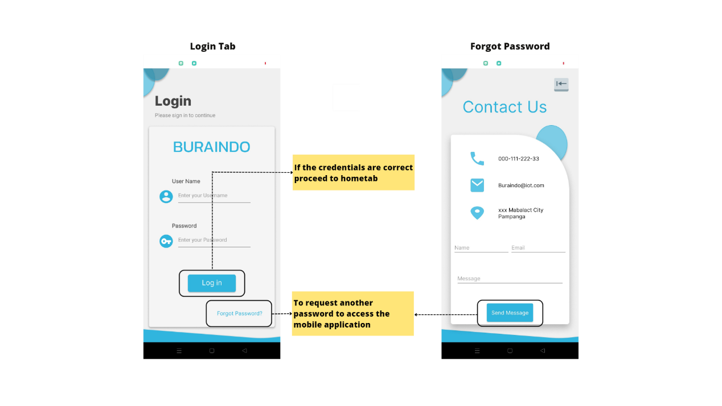

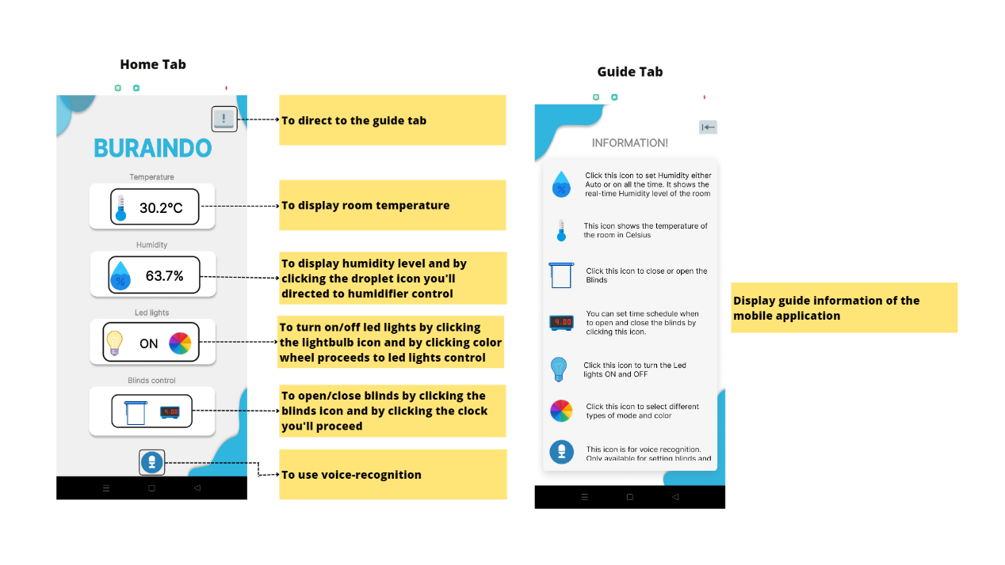

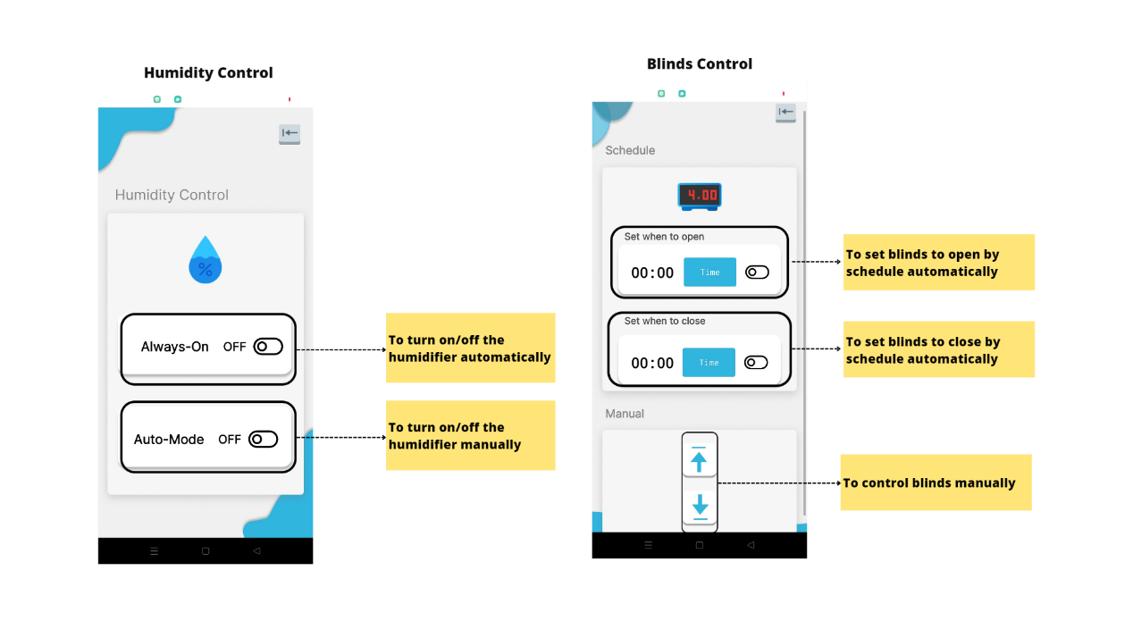

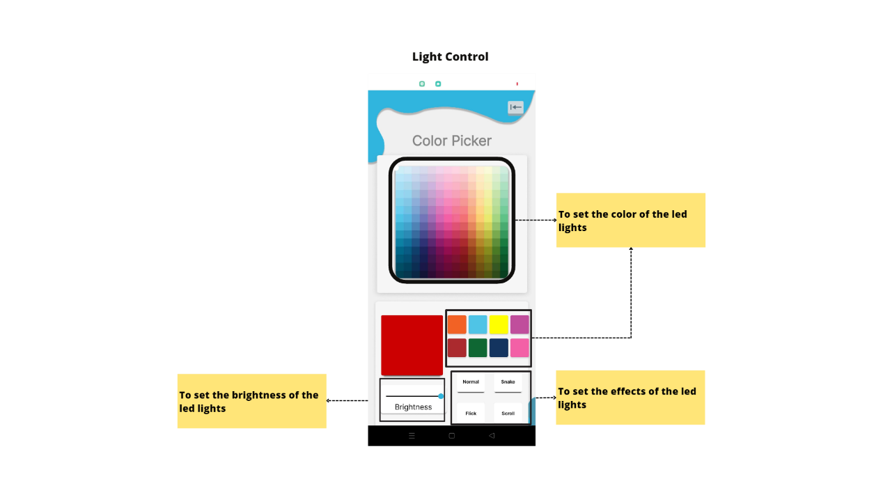

**APPENDIX B**

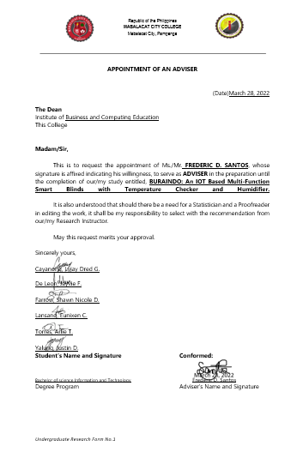**Appointment of an Adviser**



**APPENDIX C**

**Appointment of an English Reader**

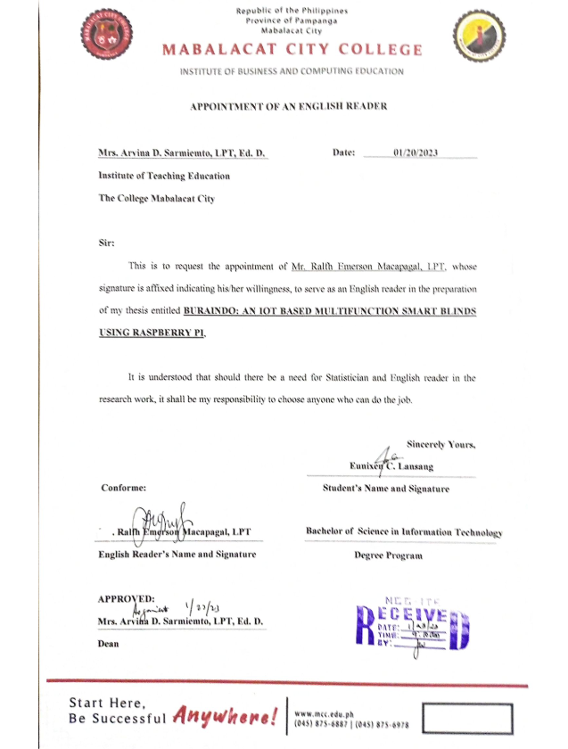

**APPENDIX D**

**Hardware Design Circuit Diagram**

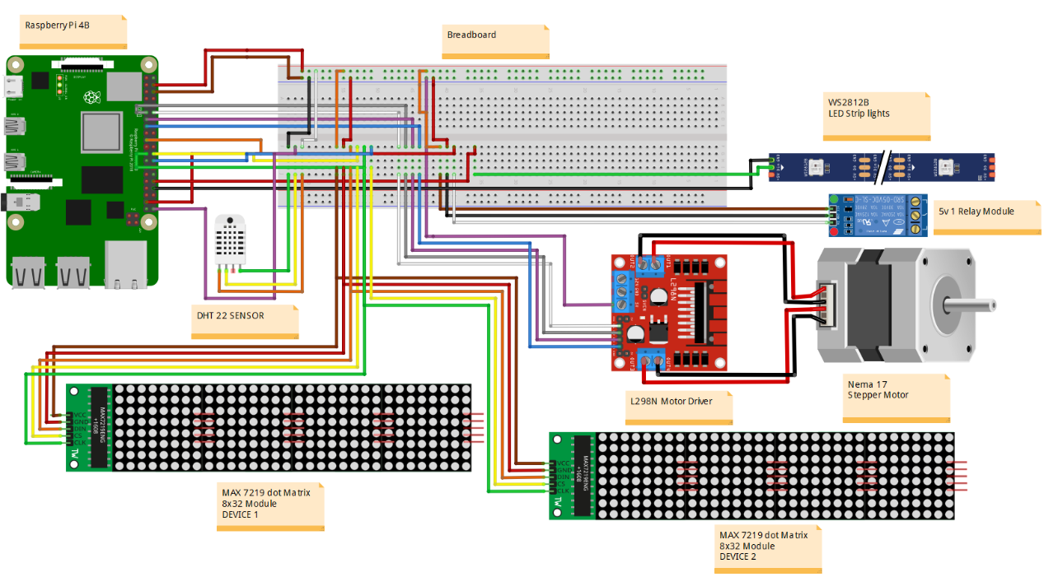

**APPENDIX E**

**Block Diagram**

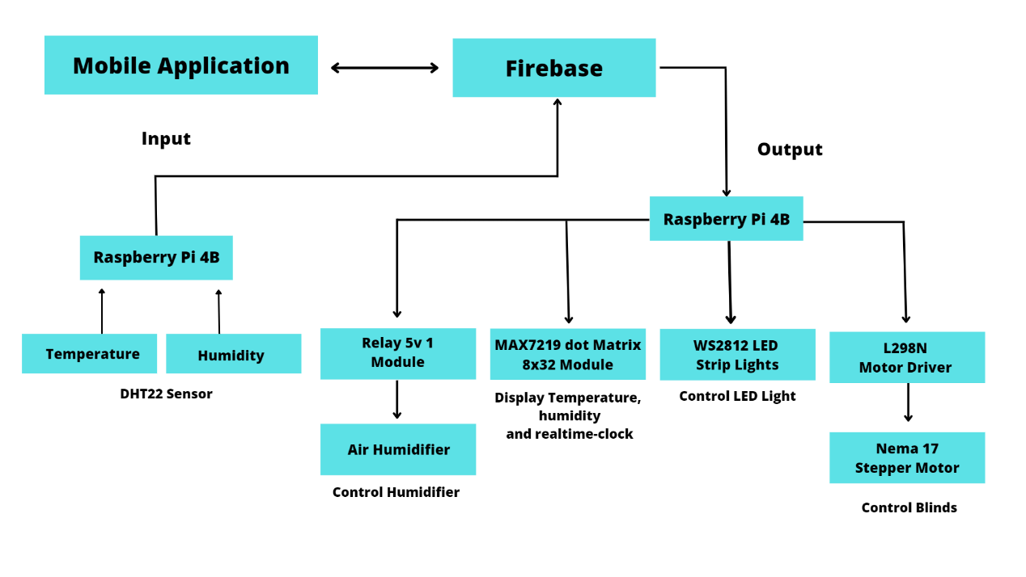

**APPENDIX F**

**Flowchart**

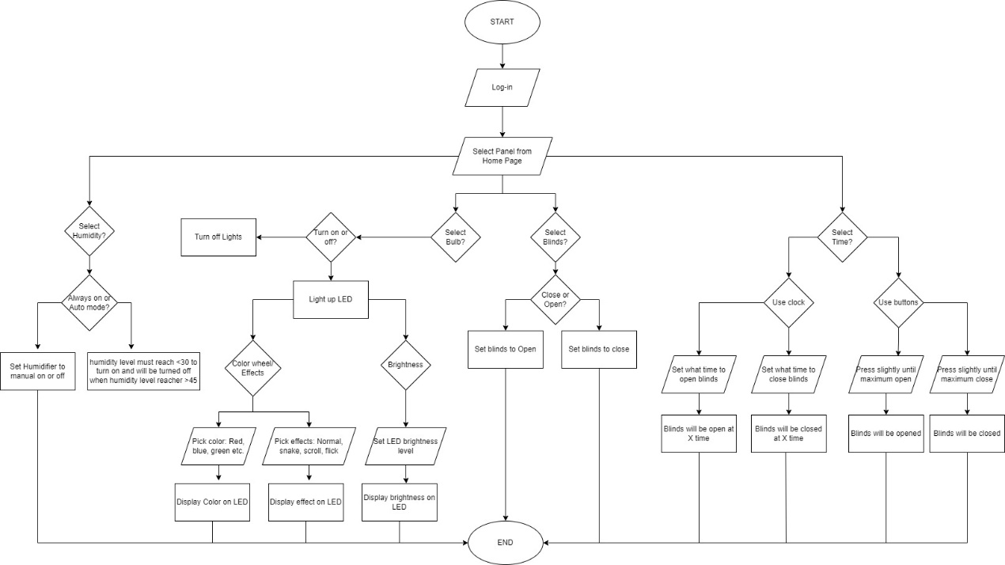

**APPENDIX G**

**Storyboard**

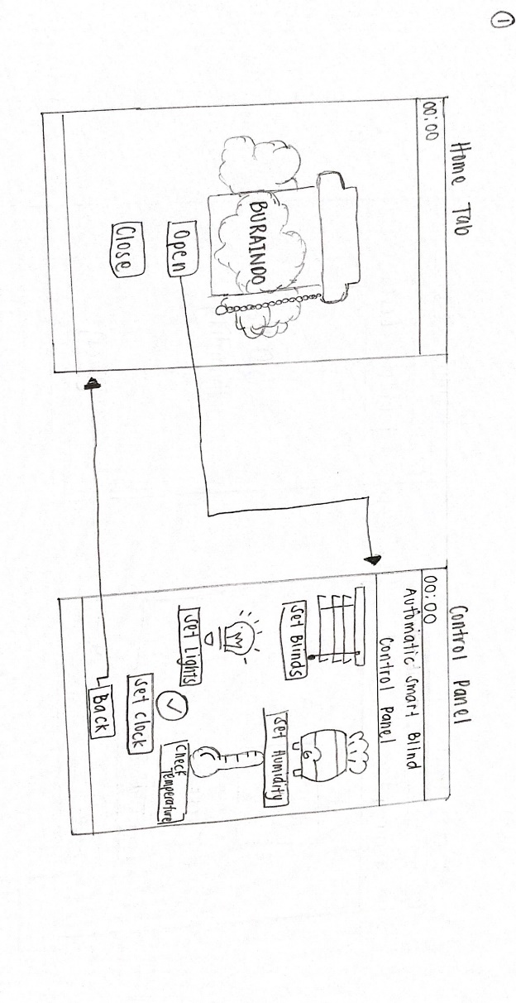

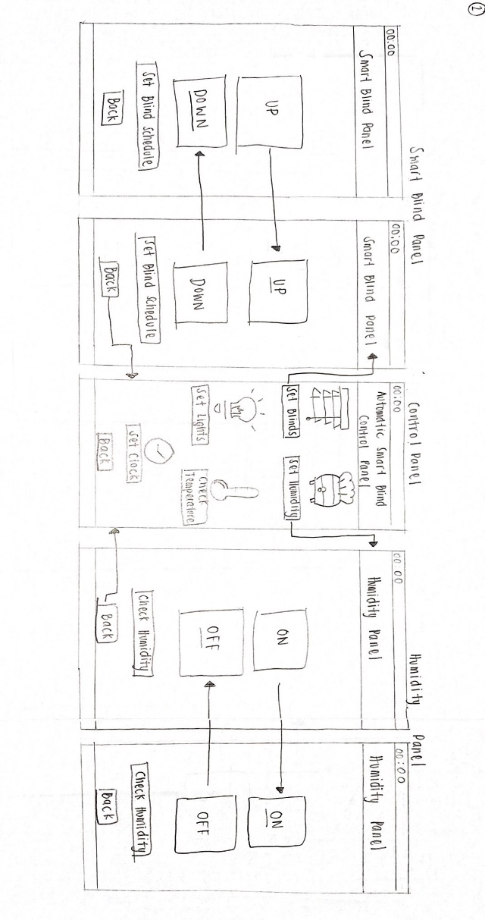

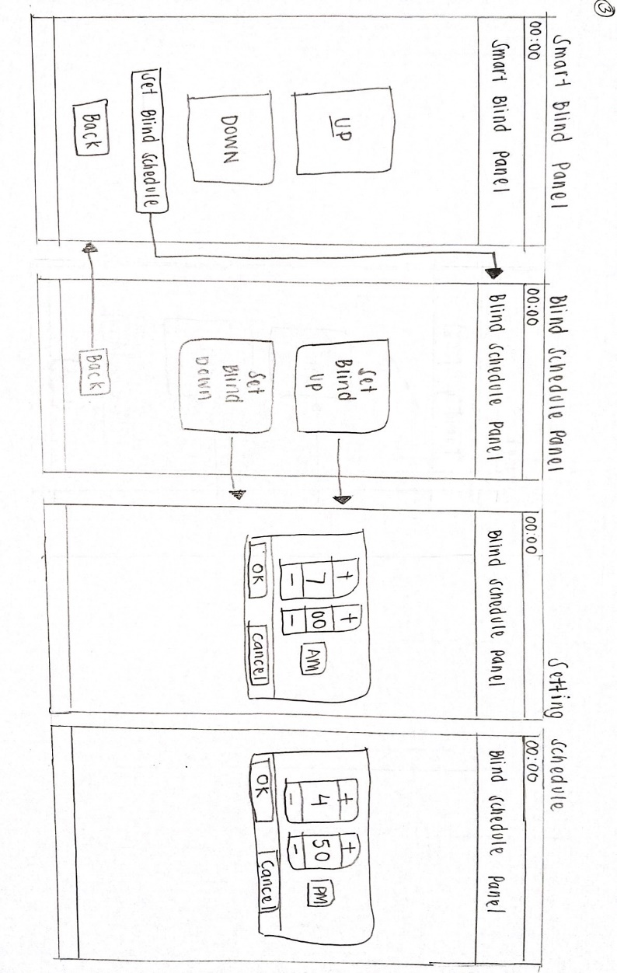

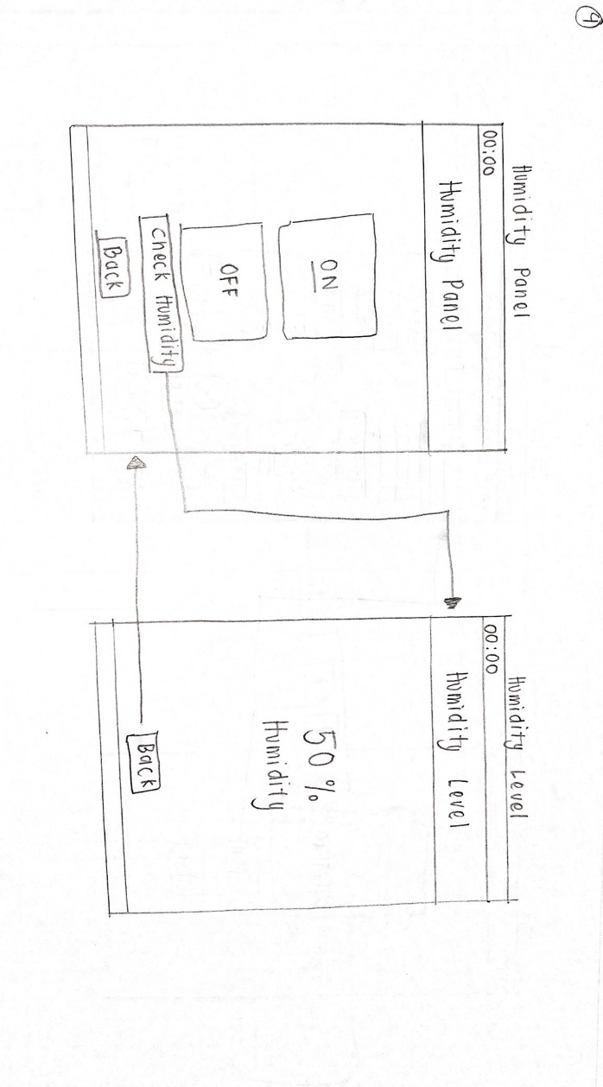

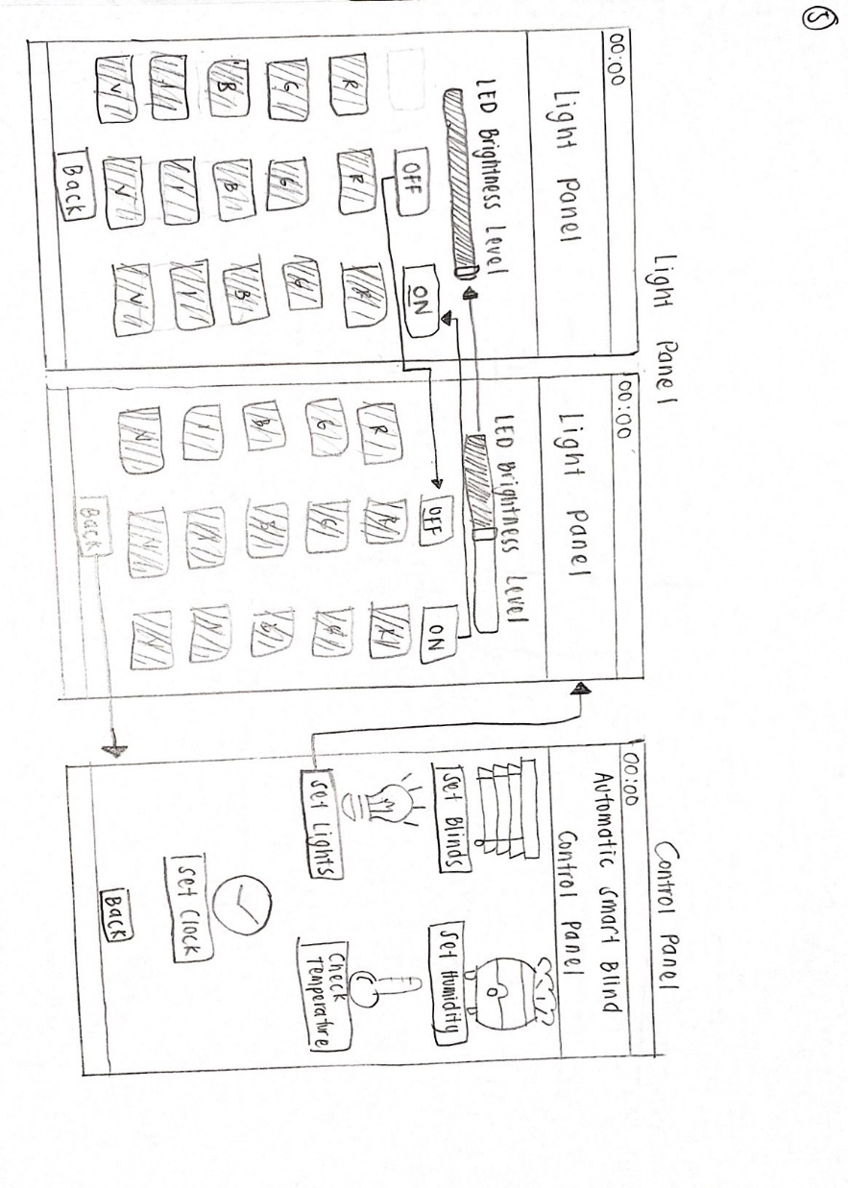

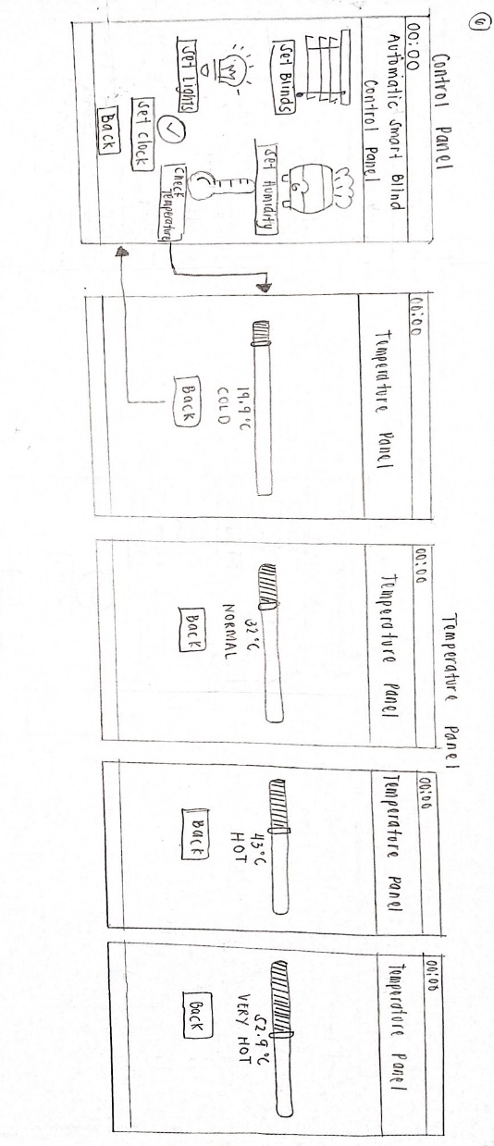

**APPENDIX H**

**Structural Design**

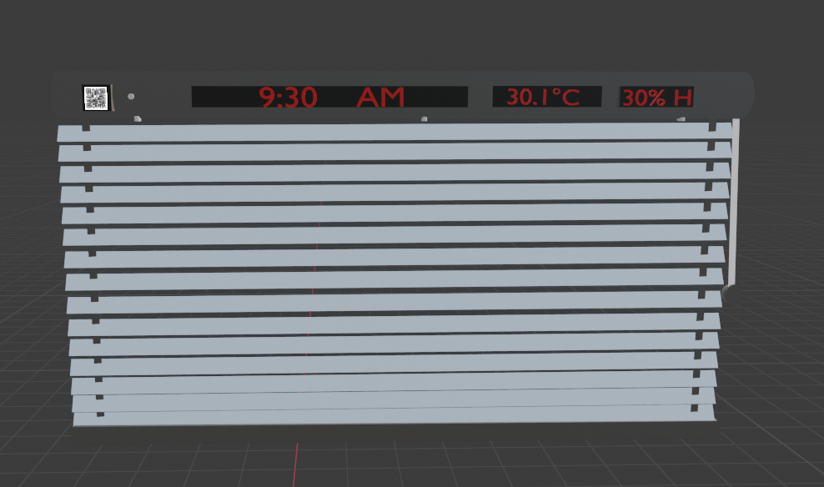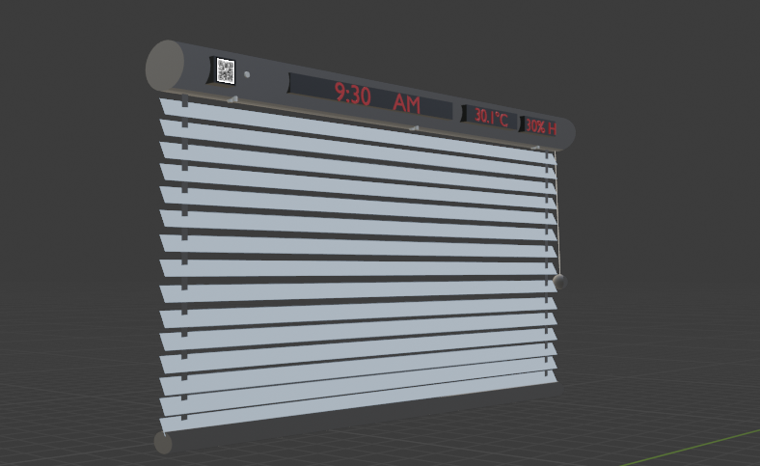

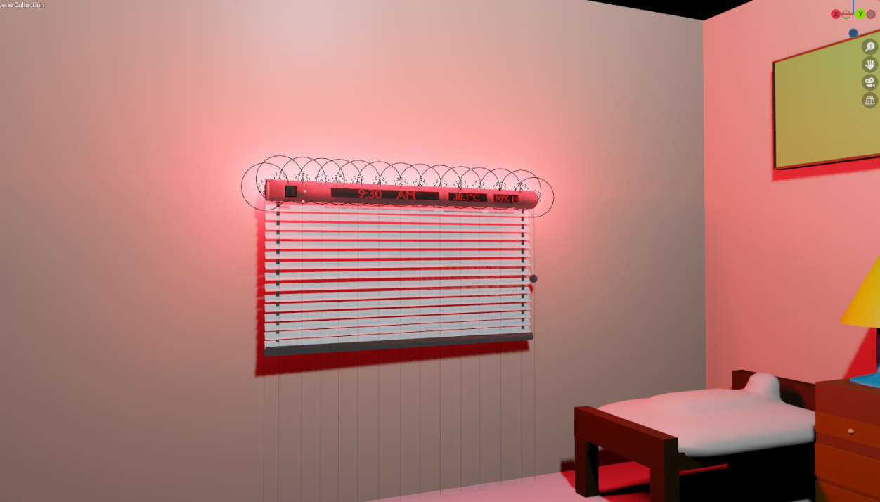

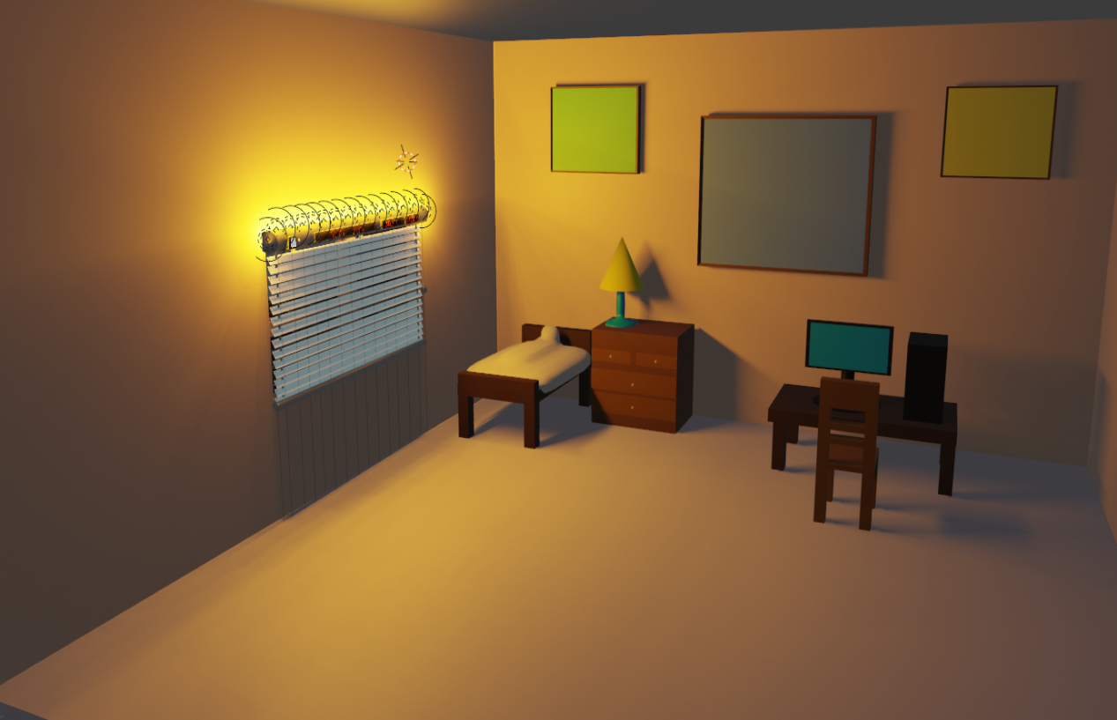

**APPENDIX I**

**Final Design**

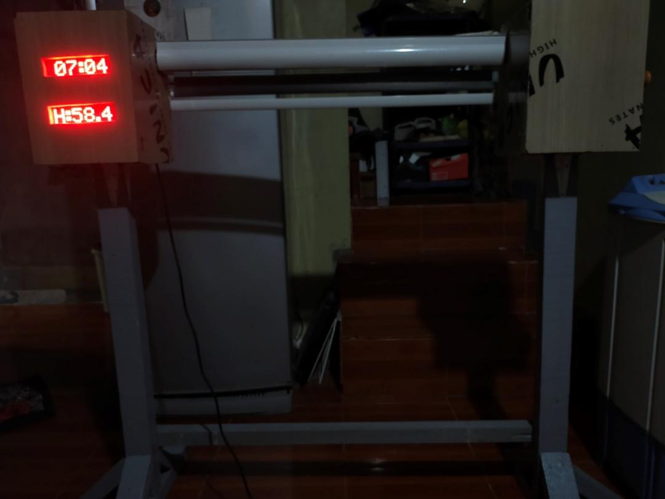

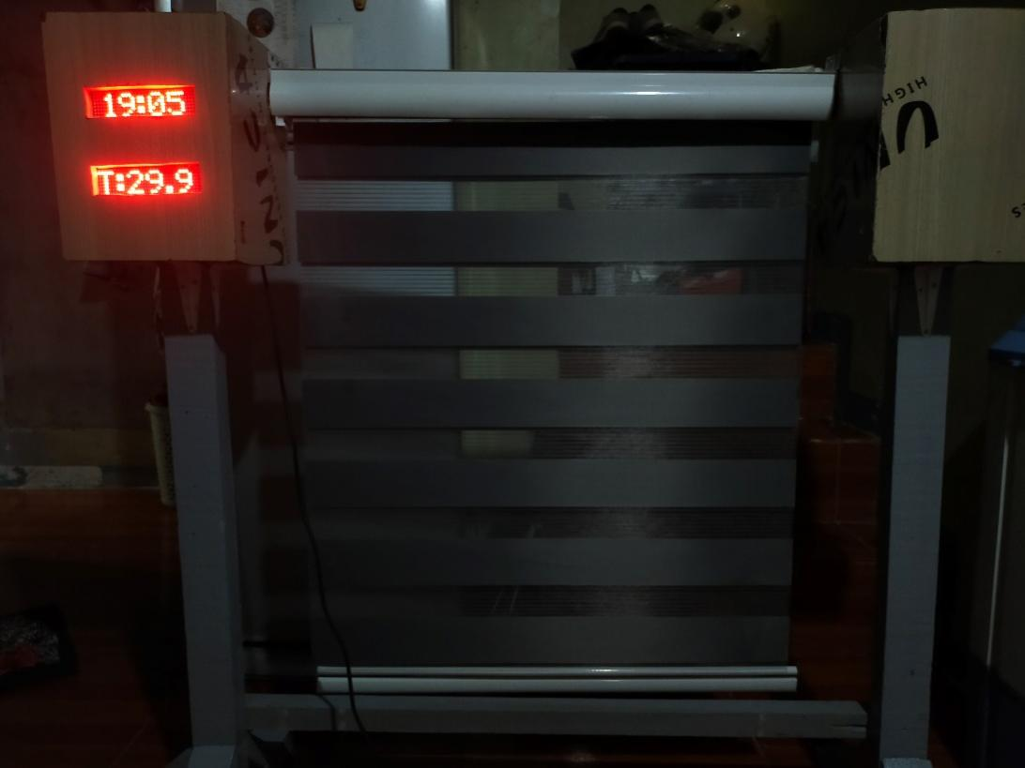

**APPENDIX J**

**Software Requirements**

|  |  |
| --- | --- |
| **Table no. 8** | |
| **Application** | **Functions** |
| 1. MIT APP Inventor V2 | To develop mobile application |
| 2. Firebase | Online database |
| 3. Raspberry Pi OS | The operating system of raspberry pi |
| 4. Figma | To design mobile user interface |
| 5. 3D Blender | To design a structural design |
| 6. Thonny | An IDE software used for python |
| 7. Python | The programming language used to develop the system |

**APPENDIX K**

**Hardware Requirements**

|  |  |
| --- | --- |
| **Table no. 9** | |
| **Components** | **Function** |
| 1. Raspberry Pi 4B | Microcontroller |
| 2. Relay 5V 1 Channel Module | To control humidifier |
| 3. DHT22 | To monitor temperature and humidity |
| 4. Nema 17 Stepper Motor | To control the blinds |
| 5. L298N Motor Driver | To control the stepper motor |
| 6. MAX7219 dot Matrix 8x32 | To display the time, temperature, and humidity level |
| 7. Air Humidifier | To produce moist air |
| 8. WS2812B | To lighten the blinds |
| 9. Android Phone | To use the mobile application |

**APPENDIX L**

**Desktop Computer Specification**

|  |  |
| --- | --- |
| **Table no. 10** | |
| **Components** | **Specification** |
| 1. Processor | Broadcom BCM2711, Quad core Cortex-A72 (ARM v8) 64-bit SoC @ 1.5GHz |
| 2. Ram | 16.0 GB (15.8 GB usable) |
| 3. OS | Windows 10 Pro |
| 4. HDD | 120GB |
| 5. SSD | 120GB |
| 6. Graphic Driver | Intel(R) UHD Graphics 630 |

**APPENDIX M**

**Raspberry Pi Specification**

|  |  |
| --- | --- |
| **Table No. 11** | |
| **Components** | **Specification** |
| 1. Processor | Broadcom BCM2711, Quad core Cortex-A72 (ARM v8) 64-bit SoC @ 1.5GHz |
| 2. Ram | 4GB |
| 3. OS | Raspberry Pi OS |
| 4. Micro SD Card | 64 GB |

**APPENDIX N**

**Project Costing Table**

|  |  |  |
| --- | --- | --- |
| **Table no. 12** | | |
| **Materials** | **Quantity** | **Price Per Piece/Set (PHP)** |
| Raspberry Pi 4B | 1 | 11,358 |
| Korean Blinds | 1 | 500 |
| Air Humidifier | 1 | 600 |
| MAX7219 dot Matrix 8x32 Module | 2 | 2,400 |
| L298N Motor Driver Module | 1 | 450 |
| DHT22 Humidity Temperature Sensor | 1 | 500 |
| Nema 17 Stepper Motor | 1 | 1,450 |
| Jumper Wires 30mm F/F M/F | 55 | 660 |
| Breadboard | 1 | 275 |
| Relay 5v 1 Channel | 1 | 250 |
| Adaptor 12V/2A | 1 | 350 |
| Adaptor 5V/2A | 1 | 350 |
| Con DC Jack w/ 2P TB | 2 | 100 |
| Wire Dual #20 (speaker) | 1 | 20 |
| Fan 5X5 12V | 1 | 250 |
| **TOTAL** |  | **19,513** |

**APPENDIX O**

**Likert Scale**

|  |  |  |
| --- | --- | --- |
| **Table no. 13** | | |
| **Answer** | **Weight** | **Percentage** |
| **Very Agree** | 5 | 80 - 100% |
| **Agree** | 4 | 60 - 79.99% |
| **Enough** | 3 | 40 - 59.99% |
| **Disagree** | 2 | 20 - 39.99% |
| **Very Disagree** | 1 | 0 - 19.99% |
| Source: *(https://www.researchgate.net/figure/The-Likert-Scale-Percentage-Value_tbl1_332417097)* | | |

**APPENDIX P**

**Gantt Chart**

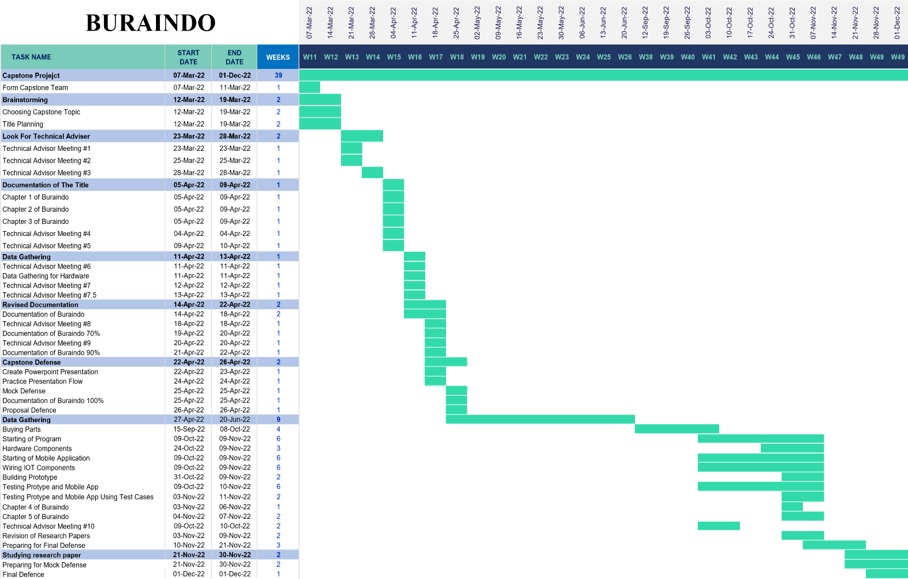

**APPENDIX Q  
Researcher Questionnaire**

**Table no. 14**

|  |  |  |
| --- | --- | --- |
| Name (Optional): | Date: | |
| Researchers Made User-Interface Test Case System Quality Standard  **BURAINDO** | Checklist | |
| YES | NO |
| **FUNCTIONAL SUITABILITY**  **Functional Completeness, Functional Correctness, Functional Appropriateness** | | |
| **FUNCTIONAL COMPLETENESS:** | | |
| The system provides a set of functions for user-interface that covers all the completeness for specified tasks and user objectives (user-access) |  |  |
| 1. USER-INTERFACE |  |  |
| 1. The system user-interface allows the user to login |  |  |
| 1. The system user-interface can access the user manual |  |  |
| **FUNCTIONAL CORRECTNESS:** | | |
| The system provides set of functions that meets the expected result (displays humidity and temperature) |  |  |
| 1. The systems user-interface display the temperature and humidity |  |  |
| 1. The systems display the real-time clock |  |  |
| **FUNCTIONAL APPROPRIATENESS:** | | |
| 1. The system provides an appropriate set of functions facilitate the accomplishment of specified user objectives. |  |  |
| 1. The system provides an appropriate set of functions facilitate the accomplishment of specified user tasks. |  |  |
| **USABILITY**  **Appropriateness recognizability, Learnability, Operability, User interface aesthetics, Accessibility** | | |
| **APPROPRIATENESS RECOGNIZABILITY:** | | |
| 1. The system mobile interface icons are recognizable |  |  |
| **LEARNABILITY:** |  | |
| 1. The system’s mobile interfaces are user-friend and relatively simple |  |  |
| 1. The system’s mobile interface can be self-learned |  |  |
| **OPERABILITY:** | | |
| The system can be operated easily and control by user. It allows the user to access and control the system. (Control the blinds, led strip lights, humidifier) |  |  |
| 1. The system needs internet to function |  |  |
| 1. The system mobile interface can control the blinds functions |  |  |
| 1. The system mobile interface can set schedule for the blinds |  |  |
| 1. The system mobile interface can turn on and off the led strip lights |  |  |
| 1. The system mobile interface can turn on and off the humidifier |  |  |
| 1. The system mobile interface can change the color of led strip lights |  |  |
| 1. The system mobile interface can change the brightness of led strip lights |  |  |
| 1. The system mobile interface can change the effects of led strip lights |  |  |
| **USER INTERFACE AESTHETICS:** | | |
| The system demonstrates the user interface enables pleasing and satisfying interaction for the effective navigation tools to ease task completion (User-interface layout, completeness of description) |  |  |
| 1. The system mobile interface background is suitable for user-experience design |  |  |
| 1. The system mobile interface graphical user interface and icon are recognizable |  |  |
| **ACCESSIBILITY:** | | |
| 1. The system can be installed anytime |  |  |
| 1. The system can be accessed anytime |  |  |
| **PORTABILITY**  **Adaptability, Installability** | | |
| **ADAPTABILITY:** | | |
| 1. The system can be installed on different blinds |  |  |
| **INSTALLABILITY:** | | |
| 1. The system can be installed easily by scanning the QR code |  |  |
| 1. The system is only applicable to android phones |  |  |

**APPENDIX R**

**Real-time Database**

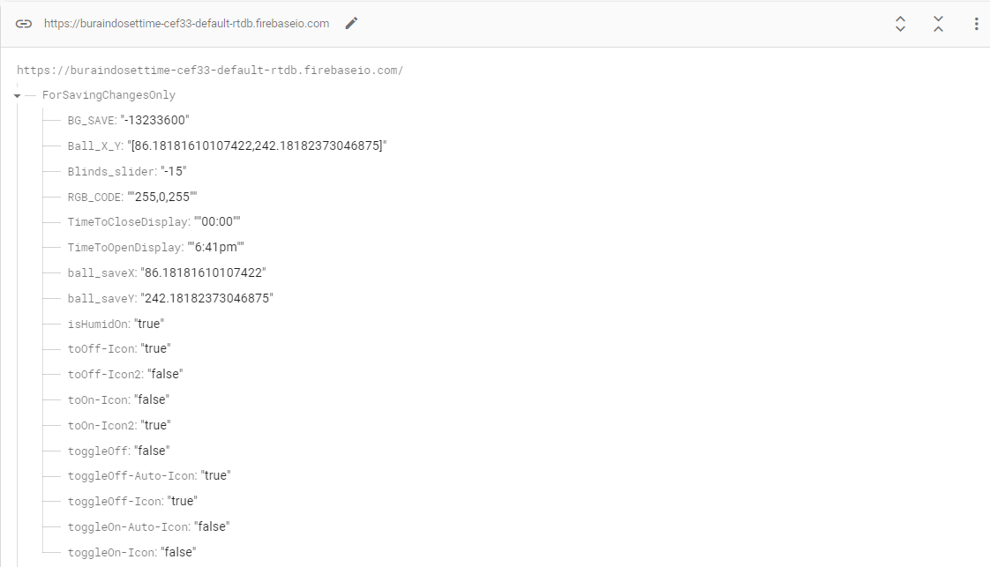

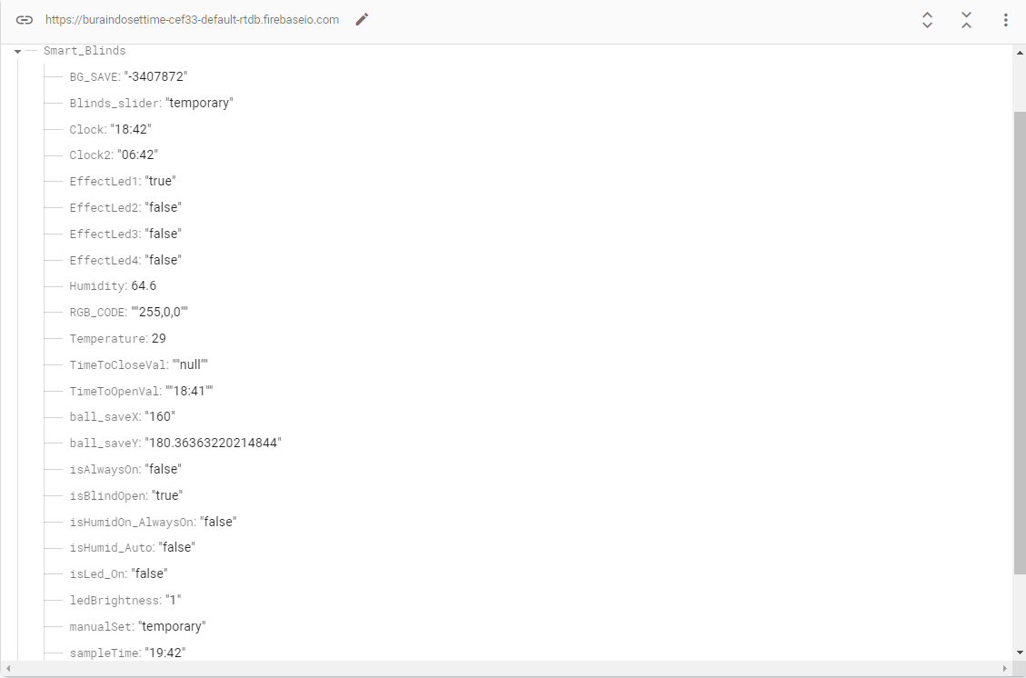

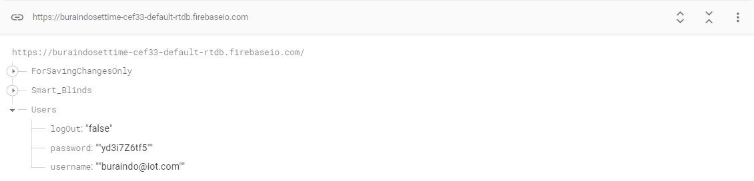

**APPENDIX S**

**Voice Recognition Commands**

|  |  |  |  |
| --- | --- | --- | --- |
| **Table no. 15** | | | |
| **Blinds Commands** | | | |
| **To close blinds** | close blind | close blinds | close curtains |
| curtains close | curtains close |  |
| **To open blinds** | blinds open | open blinds | blind open |
| open curtains | curtains open | blinds up |
| **LED Commands** | | | |
| **To turn off led lights** | turn off led | led turn off | led close |
| close lights | light close | close led lights |
| **To turn on led lights** | open led | open led | turn on led |
| turn on led lights |  |  |
| **To change color led** | led red | led lights red | led green |
| led lights green | led yellow | led lights yellow |
| led violet | led lights violet | led pink |
| led lights pink | led blue | led lights blue |
| **To change led brightness** | brightness low | low brightness | brightness mid |
| mid brightness | high brightness | max brightness |
| maximum brightness |  |  |
| **Humidifier Commands** | | | |
| **To open humidifier manual mode** | humidifier open | open humidifier | humidifier on |
| humidifier on |  |  |
| **To close humidifier manual mode** | humidity close | close humidity | humidity off |
| off humidity | humidifier off |  |
| **To open humidifier auto mode** | humidity always on | always on humidity | humidifier always on |
| always on humidifier | humidifier auto | auto humidifier |
| **To close humidifier auto mode** | humidifier auto off | off auto humidifier | close auto humidifier |
| auto humidifier close |  |  |

**APPENDIX T**

**Certificate of Plagiarism Scanning**

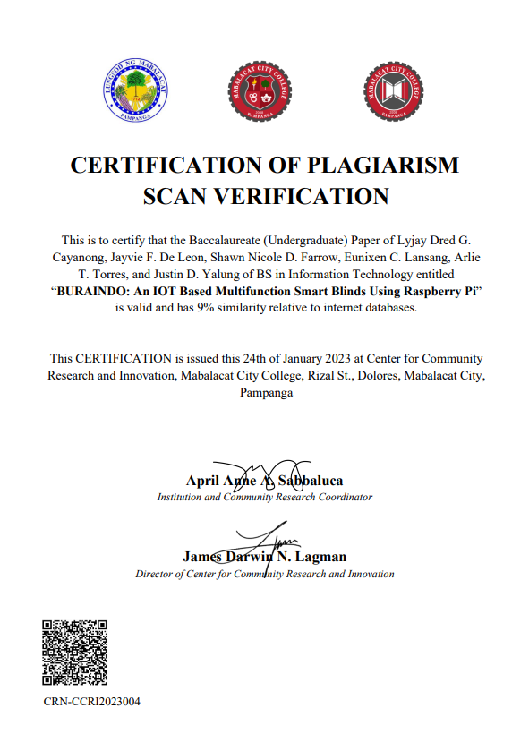

**APPENDIX U**

**Certificate of English Critic**

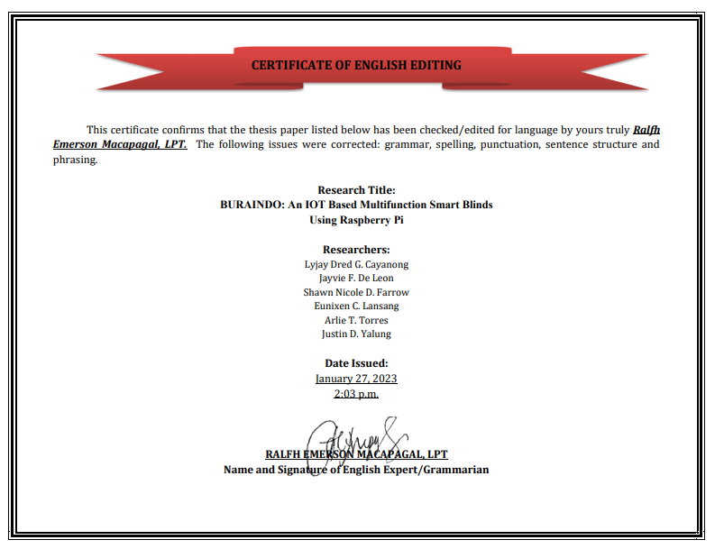

**APPENDIX V**

**Curriculum Vitae**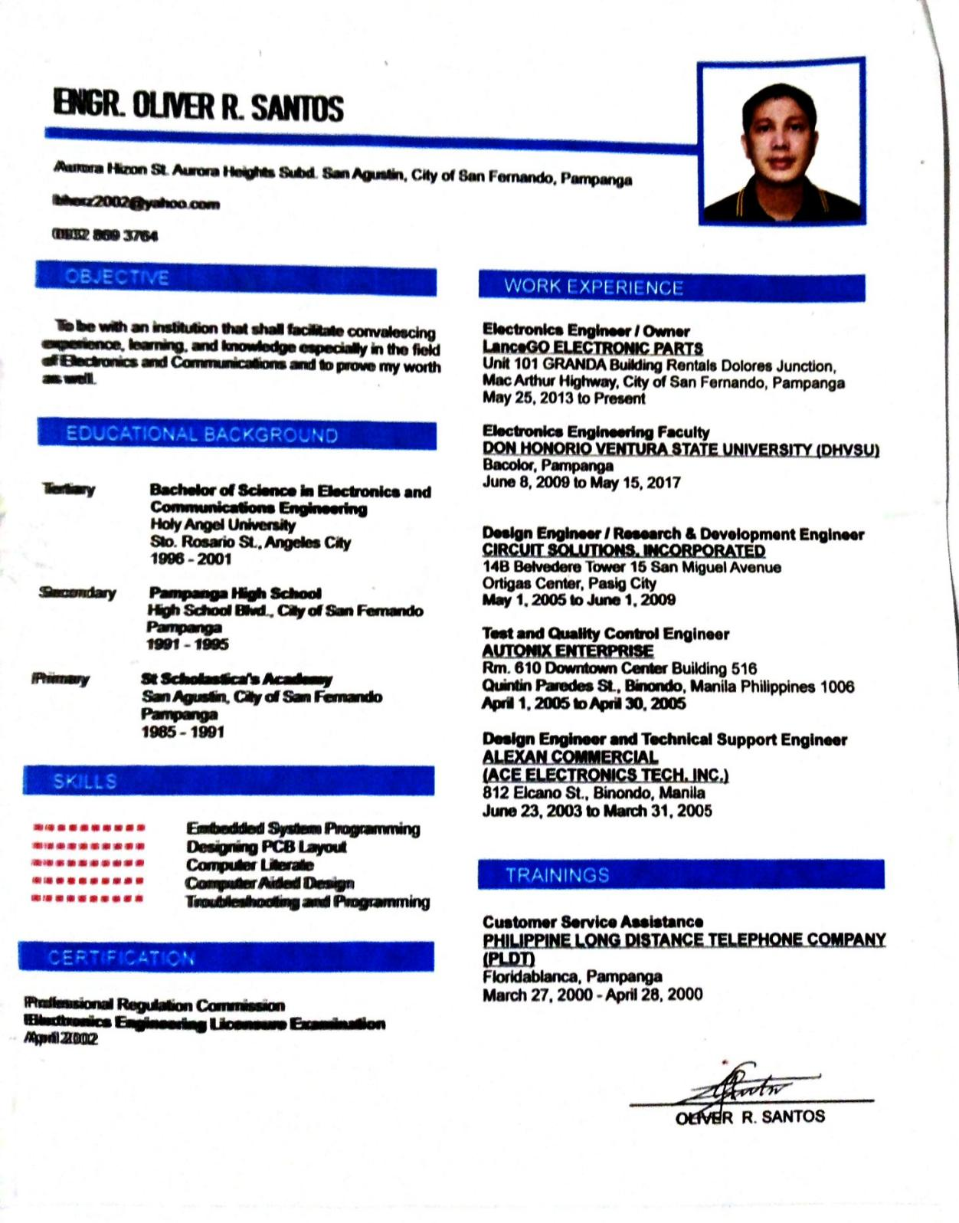

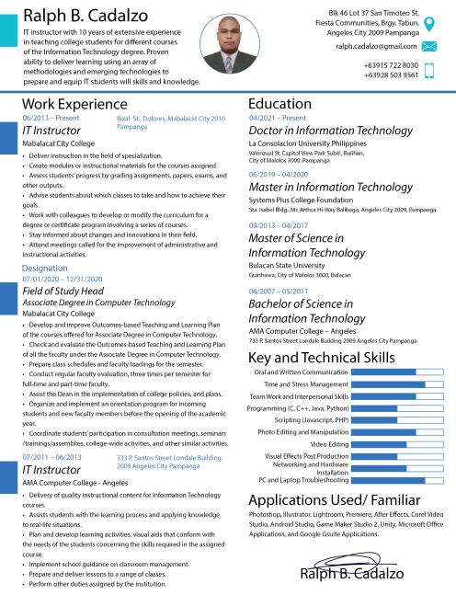



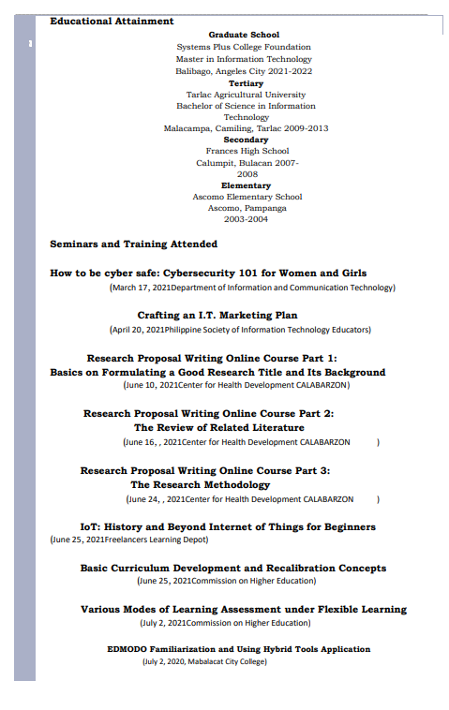

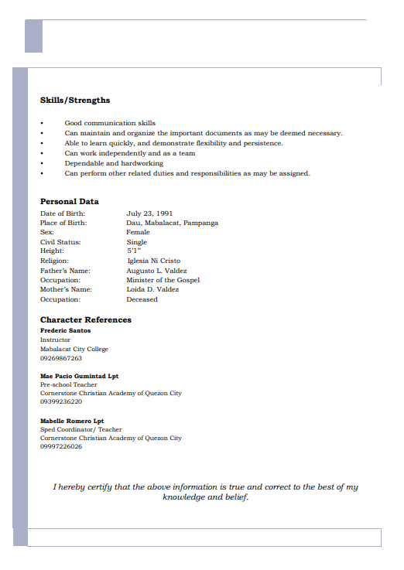

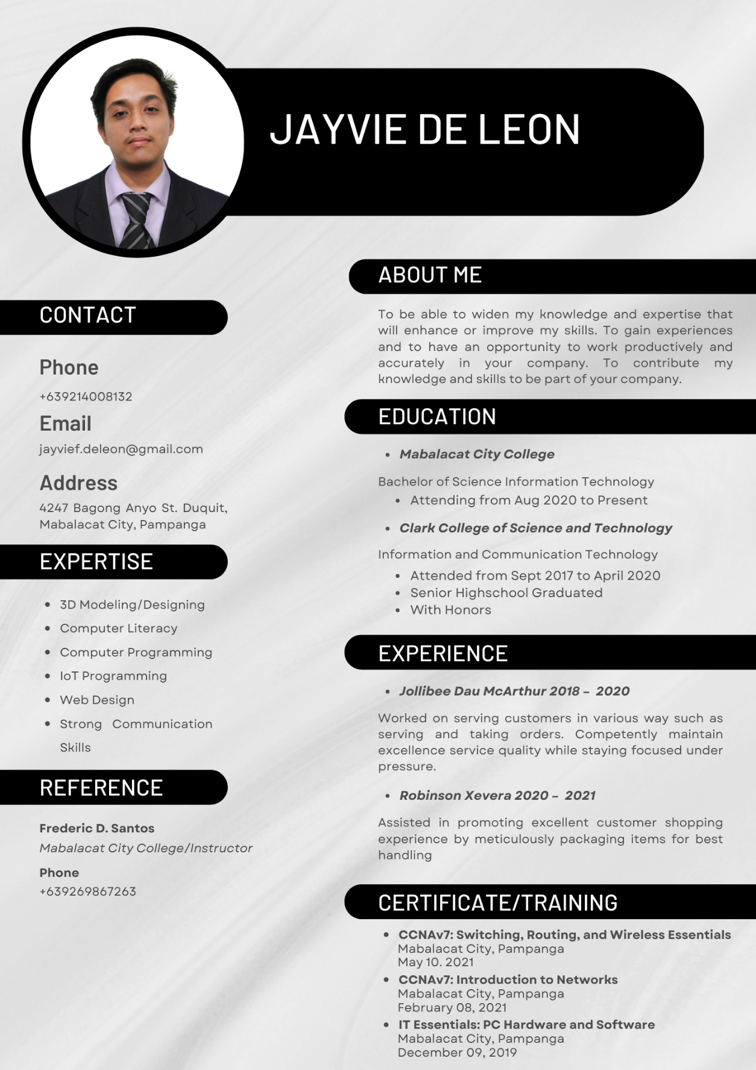

s



